Layer-by-Layer free-standing membranes made of natural polymers for drug delivery
Claire Monge, PhD, IBCP CNRS, France
Sofia Caridade, PhD, IBCP CNRS, France
Anne-Lise Paris, IBCP CNRS, France
Bernard Verrier, PhD, IBCP CNRS, France

Abstract
The performance of polymeric structures as drug delivery systems and implantable devices is fully dependent on their stability and integrity in biological environments.
The Layer-by-Layer (LbL) technology is a versatile technique that can be used to fabricate numerous structures such as planar ultrathin films and membranes, without using aggressive solvents.
LbL relies on the use of polyelectrolytes with an opposite charge assembled onto very thin (few nm) or large (several tens of µm) structures [1, 2]. The nature of polymer interactions makes the assembly a versatile platform to load and release macromolecules [3].
The deposition of hundred layers of biopolymers (polysaccharides) on a low energy substrate (polypropylene) led to the production of a thick free-standing membrane with tunable thickness (tens of µm) and mechanical properties. For example, these membranes were able to drive bone generation in vivo after loading with the osteogenic factor BMP-2 [4].
LbL free-standing membranes could be produced with various biopolymers (hyaluronic acid, collagen…) and deliver biomacromolecules such as proteins or nucleic acids or even nanoobjects for skin or mucosal applications.

Image

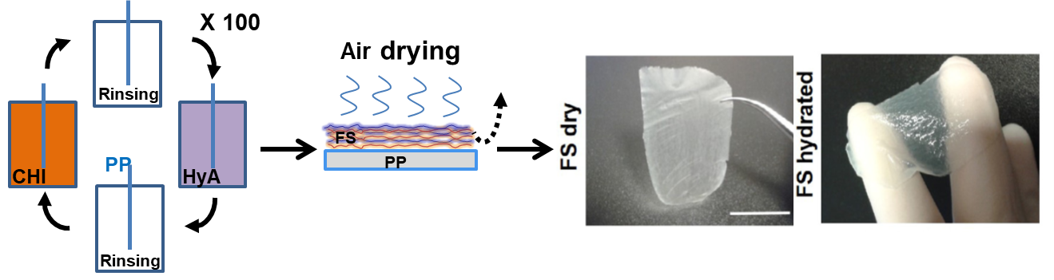

Membranes made of polysaccharides chitosan (CHI) and sodium hyaluronate (HyA) are produced by the LbL technology. They can be easily manipulated after detachment from the low energy substrate.

Recent Publications
- Decher G (1997) Fuzzy Nanoassemblies: Toward Layered Polymeric Multicomposites. Science, 1997. 277(5330): p. 1232.
- Caridade SG, Monge C, Gilde F, Boudou T, Mano JF, Picart C. (2013) Free-standing polyelectrolyte membranes made of chitosan and alginate. Biomacromolecules. 14(5):1653-1660
- Monge C, Almodovar J, Boudou T, Picart C. (2015a) Spatio-temporal control of LbL films for biomedical applications: from 2D to 3D. Advanced Healthcare Materials. 4(6):811-30.
- Monge C*, Caridade SG*, Almodovar J, Guillot R, Lavaud J, Coll JL, Mano JF, Picart C. (2015b) Myo- and osteoconductive free-standing polysaccharide membranes. Acta Biomaterialia, 15:139-49.

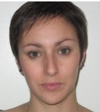 Biography
The scientific interests of Claire Monge are natural drug delivery systems. She obtained her PhD from the Grenoble Alpes University (France) in Physiology and Pharmacology and has integrated the French National Center of Research (CNRS) in 2017 as a permanent researcher in the Laboratory of Tissue Biology and Therapeutical Engineering (LBTI). She develops a research topic around the LbL technology applied to protein and nanoparticule delivery at mucosal sites (http://lbti.ibcp.fr/?page_id=2014).
Email: claire.monge@ibcp.fr

Notes/Comments:

