Abstract
Title: Measuring Clinical Supervision of Physician Residents in U.S. Teaching Hospitals: An Informatics Solution
Perez EV¹, McKay T¹, Byrne JM^{1,2}, Durkin RM³, Kashner TM^{1,2,4},
¹Center for Advanced Statistics in Education, VA Loma Linda Healthcare System, Loma Linda, CA, U.S.A.
²Department of Internal Medicine, Loma Linda University School of Medicine, Loma Linda, CA, U.S.A.
³IT Specialist with U.S. Department of Veterans Affairs Office of Information Technology, Loma Linda, CA, U.S.A.
⁴Office of Academic Affiliations, Veterans Health Administration, Department of Veterans Affairs, Washington, DC, U.S.A.

Keywords: Physician Resident Supervision, Electronic Health Record, Automated Clinical Survey
- Abstract Body
Every year in the U.S., over 124,000 physician residents and fellows rotate through teaching clinics representing 149 specialities and 10,000 accredited graduate medical education programs. The present study investigated the reliability and validity of the U.S. Department of Veterans Affairs’ (VA) new Clinical Supervision Index (CSI). CSI was designed by the authors to measure quantitatively the intensity by which those trainees are supervised while engaged in patient care. Such documentation is vital to ensure quality of care and education accreditation standards are meet. Tested for 3 years at a VA medical center, the CSI is an automated survey administered electronically through the teaching facility’s Electronic Health Record (EHR) to physician residents and their supervisors at the time they enter a progress note for an inpatient or outpatient encounter. Fully automated, the MS COM-object based software random samples encounters, administers surveys, and scores responses into 12 measures based in mathematical theory that describes supervision as a constrained optimization problem of both patient health and trainee education outcomes. CSI scores are automatically merged with data extracted from the EHR to create data files that fully describes the trainee’s supervision experience. We found CSI is feasible informatically, acceptable clinically, and valid and reliable scientifically for research, program evaluation, patient care and education quality enhancement, and accreditation purposes.

- Image:

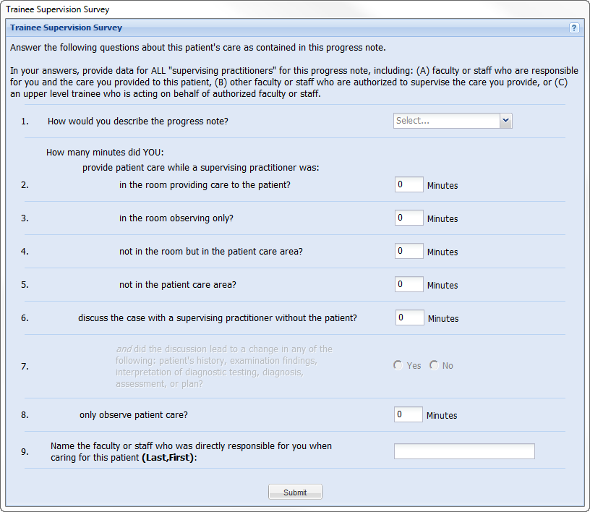
- Reference:
- Kashner TM, Byrne JM, Henley SS, Golden RM, Aron DC, Cannon GW, Chang BK, Gilman SC, Holland GJ, Kaminetzky CP, Keitz SA, Muchmore EA, Kashner TK, Wicker AB. 2010. Measuring progressive independence with the Resident Supervision Index: Theoretical Approach. J. Grad. Med. Ed., 2: 8-16
- Byrne JM, Kashner TM, GilmanSC, Aron DC, Cannon GW, Chang BK, Godleski L, Golden RM, Henley SS, Holland GJ, Kaminetzky CP, Keitz SA, Kirsh S, Muchmore EA, Wicker AB. 2010. Measuring the intensity of resident supervsion in VA: Resident Supervision Index. Acad. Med., 85: 1171-1181.
- Kashner TM, Byrne JM, Chang BK, Henley SS, Golden RM, Aron DC, Cannon GW, Gilman SC, Holland GJ, Kaminetzky CP, Keitz SA, Muchmore EA, Kashner TK, Wicker AB. 2010. Measuring progressive independence with the Resident Supervision Index: Empirical Approach. J. Grad. Med. Ed., 2: 17-30
- Biography:
With 230 publications & presentations, Michael Kashner, PhD JD and John Byrne, DO, are co-directors at the Center for Advanced Statistics in Education (CASE), Loma Linda VA Healthcare System and Professors of Medicine at Loma Linda University School of Medicine. Dr. Byrne is Associate Chief of Staff for Education and Informatics. Robert Durkin, MD, is IT Specialist and CSI developer for VA’s Office of Information Technology. CASE project director Elena Perez has a degree in health administration from the University of Phoenix in 2012. Tracy McKay has a master’s degree in health informatics from National University in 2016.

- Presenting author details


Full Name: Elena V. Perez, BSHA
Contact email: elenav.perez@va.gov
Voice: (909) 825-7084 ext. 1730
Session name/ number: Healthcare Informatics
Category: (Poster presentation)
Passport: (U.S. Citizen)

