Influence of Transcription-Coupled Repair on the Immune Microenvironment and Its Mechanism in Sensitizing Chemotherapy in NSCLC Treatment
FeiFeng ,Yanli Hou*
Chongqing Traditional Chinese Medicine Hospital
Objective: This review delves into the intricate interplay between transcription-coupled DNA repair (TCR) and the immune microenvironment in the context of non-small cell lung cancer (NSCLC) treatment. It aims to elucidate the impact of TCR on immune responses and explore its role in augmenting chemotherapy sensitivity, providing a theoretical foundation for advancing NSCLC therapeutic strategies.
Methods and Materials: TCR, a complex cellular process encompassing DNA damage repair and gene expression regulation, is central to our investigation. Our methodology involves a systematic analysis of patient samples and relevant literature, allowing for a comprehensive understanding of the mechanisms underlying the interaction between TCR and tumor immunity.
Results:
Relationship between TCR and the Immune Microenvironment:
Aberrant TCR activity may lead to excessive repair of DNA damage, suppressing the normal expression of tumor antigens. TCR's impact on the infiltration and activation of immune cells may impede the immune system's ability to recognize and attack tumors effectively.
Impact of TCR on Chemotherapy Sensitivity:
TCR abnormalities can contribute to reduced efficacy of chemotherapy drugs, exacerbating issues of chemoresistance. Modulating TCR activity has the potential to enhance sensitivity to chemotherapy drugs, thereby strengthening treatment outcomes.
Conclusion: In NSCLC treatment, the abnormal activity of TCR directly influences the immune microenvironment, hindering the effective immune response against tumors. Furthermore, excessive repair activity contributes to tumor resistance to chemotherapy drugs. Regulating TCR activity emerges as a pivotal factor in improving treatment outcomes. Future research directions may include exploring molecular targeted therapies to inhibit aberrant repair and combining immunotherapy to optimize treatment strategies. This approach holds promise for providing more personalized and effective treatment options for NSCLC patients, ushering in innovative advancements in lung cancer therapeutics.
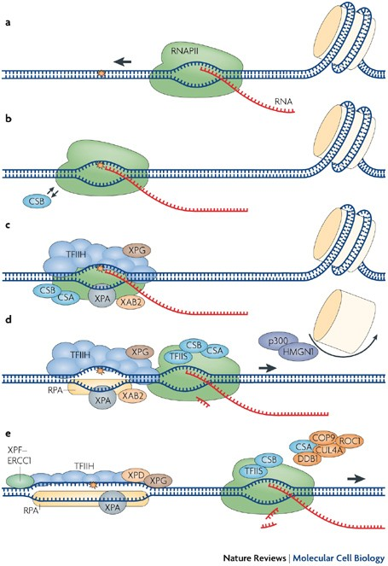
Figure1 Transcription-coupled DNA repair.
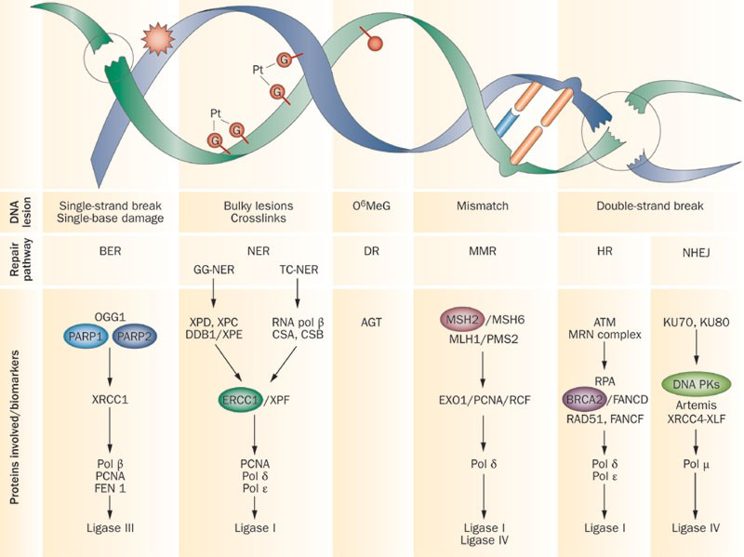
Figure2 The potential of exploiting DNA-repair defects for optimizing lung cancer treatment.

