Biochemical and genetic profiling of PALB2 within PALB2-BRCA2 interface among Pakistani breast cancer patients

Sumroon Ephraim, Forman Christian College
(A Chartered University), Pakistan

Abstract (300 word limit)
Breast cancer is one of the leading causes of death among women in the world. One of the major causes of breast cancer is through ionizing radiations which create DNA double strand breaks. Nature has blessed cells with multiple repair pathways of which homologous recombination repair pathway is of central importance. This pathway utilizes recombinase for the homology search and repair. Central to this pathway is the association of BRCA2 (breast cancer susceptibility type 2) and PALB2 (partner and localizer of BRCA2) whose disruption can predispose breast/ovarian syndrome. PALB2 is the successor of BRCA2 in cancer prevention and has been identified to show subtle point mutations in different population based studies. BRCA2 residues that bind PALB2 include Trp31, Phe32 and Leu35 which line with the hydrophobic cavity within PALB2 made by residues Val1019, Met1022, Ala1025, Ile1037, Leu1046, Lys1047, Leu1070, Pro1097 and Lys1098. We have planned our studies to investigate the Pakistani population for the identification of possible point mutations in PALB2 within the domain that interacts BRCA2. For this, breast tissue samples (healthy and tumorous) were collected from Jinnah Hospital, Lahore and preserved using paraffin embedding and microscopic slide making. High quality DNA was isolated from both healthy and tumorous samples which was then employed to PCR based amplification using gene specific primers. Gel extraction images show the isolation of the PCR amplified gene products from the agarose gels which were sent for DNA sequencing. Their results will be analysed further for the presence of possible point mutations. Our studies on PALB2 would help Pakistani breast cancer patients in future in particular and to the whole world in general.

Image
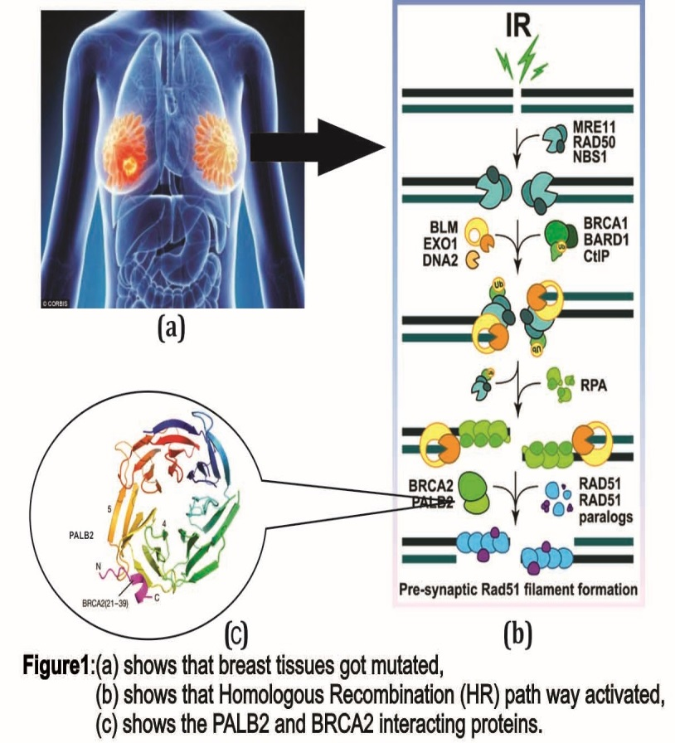

 Biography (150 word limit)

Sumroon Ephraim is student of Molecualr Pathology and Genomics at Masters level and passionate to contribute best towards health sciences. After a year of assiduous laboratory work his finding reveals that PALB2 and BRCA2 interaction plays a key role in Homologous recombination pathway involve in Double Stranded repair mechanism. Yet his research needed to get published after few more expects to disclose but still a new approach to combat against breast cancer.
Email: 17-22018@formanite.fccollege.edu.pk

Notes/Comments:

