Abstract Template

Title: Clinical application of urinary cell free DNA as a marker for cancer

Jeffrey W. Ding^{1,2,} Debin Sun, PhD¹
¹Admera Medical Technology Corporation, 218 Xinghu Road, Suzhou, Jiangsu, 215028, China
²Mountain Lakes High School, 96 Powerville Road, Mountain Lakes, NJ, 07046, USA

Keywords: urine, cfDNA, cancer, noninvasive, genetic test

- Abstract Body (up to 250 words)
The role of circulating cell free DNA holds great promise for individualized medicine for cancer. However, compared with the widely studied cell-free tumor DNA in blood, less is known about the role of urinary cell free DNA (UcfDNA) from tumor. The presence of UcfDNA signals from tumor has still remained controversial, possibly due to the lack of appropriate method and technology to robustly extract and detect the potentially highly degraded UcfDNA.

We developed and optimized UcfDNA extraction method from urine samples, and compared UcfDNA quantity and quality regarding the urine sampling time and the storage condition. As a proof of concept, As a proof of concept, we processed urine samples from pregnant women during their second trimester and used real-time quantitative PCR (qPCR) assays to successfully detect UcfDNA from fetal in maternal urine. We subsequently collected urine samples from lung cancer patients and extracted UcfDNA . The qPCR assay with the blocker-based enrichment method was developed and used for EGFR mutation detection. We successfully detected EGFR mutations in UcfDNA which also found in the corresponding tumor tissue samples, demonstrating the UcfDNA extraction and genotyping was possible from urine samples of cancer patients.

We have confirmed the existence of UcfDNA from tumor, and have shown that UcfDNA could be used for noninvasive cancer genetic test and cancer research.

- Image:

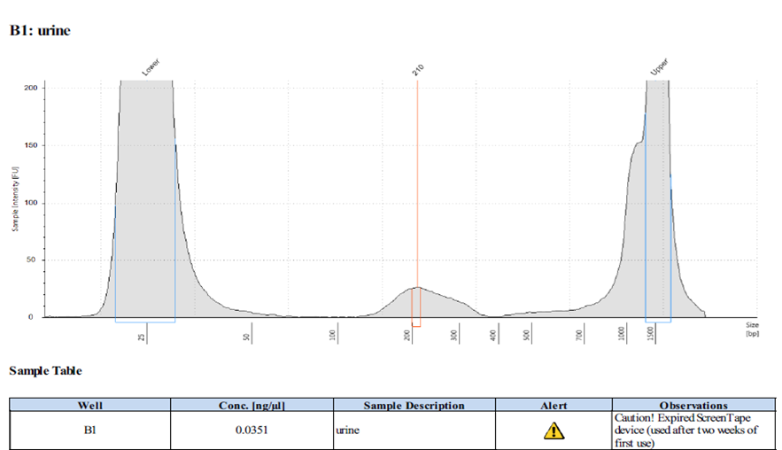

- Reference:
- Lu T, Li J. Clinical applications of urinary cell-free DNA in cancer: current insights and promising future. Am J Cancer Res. 2017 Nov 1;7(11):2318-2332.

- Biography:
Dr. Debin Sun obtained his Ph.D. degree from Rutgers University in 2010. His research interests focus on precision medicine and genetic testing. He is current responsible for the diagnostics testing division in the Admera Medical Technology Corporation.

- Presenting author details


Full Name: Jeffrey W. Ding
Contact number: 1-9732650408
Twitter account:
Linked In account:
Session name/ number:
Category: (Oral presentation/ Poster presentation):
Poster presentation
Passport Number: 503733232

