EMERGING TRENDS AND ADVANCES IN METHODOLOGIES AND TECHNIQUES IN PROTEOMICS

Author: Abhishikt David Solomon

Sam Higginbottom University of Agriculture, Technology and Sciences,
Jacob Institute of Biotechnology and Bioengineering,
Department of Molecular and Cellular Engineering

Keywords: Proteome, drug design, medicinal biotechnology, protein identification, homology modeling.

Abstract

Along with the emergence of the biotechnology practices in the research and development sector within the past decade, proteomics has played a major role in determination of the behavior of protein and its analysis in the organism’s genetic make up and expression in several species of organisms which helped the researchers and biotechnologists to identify and quantify the protein based on their amino acid sequences. It also helped to understand post translational modifications, alterations and deletions in proteins through various in vivo techniques such as real time imaging systems, vascular proteomic mapping and various tools of system biology and bioinformatics. These techniques lead to the advancement in the current scenario of proteomics and also helps to extrapolate the discoveries and researches like the characterization of human plasma proteome, protein identification leading to mosquito birth control, and pancreatic cancer research. This article retrospects and introspects upon the methodologies and the techniques used to predict the protein structure in order to bring about the advances in the proteomics research and bioinformatics such as in the field of medicinal biotechnology, drug design (CADD), homology modeling, ab initio structure prediction, nano-LC, etc.

References

- Sallie Robertson, 2019, Protein discovery could lead to mosquito “birth control”

- Yolanda Smith, 2018, Emerging trends in proteomics

Steve Ray Wilson. Tore Vehus, Henriette Sjanes Berg, 2015, Nano-LC in proteomics: recent advances and approaches

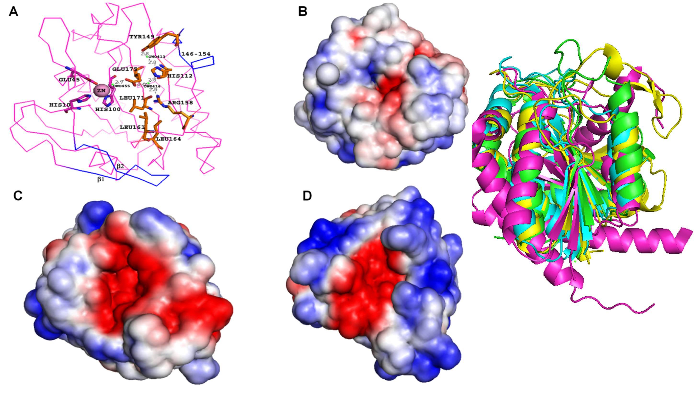

Biography

Abhishikt David Solomon is an undergraduate student of B.Tech in Biotechnology who is studying in his 3rd year of his course of study at Sam Higginbottom University of Agriculture, Technology and Sciences (SHUATS), Allahabad (Formerly Allahabad Agriculture Institute). He has had a good experience in the field of plant tissue culture and various laboratory practices and techniques during his training at recognized institutions such as ICAR-IISR (Indian Council of Agricultural Research- Indian Institute of Sugarcane Research) and CSIR-CIMAP (Council of Scientific and Industrial Research-Central Institute of Medicinal and Aromatic Plants).

Presenting Author Details



Full Name: Abhishikt David Solomon
Contact number: +918795291304
E-mail: abhishiktsolomon914@gmail.com
Category: Oral Presentation
Session name/ number:International Conference on Bioinformatics and System Biology 2019 March 20-21, 2019, Singapore.
Passport Number: R1028082

