Abstract Template

Title: IN SILICO STUDIES ON DEVELOPMENT OF NOVEL PTERIN BASE INHIBITORS AGAINST MENINGITIS DISEASE
Name(s) of Authors and Co-authors: Vaibhav Sabale^{1,2}, Arun Ingale^{,1}

Affiliations:
1Department of Biotechnology, School of Life Sciences, K.B.C. North Maharashtra University, Jalgaon, INDIA.
2Department of Bioinformatics, Datar Cancer Genetics Limited, Nashik, INDIA.

Keywords: Meningitis, Dihydropteroate synthase (DHPS), Docking, Pharmacophore, Pterin site.
- Abstract Body (up to 250 words)
Bacterial meningitis is caused by Neisseria meningitis and characterized by inflammation of the lining of the brain and spinal cord, has high mortality rate. Dihydropteroate synthase (DHPS), an enzyme plays a critical role in the bacterial folate metabolism which catalyzes the formation of 7, 8- dihydropteroate from p-aminobenzoic acid (pABA) and 6- hydroxymethyl-7, 8-dihydropterin-pyrophosphate (DHPP). The absence of the folate pathway in higher eukaryotes makes it an attractive drug target. The pterin base inhibitors were used to target pterin site for DHPS inhibition. Further, the approach of these pterin base inhibitors towards DHPS is unknown. Hence, the structural bioinformatics study of DHPS enzyme from N. meningitis was carried out using homology modeling and molecular docking techniques. The 3D model of Dihydropteroate synthase (DHPS) protein of Neisseria meningitis were designed using the templet (PDB ID: 2DQW) in Modeller9.12v. The validation of generated model was obtained using several validation methods including RAMPAGE, PROSA and RMSD. The Quality assessment of DHPS protein model with PROSA revealed the Z-score value -7.86. The low RMSD observed between the target and template reflects the presence of strong homology. It was found to be 0.80. Towards this end, molecular docking was performed with Molecular Operating Environment (MOE) and Pharmacophore Mapping has been conducted using Accelrys Discovery Studio (DS) to extract a 3D pharmacophore that reflects the important functional groups that are essential for inhibitor binding.
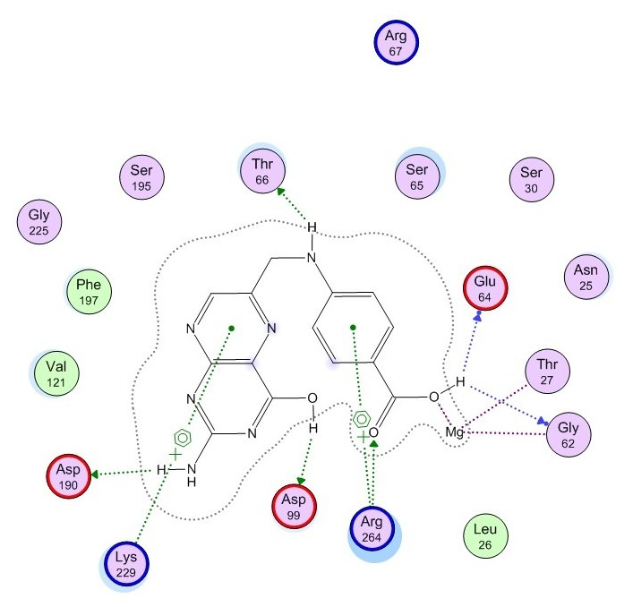
- Image

- Biography:
Vaibhav Sabale has completed his PhD work from K.B.C. North Maharashtra University, Jalgaon and now working as Bioinformatician at Datar Cancer Genetic Ltd Nashik India. He has published 2 papers in reputed journals and some research work is in pipeline.
- Presenting author details
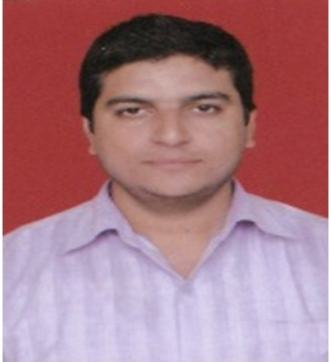

Full Name: Vaibhav B. Sabale
Contact number: +91-9881580130
Email-id(s): vaibhavsabalebi@gmail.com
Twitter account: vaibhavsabale
Linked In account: VaibhavSabale
Session name/ number:
Category: Poster presentation
Passport Number: L2461646

