Pulverised biofuels flame propagation in comparison to coals
Saeed M Azam, PhD, Energy Research Institute, School of Chemical and Process Engineering, University of Leeds, UK

Abstract (300 word limit)
High emissions from burning of fossil fuels and their adverse environmental effects are serious issues that are discouraging their use in the power generation plants. The harmful gases like Carbon dioxide, Nitrogen dioxide and Sulphur dioxide return to land, as acid rain, that is a serious threat. UK relies heavily on the coal power generation plants and around 31% share of electricity was generated from existing coal power generation plants. The coal, in these plants is replaced by renewable biofuels for sustainable power generation. Utilization of coal for generation of electricity has fell down to 36% in 2014 compared to 2013. As a result, the overall emission to be decreased to 45 million tonnes of carbon dioxide that is 9.7% reduction in 2014 compared to 2013. However, there are scarce data of combustion properties for the biofuels (Saeed et al., 2017, 2016a,b,c, 2014). The exploitation of biomass materials in place of coal require detailed investigation of their properties of flame propagation for retrofitting of existing coal power plants which is the aim of this work.
Different phases including dust dispersion, ignition and flame propagation were compared for fine and coarse size bagasse dust as shown in Fig. 1. It was found that the fine size bagasse dust was uniformly dispersed and efficiently combusted whereas the irregularities and delay in combustion were observed for coarse size bagasse dust. These irregularities were due to the wide range of particle size distribution in the coarser fraction. It was concluded that combustion initiates with preferential burning of fine size particles and the liberated heat causes the coarse size particles to release volatiles leading to their partial combustion.
Flame propagation and explosibility results of selected biomass dust and coal samples were measured, using modified ISO 1m³ vessel. It was found that biomass dust especially 2nd generation crop residue waste with no end use were more reactive with higher risk of combustion compared to coal samples.

Image
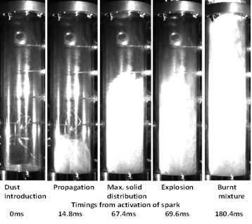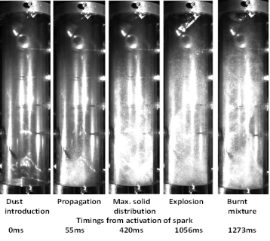
(a) (b)
Figure 1: Particles dispersion and flame propagation of fine and coarse size bagasse dust in modified Hartmann tube a) fine fraction < 63 µm and b) coarse fraction (150-300 µm)
Recent Publications (minimum 5)
- Saeed MA, Anez NF, Andrews GE, Phylaktou HN. & Gibbs BM (2017) Steam exploded pine wood burning properties with particle size dependence. Fuel 194: 527-532.
- Saeed MA, Andrews GE, Phylaktou HN, Gibbs BM (2016a) Raw and steam exploded pine wood: Possible enhanced reactivity with gasification hydrogen. International Journal of Hydrogen Energy 41: 16566–16576.
- Saeed MA, Andrews GE, Phylaktou HN, Gibbs BM (2016b) Global kinetics of the rate of volatile release from biomasses in comparison to coal. Fuel 181: 347-357.
- Saeed MA, Slatter DJ, Andrews GE, Phylaktou HN, Gibbs BM (2016c) Combustion of Pulverized Biomass Crop Residues and Their Explosion Characteristics. Combustion Science and Technology 188: 2200-2216.
- Saeed MA, Medina CH, Andrews GE, Phylaktou HN, Gibbs BM (2014) Agricultural waste pulverised biomass: MEC and flame speeds. Journal of Loss Prevention in the Process Industries 36: 308-317.

Biography (150 word limit)
Muhammad Azam Saeed has recently completed his PhD, in the field of ‘Pulverized Biomass Flame Propagation’, from University of Leeds, UK. His main expertise are in the agricultural waste crop residue as energy source and hazards assessment associated with these fuels. He has eight conference papers presented in the renowned International conferences. He has six published journal paper in the ‘Fuel Journal’, ‘International Journal of Hydrogen Energy’, ‘journal of Loss prevention’ and ‘Combustion Science and Technology Journal. Currently Mr. Saeed is serving as Assistant Professor and leading researcher in the University of Engineering and Technology, Lahore (Faisalabad Campus), Pakistan.
Email: azamsaeed86@hotmail.com

Notes/Comments:

