Title: Wastewater Treatment and CO₂ Sequestration with Simultaneous Generation of Bioelectricity, Volatile Fatty acids and Bioalgal lipids using Algal Assisted Microbial Fuel Cells (AAMFC).

Lakshmidevi Rajendran¹, Bharathidasan Kanniappan¹, Delma Jones Rufina Rajan¹, Muthukumar Karuppan¹
¹ Department of Chemical Engineering, Alagappa College of Technology Campus, Anna University, Chennai, Tamilnadu, India

Keywords: Microalgae, Microbial fuel cell, Anaerobic bacteria, Chlorella sp, Current Generation, Biofuel

- Abstract (up to 250 words)
Microalgae are considered to be the promising feedstock for biofuel and bioenergy production. The algal biofuels are not economically viable due to the problems associated with cultivation of algae. MFC is a sustainable energy device that can enhance the demands of world’s energy consumption. This study demonstrates the potential treatment of municipal solid wastewater with simultaneous generation of electricity, volatile fatty acids and algal oil in a double chambered AAMFC fabricated using less expensive electrode materials. Microbial produced volatile fatty acids (acetic acid, propionic acid, and butyric acid) can be considered as an alternative for petroleum based volatile fatty acids. AAMFC consists of a double chambered cell with anaerobic hydrogen producing bacteria and microalgae Chlorella species in the anode and cathode chamber respectively. A series of five experimental studies were conducted, along with control samples. The algae grown in the cathode chamber was monitored and algae were harvested for the lipid analysis. The anaerobic hydrogen producing bacteria in the anode chamber produced volatile fatty acids along with current generation and CO₂ were measured at regular time intervals. Polarization curves were obtained to calculate the power density and current density. The AAMFC achieved a power density of 62.81± mW/m² and a current density of 102.28 ± mA/m². The volatile fatty acid productivity was found to be 6.8 g/l. It was observed that the COD value was reduced with high removal efficiencies of 65.5% and higher biomass concentration of 3.52 g/l was achieved with maximum protein and lipid concentration of 365.3mg/l and 563.78 mg/l respectively. This study provides a potentially cost-effective, renewable and sustainable bioelectricity option associated with environmental remediation in terms of wastewater recycling.

- Image:

- Reference:
- Cui, Y., Rashid, N., Hu, N., Saif, M., Rehman,U., Han, J., 2014. Electricity generation and microalgae cultivation in microbial fuel cell using microalgae-enriched anode and bio-cathode. Energy Convers. Manag. 79, 674–680.

- Lee, K., Lee, C., 2001. Effect of Light / dark Cycles on Wastewater Treatments by Microalgae Cell Growth under Different Light Conditions. Biotechnol. Bioprocess Eng. 6, 194–199. doi:10.1007/BF02932550.

- Maity, J.P., 2014. The production of biofuel and bioelectricity associated with wastewater treatment by green algae. doi:10.1016/j.energy.2014.06.023.
IV. Biography:
R.Lakshmidevi has completed her B.Tech., M.S from Anna University, India, She has worked as Research officer in ABAN Infrastructure Pvt ltd (Biotechnology division). Currently doing her Ph.D in Anna University She has a hands-on experience of six years in Bioenergy and Biofuel Division. She has attended various National and International Conferences and has 4 International Journal publications to her credit.


Presenting author details

Full Name: R.LAKSHMIDEVI
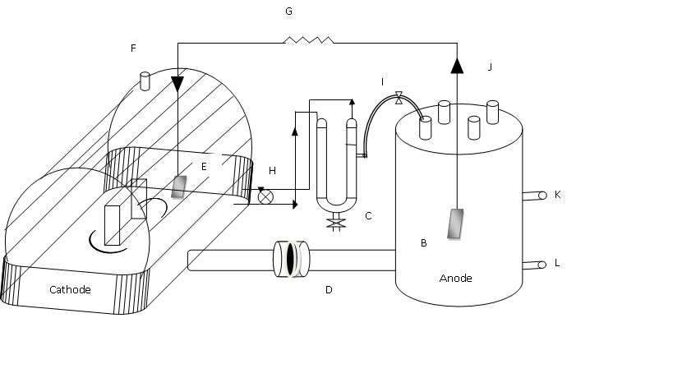
Contact number:+919566028045
Session name/ number: Algae Biofuels
Category: (Oral presentation )
Passport Number: L8461615

