Abstract Template

Title: Characteristic of tar content and syngas composition during cereal straw gasification

JACEK KLUSKA¹, MATEUSZ OCHNIO¹, PAWEŁ KAZIMIERSKI¹, DARIUSZ KARDAŚ
¹Institute of Fluid Flow Machinery. Fiszera 14. 80-231 Gdańsk. Poland

Keywords: straw, updraft gasification, tars

- Abstract

This work aims to study the effect of the equivalence ration and temperature on the updraft gasification of cereal straw. Gasification is a complex thermochemical process to convert biomass or another a carbonaceous solid fuel like coal and waste to gaseous fuel. This process takes place at high temperatures (700 - 1500 °C) and in the presence of air or oxygen as a gasifying agent [1,2]. The updraft gasification stand is presented in Fig. 1. The total high of gasifier is 135 cm and the internal radius is 22 cm. The air inlet nozzles were installed 52 cm from the bottom of the reactor, and the syngas outlet was installed 111 cm from the bottom. The main aspects was to analyze the influence of temperature distribution and amount of supplied air on the fuel consumption and syngas composition as well as tar formation characteristics during the gasification process. The light tar content and composition were analysed using gas chromatography coupled with mass spectrometry (GC–MS). Experimental studies have shown that the amount of air supplied does not affect the parameters of the gasification process linearly and a striking is to compare the amount of air supplied with fuel consumption and temperature to analyze the updraft gasification. The results indicate that both light and heavy tar are changing nonlinearly for different operating conditions. The obtained results indicate the possibility of using straw in thermochemical processes to produce heat and electricity in agriculture areas.

- Image:

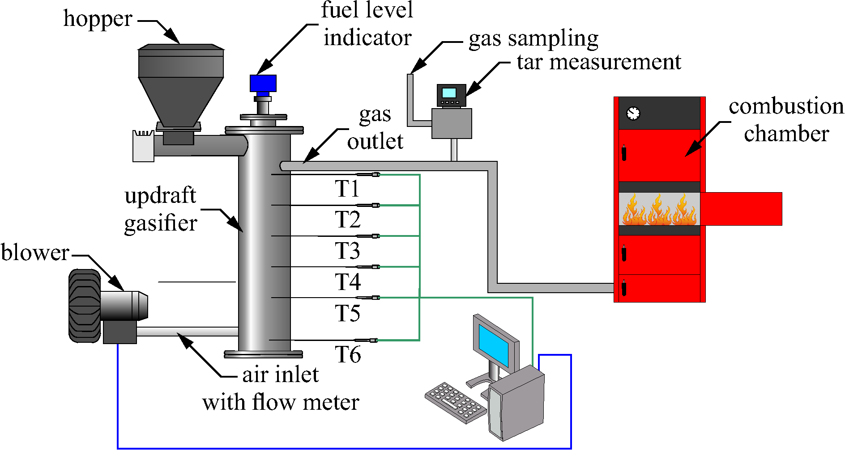
Fig. 1 Schematic diagram of the experimental setup

- Reference:
- McKendry, P. 2002. Energy production from biomass (part 3): gasification technologies. Bioresource Technol., 83; 55 - 63.
- Chen, W., Annamalai, K., Ansley, R.J., Mirik, M. 2012.Updraft fixed bed gasification of mesquite and juniper wood samples. Energy, 41; 454 - 461.

- Biography:
JACEK KLUSKA has completed his PhD at the age of 31 years from The Institute of Fluid Flow Machinery Polish Academy of Sciences. He is the author of many publications and monographs related to the subject of gasification and pyrolysis of biomass and waste. He participated in research projects as "Agroenergetic complexes model as an example of distributed cogeneration based on local and renewable energy sources" (POIG.01.01.02-00-016/08), "Autothermal reactor of municipal waste gravity gasification", co-financed from the funds of the Provincial Fund for Environmental Protection and Water Management in Gdańsk.
- Presenting author details


Full Name: Jacek Kluska
Contact number: +48 691 328 422
Twitter account:@jacek_kluska
Linked In account: www.linkedin.com/in/jacek-kluska
Session name/ number:
Category: Poster presentation
Passport Number:

