Title: Cloning, expression and characterization of β-xylanase gene from Thermotoga naphthophila

MUHAMMAD NAUMAN AFTAB¹

¹Institute of Industrial Biotechnology, Government College University, Lahore, Pakistan

Keywords: Cloning, characterization, xylanase, Thermotoga naphthophila,

I. Abstract Body

A highly thermostable β-xylanase gene encoding 1059 amino acids was amplified by using specific primers. The amplified gene was restricted with NdeI and HindIII enzymes and ligated with double restricted pET-21a(+) expression vector. The recombinant plasmid was transformed into Escherichia coli strain BL21 for expression of β-xylanase gene. Recombinant β-xylanase enzyme was purified by ammonium sulphate precipitation, followed by single step immobilized metal ion affinity chromatography with 2.73 fold purification having 23.62 Umg⁻¹ specific activity and recovery of 36.16 %. Molecular weight of the purified β-xylosidase, 152 kDa, was determined by sodium dodecylsulphate polyacrylamide gel electrophoresis (SDS-PAGE). The enzyme was stable upto 90°C with a broad pH range of 3-9, with optimum temperature 80ºC and pH 7.0. The enzyme activity was increased in the presence of metal ions especially Mg⁺² and was not affected by EDTA. However, an addition of 1% Tween 80, β-mercaptoethanol and DTT resulted in increase of enzyme activity by 9%, 21% and 27% respectively. Organic solvents with concentration of 10-40% did not showed any effect upon enzyme activity. The results suggest that recombinant xylanase can be used in the bioconversion of natural biomasses into simple sugars which could be further used for the production of biofuel.

II. Image:
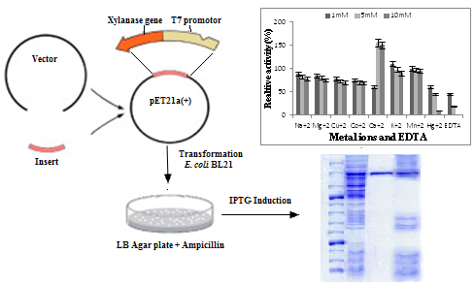

III. References:
- Aditya-Bhalla A, Bischoff KM, Uppugundla N, Balan V, San R.K. 2014. Novel thermostable endo-xylanase cloned and expressed from bacterium Geobacillus sp WSUCF1 .Bioresource Technology., 165.
- Banka AL, Guralp SA, Gulari E (2014). Secretary expression and characterization of two hemicellulases, xylanase and β-xylosidase, isolated from Bacillus Subtilis M015. Appl Biochem Biotechnol., 174:2702–2710.
- Verma DI, Anand A, Satyanarayana T (2013). Thermostable and alkalistable endoxylanase of the extremely thermophilic bacterium Geobacillus thermodenitrificans TSAA1: cloning, expression, characteristics and its applicability in generating xylooligosaccharides and fermentable sugars. Biochem Biotechnol., 170(1): 119-30.
- Zhan D, Lei L, Jin H, Guan S, Han W (2016) Molecular Modeling and MM-PBSA Free Energy Analysis of Endo-1, 4-β-Xylanase from Ruminococcus albus 8. Int J Mol Sci., 15(10): 17284-17303.
- Zhou J, Qian W, Zhang R, Mo M, Tang X, Li J, Xu B, Ding J, Lu Q, Huang Z (2014). A thermo-halo-tolerant and proteinase-resistant endoxylanase from Bacillus sp. HJ14. Folia Microbiologica., 59(5): 423-431.

IV. Biography
Dr. Muhammad Nauman Aftab has completed PhD from Institute of Biophysics, Chinese Academy of Sciences, Beijing, China. He has completed post-Doc from Sanford Burnham Preby Medical Discovery Institute, Orlando, Florida, United States. Currently he is working as Associate Professor at Institute of Industrial Biotechnology, GC University, Lahore, pakistan. He has published 45 papers in reputed impact factor journals. His area of research is renewable energy.

V. Presenting author details


Full Name: Dr. Muhammad Nauman Aftab
Contact number: 0092-3444704190
Twitter account: Nil
Linked In account: https://www.linkedin.com/in/muhammad- aftab-91b03724/
Session name/ number: Bioethanol
Category: Oral presentation
Passport Number: AP1572652

