Title: Development of Biodiesel Production from Brown Grease

Mirit Kolet, Faina Nakonechny and Marina Nisnevitch

Department of Chemical Engineering, Biotechnology and Materials, Ariel University, Ariel, Israel

Keywords: Biodiesel, Brown Grease, Esterification, Ultrasonic activation.
- Abstract
The dramatic increase in oil prices, in spite of transient decreases, and global climate changes, affected by a rise in the atmospheric CO₂ concentration, have led to a need in alternative energy sources. Reducing dependence on fossil fuels could decrease concerns about energy security. For these reasons, a quest for sustainable and renewable biofuels has been gaining momentum in recent years, and bioenergy in general and renewable biofuels in particular are attracting increasing attention as a part of a trend to develop a sustainable and environmentally friendly economy.
The present study is focused on development of a scheme for continuous biodiesel production from cooking oil waste - brown grease. This scheme will enable to solve two problems: energetic and environmental. Brown grease has high free fatty acid content and therefore can serve as a potential feedstock for biodiesel production.
First, a protocol for separation of a fat layer from brown grease wastes was elaborated, and then conditions for an effective esterification reaction were chosen when heating was replaced by an ultrasonic activation. At each experimental stage samples were tested by HPLC.
The results show that efficient separation of the fat layer from brown grease can be obtained under heating the wastes at 60°C for 15 min and following centrifugation at RCF 3,750 g for 5 minutes. The ultrasonic activation is expecting to serve as a basis for development of an innovative and efficient and biodiesel production in a continuous regime.
- Image:

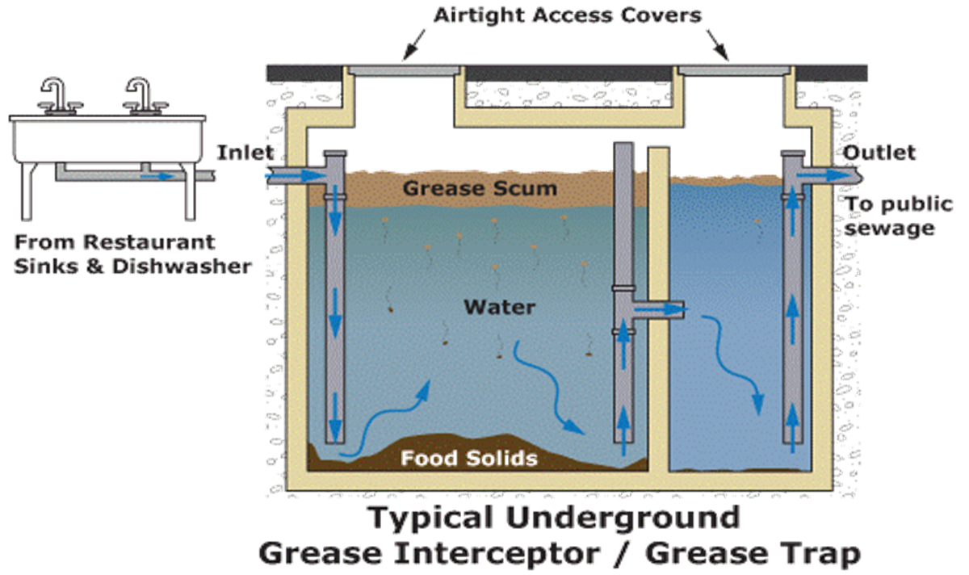
- Reference:
- Pittman, J.K., Dean, A.P., Osundeko, O., 2011. The Potential of Sustainable Algal Biofuel Production Using Wastewater Resources. Bioresour. Technol. 102, 17–25.
- Salamatinia, B., Abdullah, A.Z., Bhatia, S., 2012. Quality Evaluation of Biodiesel Produced through Ultrasound-Assisted Heterogeneous Catalytic System. Fuel Process. Technol. 97, 1–8.
- Wirasnita, R., Hadibarata, T., Novelina, Y.M., Yusoff, A.R.M., Yusop, Z., 2013. A modified methylation method to determine fatty acid content by gas chromatography. Bull. Korean Chem. Soc. 34, 3239–3242.
- Biography:
Mirit has completed her M.Sc. at the age of 32 years from Ariel University, Ariel University, Israel. She started her Ph.D. in the 2016. She is on her second year as Ph.D. student. her research under the direction of Prof. Marina Nisnevitch, head of the Department of Chemical Engineering and Faina Nakunchani Senior Staff, is devoted to the innovative development of continuous production of biodiesel by chemical reactions (esterification and transformation with a solid heterogeneous catalyst or dissolved gaseous catalyst in liquid phase with its separation at the exit from the reactor and its recycling for reuse).
- Presenting author details


Full Name: Mirit Kolet
Contact number: +972-523408462
Category: Oral presentation

