Title: Biofuels and Bioenergy play an important role in the basic need of life, reduction in poverty and hunger in the world.
Abstract:

The role of biofuels and bioenergy is major source of bioenergy and can be produced from plant, plant derived materials, renewable in nature, derived from biomass and used directly for heating known as biomass fuels. Biofuels can be broadly defined as solid, liquid, or gas fuel consisting of or derived from biomass. Biomass is a biological materials derived from living organism including plants and animals, known as agricultural biomass. As per report in Pakistan, a single cow is sufficient to provide a whole family with their milk and energy needs as biogas generated from the dung of cow. This is not only the cheapest source of energy but also an important alternative to replace the costly item like furnace oil, coal, natural gas used for non-renewable energy. In view of the importance of bioenergy, the developing counties are still facing energy crises due to dense population and highly dependence on non-renewable energy although a great potential of bioenergy are available. Keeping in view the importance of bioenergy, it is necessary that the potential of biofuel and bioenergy may be commercialized to generate income, create employment, and reduce the energy crises as well as poverty in the world.

Biography: Mr. Muhammad Usman, Former Director General of Agricultural Research System, Government of Pakistan who retired from service after a spotless career of about 35 years with senior level experience on research and development of integrated agricultural production particularly Biofuel and Bioenergy on a sustainable way.
Mr. Usman is consider as the senior most scientist in the world, always participated in the international conferences.
Mr. Usman has established “Prominent Agro Based Industries SDN BHD”, “Agro Based Industries and Consultancy SDN BHD” in Malaysia and “Foundation for Rural Development in Pakistan”, with primarily aims to work on integrated agricultural project for Rural Development through improvement in agriculture and consultancy services to the formers at Malaysia.

References
1) Berglund M, Börjesson P (2006) Assessment of energy performance in the life-cycle of biogas production. Biomass Bioenerg 30(2006):254–266
2) Cherubini F, Ulgiati S (2009) Crop residues as raw materials for biorefinery systems - A LCA case study. Appl Energy 53(8):434–447
3) herubini F, Bird N, Cowie A, Jungmeier G, Schlamadinger B, Woess-Gallasch S (2009a) Energy and GHG-based LCA of biofuel and bioenergy systems: key issues, ranges and recommendation. Resourc Conserv Recy 53:434–447


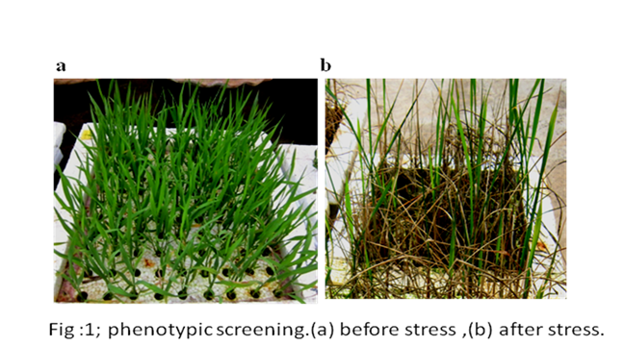
Name: Muhammad Usman
Contact number: +923459455262
Session: Biofuel 2018
Category: Oral Presentation, Keynote Speaker
Passport No: AP2854952

Muhammad Usman, Moderator of The conference of Biochemistry 2017 Felicitate Prof. Jaleel K Ahmed with Keynote Certificate On Sep, 29 at Dubai

