Agricultural Waste to Energy toward Biomass Community Planning
Kazuei Ishii PhD, Hokkaido University, Japan

Abstract
Biomass resources are abundant, and especially the large amount of agricultural waste, such as cow manure, rice straw, rice husk, etc., is generated in Hokkaido, Japan. Since a law for feed-in tariff (FIT) was enacted, the number of biogas plants for cow manure has been increasing to produce electricity. In addition, new businesses related to the biogas plants have been launched. For example, in Shikaoi town, mango is cultivated and sturgeon is cultured by using heat generated from biogas. In addition, biogas is converted to hydrogen to be stored for a long period. On the other hands, 60% of rice straw in Japan is incorporated into paddy fields and naturally degrades into the paddy soils, following the 1997 ban of open field burning of rice straw, although some rice straw is effectively used already. Rice straw pellets were produced commercially in Nanporo town. It was the first case in Japan. The rice straw pellets are used at a public bath (biomass boiler) and public facilities (pellet stove). I will introduce successful examples, including the examples other than the above, for agricultural waste to energy in Hokkaido and discuss what kinds of benefits have been generated for local community.

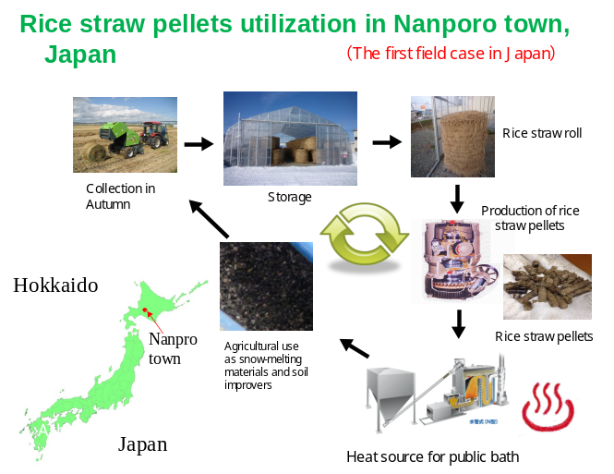
Image
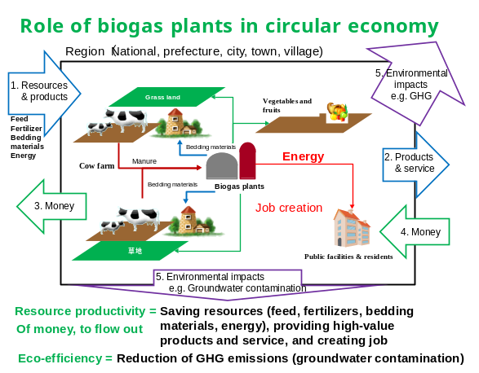
Recent Publications
- Kazuei Ishii, Atsushi Fujiyama, Masahiro Sato, Toru Furuichi(2019) A three-dimensional simulation of 1,4-dioxane contamination in an aquifer with a complex hydrogeological setting – application of a coupled estimation method, Journal of solid waste technology and management (in printing)
- Kazuei Ishii, Toru Furuichi, Atsushi Fujiyama, Shintaro Watanabe(2016) Logistics Cost Analysis of Rice Straw Pellets for Feasible Production Capacity and Spatial Scale in Heat Utilization Systems: A Case Study in Nanporo Town, Hokkaido, Japan, Biomass and Bioenergy, 94, 155-166.
- J. Al-Mallahi, T. Furuichi and K. Ishii(2016) Appropriate conditions for applying NaOH-pretreated two-phase olive milling waste for codigestion with food waste to enhance biogas production, Waste Management, 48, 430-439

4. J. Al-Mallahi, T. Furuichi and K. Ishii(2015) Mechanical and alkaline pretreatment of two phase olive mill waste for improving methane production, The Journal of Solid Waste Technologies and Management, Vol. 41, No. 3, pp. 315-324
5. K. Ishii and T. Furuichi(2014) Influence of Moisture Content, Particle Size and Forming Temperature on Productivity and Quality of Rice Straw Pellets, Waste Management, Vol. 34, pp. 2621-2626

 Biography
Kazuei Ishii is professor in Laboratory of Sound Material Cycle Systems in Faculty of Engineering, Hokkaido University, since 2018. His research topics is as follows:
1.Research on soil and groundwater contamination and remediation: (1) Numerical simulation of contaminants transport and fate in groundwater: (2)Development of biological treatment method (bioreactor or in-situ bioremediation): (3)Nitrate groundwater pollution by daily farms, 2. Research on final disposal system of municipal solid waste: (1) Method of promotion to stabilization of landfilled waste: (2) Numerical modeling for washing pollutants from waste layer, 3. Research on development of biomass utilization systems such as biogas and biosolid fuels
Email: k-ishii@eng.hokudai.ac.jp

Notes/Comments:

