Biodiesel production by using of lipase produced by Pseudomonas stutzeri as a biocatalyst for transesterification reaction of olive oil
Alaa Naseer Mohammed Ali¹, Sahira Nsayef Muslim¹, Nadheema Hammood Hussein¹, Israa M.S. AL-Kadmy¹, Sarah Naji Aziz¹ and Samah N. El-Shafiey², Susan A. Ibrahim¹, Nadal A. Al-Saryi¹
¹Branch of Biotechnology, Department of Biology, College of Science, Mustansiriyah University, 10422, Baghdad, Iraq
² Plant Protection Research Institute, Agricultural Research Center, Dokki, 44516 Giza, Egypt

Abstract
The rapid consuming of fossil fuels will lead to rapid exhaustion. Therefore, it is imperative to develop alternative and inexpensive new technologies to produce sustainable fuels such as biodiesel productionby using of lipase as biocatalyst for performing esterification reactions for the production of biodiesel.
Two Pseudomonas stutzeri and two Pseudomonas oryzihabitans were isolated from ruined olive fruits. These isolates screened for production of lipase from vegetable oils and others fats and found that the Ginger oil was the best among all the used oils for induction of lipase production in the medium. Lip gene for lipase was used for confirmation the presence of lipase gene in Pseudomonas stutzeri and Pseudomonas oryzihabitans. The lipase enzyme was used as a biocatalyst for the transesterification reaction step in biodiesel production and found that the olive oil was more suitable than the almond oil for biodiesel production, also the free fatty acid (Oleic acid) was present in the major amount which is best suited for biodiesel production followed by fatty acid methyl esters (FAMEs) with 37%. The processing of the bacterial supernatants led to increase the performance in comparison to the non-processed samples since an easy and cheap process of concentration and dialysis could increase the yield of biodiesel production.
.

Image

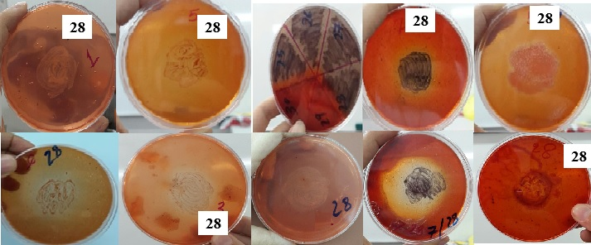
Figure 1: show the bacteria which gave positive results in lipase test and analysisthe oil by change the color of media and appear clear zone around the culture

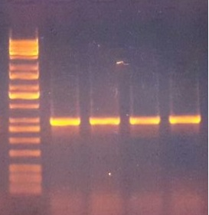
Figure: Gel electrophoresis (1% agarose, 7 V/cm for 90 min) for Lip gene for pseudomonasisolates. Line M 10Kbp DNA ladder, and all others lines positive results with 550bp amplicon.
Recent Publications (minimum 5)
- 1- Ruppé, E.; Hem, S.; Lath, S.; Gautier, V.; Ariey, F.; Sarthou, J.L.;Monchy, D. and Arlet, G. (2009).CTX-M β-Lactamases in Escherichia coli from Community-acquired Urinary Tract Infections, Cambodia.Emerg Infect Dis. 15(5):741-748.
- 2- Atshan, S.S.; Shamsudin, M.N.; ZamberiSekawi, Z.; Lung, L.T.; Hamat, R.A.; ArunkumarKarunanidhi, A.; Ali, A,; Ghaznavi-Rad, E.; Ghasemzadeh-Moghaddam, H.; Seng, J.S.; Nathan, J.J. and Pei Pei, C. (2012). Prevalence of Adhesion and Regulation of Biofilm-Related Genesin Different Clones of Staphylococcus aureus . J. Biomed. Biotechnolo. ID 976972, 10.

 Israa M.S. AL-Kadmy
MSc in Microbiology from Mustansiriyah University, College of Science, Department of Biology. (Iraq).. interested in molecular microbiology, Biotechnology, Nanobiotechnology.

Email:israaalkadmy@gmail.com

Notes/Comments:

