Triacylglycerol profile of marine microalga Skeletonema costatum from the Saintmartin Island (Bangladesh): Evaluation of its potentiality as biofuel feedstock.
Dr Chy Mohammad Monirul Hasan¹ and Mohammad Rashedul Hassan Chowdhury²
¹Department of Biochemistry & Molecular Biology, University of Chittagong, Chittagong 4331, Bangladesh
²Department of Pharmacy, University of Science and Technology, Chittagong, Bangladesh.
I. Abstract
One of the greatest challenges for the society in the 21st century is to meet the growing demand for energy for transportation, heating, and industrial processes which are significantly related to Greenhouse Effect and to provide raw material for the industry in a sustainable way. Also increasing concern for the security of the oil supply has been evidenced by increasing oil as well as food prices. In order to mitigate climate change without adversely affecting global energy supply, there is growing interest in the possibility of producing transportation fuels from renewable sources.
Marine microalgae are the most promising oil sources for making biofuels, which can grow very rapidly and convert solar energy to chemical energy via CO₂ fixation. The fatty acid profile of almost all the microalgal oil is suitable for the synthesis of biofuel. In this research, fatty acid and lipid contents of Bangladeshi strains of marine microalgae Skeletonema costatum was performed. For this, the crude oil was extracted by Soxhlet extraction method, using three most common solvent systems, pure hexane and mixture of CHCl₃ : MeOH (2 : 1) and hexane : EtOH (3 : 1) one by one. Highest oil recovery (15.37%) came from CHCl₃ : MeOH (2 : 1) solvent system from dry biomass whereas the lowest (2.49%) came from n-hexane from wet biomass. The qualitative analysis of the extracted oil by GC/MS analysis revealed that it contained significant amount of myristic acid (C14:0), palmitic acid (C16:0), stearic acid (C18:0), and palmitoleic acid (C16:1). It also indicated presence of hexadecatrienoic acid, benzenedicarboxylic acid, oleic acid, arachidonic acid, eicosapentaenoic acid (EPA), 9-Octadecenoic acid methyl ester (C₁₉H₃₆O₂), and so forth. The obtained fatty acid profile indicates high potentiality of S.costatum species to be used as promising biofuel feedstock a little improvisation and substantially it can replace diesel in near future.
II. Image

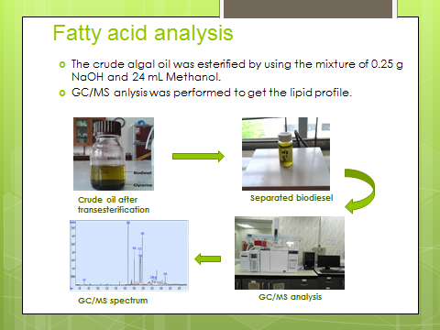

III. Biography
Dr Chowdhury Mohammad Monirul Hasan has completed his PhD from Kyushu Institute of Technology, Japan and postdoctoral studies from University of Kabangsaan Malaysia. He is the professor of Biochemistry and Molecular Biology, University of Chittagong, Bangladesh. He is interested in biofuel production from marine algae, metabolic engineering and microbiology. He has published more than 20 research papers in reputed journals.
E mail Id: monirbiochem@cu.ac.bd
IV. Research Interest
Metabolic engineering, Fermentation technology, Bioresource technology, Algal Biofuel, Industrial biotechnology and Microbiology
Presenting Author details:
Full Name: Dr Chy Mohammad Monirul Hasan Contact number: +880312582144, +8801824944652
Category: Oral presentation Passport Number: BE 0917872

