Removal of Heavy Metals and Salmonella Pathogens from Sewage Sludge using a novel Chelating Agent Derived from Succino-hydrazide and its reuse as a fertilizer

Sara Mohamed Yonues
Chemical Engineering Department, Borg El Arab Higher Institute Engineering and Technology, Alexandria, Egypt- e-mail: ch_sara2011@yahoo.com Tel: 002- 01061603613-, 002-01281362717

- Abstract
The direct use of sewage as fertilizers in agriculture without proper treatment has leaded to substantial economic environmental, and healthy ramifications. Proper treatment as well as adequate environmental management of sewage sludge is a necessity in order to eliminate the negative sequences of its utilization in the agriculture field. In this paper, a novel organic Schiff base chelator derived from hydroxybenzylidene succinohydrazide (HBSH) has been successfully synthesized and characterized by elemental analysis, 1H-NMR as well as infrared spectroscopy. The effect of sewage treated with varying concentration of the Schiff base chelator (0.8, 1.6 and 2.4 g/L) as well as the untreated sewage on the sludge solid reduction, removal of heavy metals and salmonella pathogens has been investigated. The implementation of raw as well as treated sludge on the growth as well as the heavy metal content of radish plant have been also investigated. It was observed that, the treated sample showed a reduction in the total content of Zn, Ni, Cr and Cu and enhancements in the yield, stem length, leaves number and flourishing.

- Image
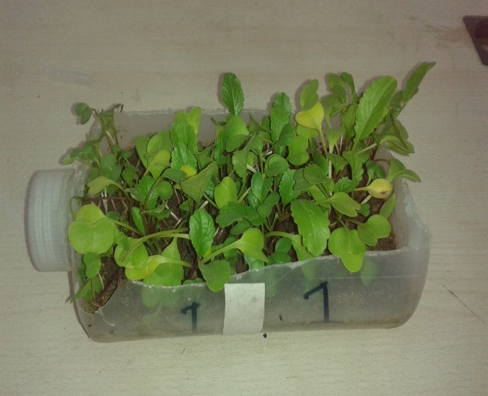
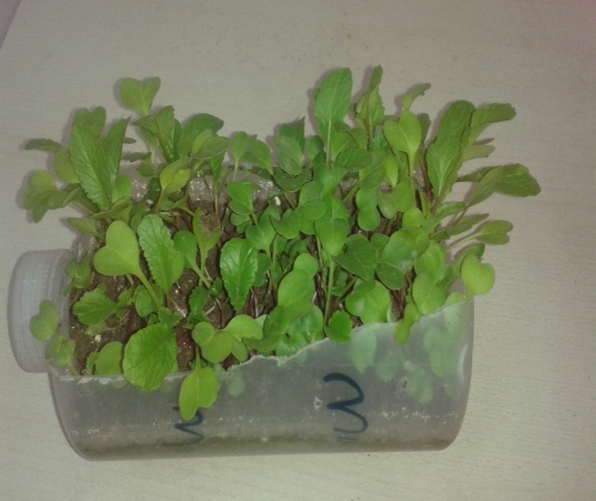
Effect of a) raw and b) treated sludge with 2.4 g/L Schiff base on the growth and flourishing of radish plant

III- Presenting author details
Full Name: sara mohamed younes
Contact number: 00201061603613- 00201281362717
Linked In account: ch_sara2011@yahoo.com
Session name/ number: 1
Category: (Oral presentation/ Poster presentation)
Passport Number:A04056686

