Feasibility of UAE Native Seaweed (Macroalgae) for Production of Jet-fuel and High value Chemicals: From a Bio-Refinery Prospective
Rashed Husain Farzanah –UAE
Kingston University London
School of Engineering and the Environment-UK

Abstract (300 word limit)

Globally, researchers have found that the underlying cause of energy crisis scopes beyond the scarcity but to lack of knowledge and limitation of nature. This prompts the need for engaging in research for promoting the alternative fuels and development of new energy sources which are both renewable and inexhaustible .With more than 2000 km of coastline UAE is home to a large number of marine habitats, and with scorching weather dominating the summer and relatively low temperatures in winter the living organisms in the UAE are adapted to the harshest of environments. These aquatic biomasses are seaweed (macroalgae) which contains no lignin which makes the biomass less recalcitrant compared to terrestrial lignocellulosic biomass. They grow in saline and brackish water which make them perfect biomass in UAE’s environmental conditions. In this paper, through a techno-economic evaluation process, this study would evaluate the production of bio-jet fuel, chemical propulsion fuel and high-value bio-chemicals from macro-algae biomass native to UAE . The study will focus on adding new renewable sources of energy for aviation sectors in UAE and examine the available seaweed strains in the costal line of UAE and its bio-refinery capacity in production of fuel and high value chemicals. Several local seaweed species has been screened and its chemical properties has been determined and the selected strains will undergo pretreatments, chemical extractions and biofuel conversion experiments. Figure 1 shows potential high value chemicals extraction from macro algae as they generally have a greater hydrolysable carbohydrate content than microalgae and therefore tends to contain more high value products.

Image
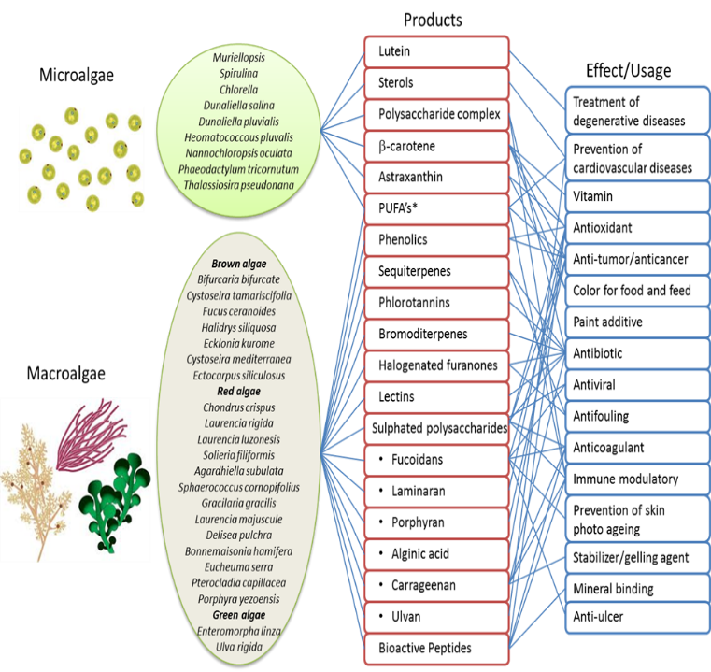

Figure1 : Components of secondary metabolites of marine algae and their possible application

Recent Publications (minimum 5)
- Farzanah R.H., Brudecki G.P., Cybulska I., Bastidas-Oyanedel JR., Schmidt J.E., Thomsen M.H. (2019) Screening and Production of Biogas from Macro Algae Biomass of Padina boergesenii, Colpomenia sinuosa, and Ulva sp.. In: Bastidas-Oyanedel JR., Schmidt J. (eds) Biorefinery. Springer, Cham
- Heil Grzegorz Brudecki, Rashed Farzanah, Iwona Cybulska, Jens E. Schmidt, Mette H. Thomsen, Evaluation of Composition and Biogas Production Potential from Seagrass (Halodule uninervis) Native to Abu Dhabi, Energy Procedia, Volume 75, 2015,
- Brudecki, G.P., Farzanah, R., Cybulska, I., Schmidt, J.E., & Thomsen, M.H. (2015). Evaluation of Composition and Biogas Production Potential from Seagrass (Halodule uninervis) Native to Abu Dhabi
- Alassali, Ayah & Cybulska, Iwona & Brudecki, Grzegorz & Farzanah, Rashed & Thomsen, Mette. (2016). Methods for Upstream Extraction and Chemical Characterization of Secondary Metabolites from Algae Biomass. Advanced Techniques in Biology & Medicine. 4. 2379-1764. 10.4172/2379-1764.1000163.
- Ashraf, M., C. Fang, T. Bochenski, I. Cybulska, A. Alassali, A. Sowunmi, R. Farzanah, G. Brudecki, T. Chaturvedi, S. Haris, J. Schmidt, and M. Thomsen. “ESTIMATION OF BIOENERGY POTENTIAL FOR LOCAL BIOMASS IN THE UNITED ARAB EMIRATES”. Emirates Journal of Food and Agriculture, Vol. 28, no. 2, Nov. 2017, pp. 99-06,

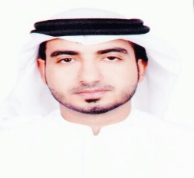

Biography (150 word limit)
Rashed Husain, is an Emirati (UAE) researcher in field of biofuel and bioenergy process. Rashed is currently a PhD candidate at Kingston University London ,UK , focusing on UAE native seaweed bio-refinery. Rashed did his Master from Masdar Institute of Science and Technology in Chemical engineering and served as Research Assistance at the Masdar Institute for nearly 4 years and then worked at Al Taweela Refinery as Process Engineer in Refinery development and optimization department. Rashed has published several papers, conference papers and posters as author and co-author in field of bioenergy and biofuels.
Email: rashedfarzanah@gmail.com

Notes/Comments: Preferably a Poster Presentation

