ENSO, Climate change and Ethiopian Long Rain Season from the Global Circulation Model Output Data

Solomon Addisu (PhD)
Department of Natural Resources Management, College of Agriculture and Environmental Sciences, Bahir Dar University, Bahir Dar, Ethiopia), Email: soladd2000@yahoo.com

Abstract
The primary reason to study summer monsoon (long rain season) all over Ethiopia was due to the atmospheric circulation displays a spectacular annual cycle of rainfall in which more than 80% of the annual rain comes during the summer season comprised of the months June to September. Any minor change in rainfall intensity from the normal conditions imposes a severe challenge on the rural people since its main livelihood is agriculture which mostly relies on summer monsoon.The objectives of the research were to examine the global circulation model output data and its outlooks over Ethiopian summer rainfall and temperature. These data were analyzed by using Xcon, Matlab and Grid Analysis and Display System computer software programs. The analysis of the Global Circulation Model (GCM) data output and the National Center for Environmental Predictions (NCEP) re-analysis of the period 1971 to 2010, the trend analysis and the future predictions (2015 to 2054) have been stated by a comparative method. The results revealed that, the past Ethiopian summer monsoon has declined by 70.51mm.Most of the models have failed to capture Ethiopian summer rainfall due to the fact that the altitudinal climate controlling effects have been dominating than the latitudinal one. The best performed models having similar trends to the observed data predicted the future summer monsoon as a decline of 89.45mm by model beccr to 60.07mm by model cccma. On the other hand, the summer mean temperature of the past four decades has increased by 0.548ºC and it will be expected to increase by 0.59^{O}C (bccr) and 0.743^{O}C (cccma) by the next four decades.To conclude, the legislative bodies and development planners should design strategies and plans by taking into account impacts of declining summer rainfall and increasing temperature on rural livelihoods.

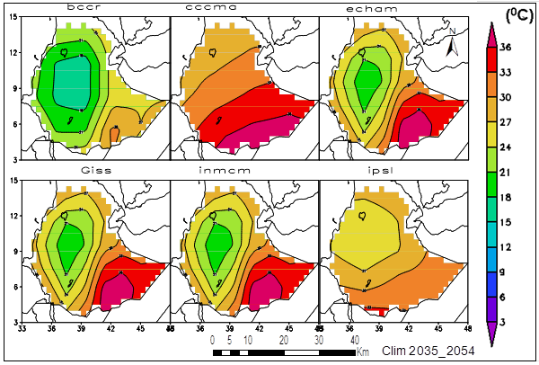


Figure: Time series summer temperature pattern (2035 to 2054)

Recent Publications
- CSA ( Central Statistical Agency). (2007). Central Statistical Agency Population and Housing Census of Ethiopia, Addis Ababa. Retrieved August, 2013, from CSA database
- Doswell, C. A., Harold, E. B. and Michael, P.K. (2005).Climatological estimates of daily local non-tornadic severe thunderstorm probability for the United States. American Meteorological society, 2005.Vol 20,pp 577
- IPCC-DDC. (2007). Model Output archive run by Program for Climate Model Diagnosis and Inter-comparison (PCMDI).Retrieved May, 2013, fromhttp://www.ipcc-data.org/gcm/monthly/SRES_AR4/index.html
- Yatagai, A., Osamu, A., Kenji, K., Haraku, K., Masato, I. and Atsushi, H. (2009). A 44 year daily gridded precipitation data set for Asia based on a dense network of rain gauges SOLA (5), 137-140, doi; 10.2151/sola.2009-035.
- McSweeney, C., New, M., and Lizcano, G.(2008). UNDP climate change country profile Ethiopia. School of Geography and Environment, university of Oxford and Tyndall Center for climate change research.
- Joel, B. S. and Mike, H.(2006).Climate change scenario. Handbook climate research unit, university of East Anglia, Norwich, UK.2006, pp.355. Sullivan EV, Zahr NM (2008)

Biography
Solomon Addisu has expertise in Environmental Sciences specialized in climate change. +251911041030, Email: soladd2000@yahoo.com

