Title: Response of soil application of biochar on growth, dry matter yield and nutrition of corn (Zea mays
L.) grown on sandy loam soils of Gujarat, India

Dr. Pravinchandra C.Patel and Naresh. K.Yadav.
1 College of Agriculture, Parul University, P.O., Limda-391760, Ta. Waghodia Vadodara, Gujarat, India
2 Post-graduate student, B. A. College of Agriculture, Anand Agricultural University, Anand, Gujarat, India
I. Abstract Body (up to 250 words)
Biochar was generated at the Anand Agricultural University, Gujarat, India using the standard method using 2 kilns from agriculture by-product corn stover (Zea mays, L), cluster bean stover (Cyamopsis tetragonoloba) and Prosopis julifera wood. The present study investigated 4 organic sources (3 biochars; corn stover biochar (CSB), cluster bean stover biochar (CBSB) & Prosopis julifera wood biochar (PJWB) and farmyard manure (FYM) with 2 rates of biochar (5 & 10 MT ha⁻¹), so 8 organic treatments, while said 8 organic treatments was applied with the recommended dose of fertilizers (RDF, 80-40-0 kg NPK ha⁻¹) , so total 16 treatments in field trial. Application of CSB @ 10 MT ha⁻¹ along with RDF increased dry matter (DM) yield, crude protein (CP) yield, chlorophyll content and plant height (at 30 and 60 days after sowing) than CBSB and PJWB and FYM. It was found that soil application of RDF + CSB @ 10 MT ha⁻¹ exhibited the highest impact in obtaining significantly higher dry matter and crude protein yields and larger removal of nutrient ( P, K, Ca, Mg, S and Cu, significantly higher than others ) from the soil and it also beneficial for built up nutrients in soil. It also showed significantly higher organic carbon content and cation exchange capacity in sandy loam soil. This study highlights the importance of mixing of biochar along with RDF on its synergistic effect on sandy loam soil nutrient retention, organic carbon content and water holding capacity hence, the amendment value of biochar in sandy loam soil.
II. Image:
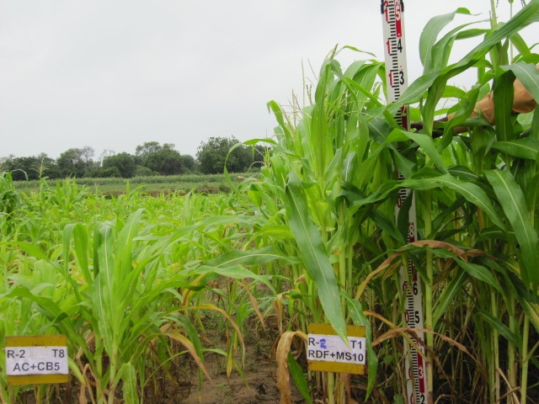

III. Biography (Up to 100 words)
Dr. Pravinchandra C. Patel is a Professor at Parul University, Vadodara, Gujarat, India. He holds a PhD in Soil Science. He has 40 years experiences in agriculture teaching, research and extension. He obtained Hari Om Ashram Ayojit J. P. Trivedi Award during 2006 for the best contribution in Soil Science research. He has participated in 18th WCSS, Frontiers of Soil Sci. Technology and the Information Age at Philadelphia, Pennsylvania, USA in 2006 & presented 3 research papers. He has contributed 52 research papers, 2 books, 3 bulletin, and 40 popular articles.

IV. Research interest:
Soil fertility management, forage crops production and quality, soil and plant analysis,
development, farming, reclamation of problematic soils

V. Presenting author details
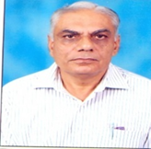

Full Name: Dr.Pravinchandra Chaturlal Patel
Contact number: 91-9909022116
Twitter account:
Linked In account:
Session name/ number:
Category: (Oral presentation/ Poster presentation): Poster presentation
Passport Number: M0157851

