SLAVERY OF WATER AND CLIMATE

The evaporation of water and the spread of its vapors in the air is the main element of the mechanism of atmospheric phenomena. Molecules in different concentrations, compounds with molecules of other gases, in interaction with temperature, pressure, air movement condense into drops of water, turn into fog, cloud. With increasing volumes, the clouds thicken, increase, block the flow of solar radiation. In this state, they can hang from several minutes to several days. The droplet state passes into the molecular state and vice versa. This we can see in clear weather, with little cloud cover. By focusing on a small cloud, you can see how it disappears. In the atmosphere there are processes that are poorly understood, but, with their active participation, biota and modern nature appeared.
At full saturation, a lightning discharge, drops combine and precipitate. The speed and volume of condensations, the trajectories of the movements of the clouds correspond to certain unexplored laws. As a result of the operation of these laws, a special mechanism was built over millions of years - the water cycle between the atmosphere and soil. The main links in this cycle are:
• Evaporation of water from open surface water bodies, soil, transpiration of plants, from animal excreta.
• Drop condensation, concentration and cloud formation. The movement and growth of clouds, species, altitude, concentration and other parameters are poorly understood and uncontrollable. Perhaps the diversity of cloud types depends on the quality of the vapors. Interesting clouds have recently appeared, http://chydesa-mira.ru/oblaka-asperatus/ :
Clouds of asperatus: what is this phenomenon. It is known that in the 21st century their appearance began to be noted much more often. This prompted the scientists of the World Meteorological Organization in 2009 to separate them into a separate type of clouds and include them in the “International Atlas of clouds”. But it is not known exactly when such clouds were seen for the first time.

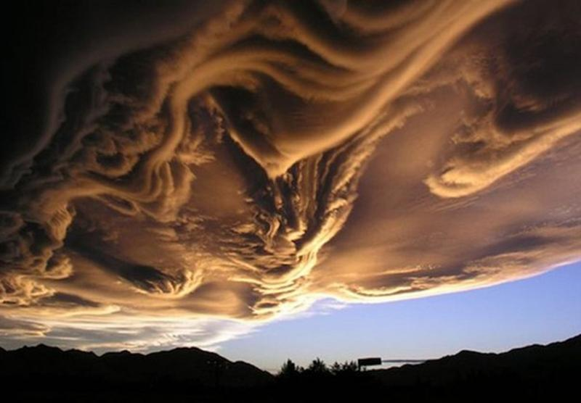
It is assumed that this is a condensation of particles of a special kind, perhaps the composition of the clouds was formed from non-natural vapor.
• Precipitation.
• Precipitation on land forms streams and replenishes rivers, goes into underground networks. Dissolve in itself minerals and decaying organic matter.
• Water with substances dissolved in it enters the roots of plants, nourish animals. A third of the entire planet’s surface is land. The common notion that the seas and oceans, which cover 2/3 of the entire planet, therefore evaporate most of the water, is a myth. It was found that, if we summarize the transpiration surface of the vegetation of all land, each leaf of which is an evaporator, then the entire area of ​​evaporation becomes equal to the surface of the oceans and seas. It should be added that on each hectare of fertile soil 20 tons of underground living creatures inhabit, each unit of which consumes water, releases salt from it, converts it into various elements of its body and releases it into the atmosphere as waste. Therefore, evaporation from land not less than half of all moisture in the atmosphere - the main component of atmospheric mechanisms.
• Conversion of the incoming fluid into the roots of plants and animal stomachs, the creation of chemical reactions to build the body and the release of moisture into waste. Part of the water remains in organisms and plants for long periods, for example, in growing bones and wood, but most of it comes out regularly during the day with secretions, expiration, and transpiration.
• Everything that is consumed by biota - everything is processed with the extraction of minerals and salts. Purified moisture is no longer just H2O. This is a special moisture with the molecular structure of a particular body and plant with some special properties, such as odors. All this comes out with various excretions that act as signaling for partners, predators and victims. All unused leaves in the clouds.
The loop is closed.
It should be taken into account that the quality of the consumed water is the same in every place, and the quality of the output vapors and emissions is strictly individual for each consumer and varies in each consumer - many types, for example, sweat, expiratory moisture, urine, blood.
All the biota vapor, in each of its molecules, is not just H2O, but the structures corresponding to the source. Surely the molecule that emerged from the flower’s petal is different from the molecule exhaling an elephant and from a molecule or raised from a puddle on the asphalt. Molecular structures form an individual substance in the atmosphere above each geographical point in certain combinations, volumes, stability of the gas state, and light transmission. In the process of atmospheric transformations, many factors are involved. One of the most important is the quality of the substance. It is quite acceptable that this parameter is involved in determining the time, places and volume of precipitation.
The everlasting circuit has created and maintained millions of years of many different natural habitats - the tropics and shrouds, forests and steppes, deserts and glaciers. Each of the ranges has its own regimes, temperatures, precipitation, volumes, rates and quality soaring. The moisture of the atmosphere, its quality and quantity are the main element in the creation and formation of clouds. Clouds, depending on these parameters, form their properties and affect the life of biota on the soil and nearby layers. According to information from: https://ozlib.com/831917/sotsium/znachenie_rol_vodyanogo_para_atmosfere : Another physical property of water vapor is its ability to strongly absorb and hold the Earth's infrared (long-wave, reflected) radiation, but water vapor itself emits it quite strongly why, in addition, its amount goes again to the earth's surface, which greatly enhances the greenhouse effect and leads to a significant increase in temperature on the planet.
https://salik.biz/articles/46567-krugovorot-vody-v-prirode.html

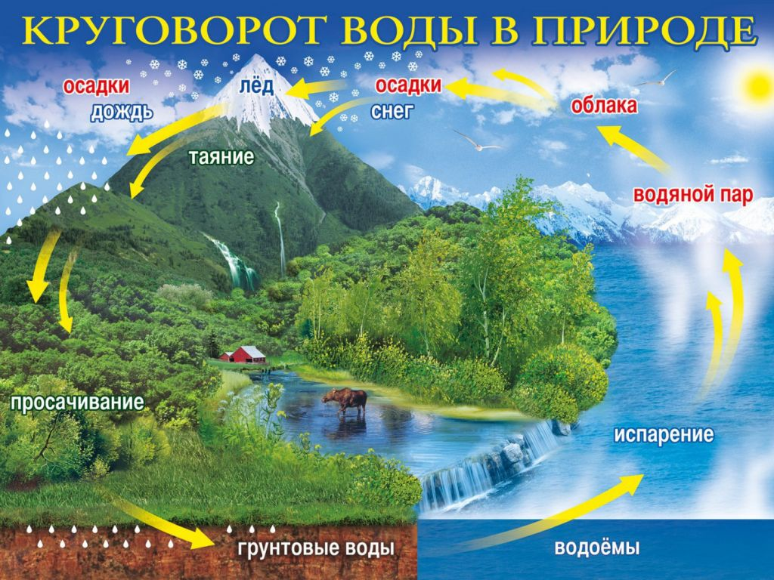

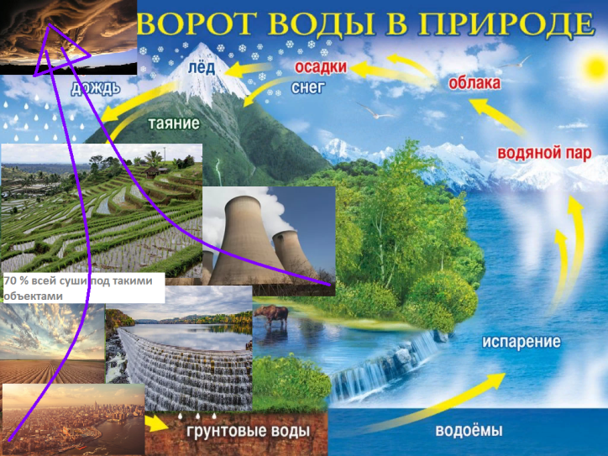
That is why water vapor is considered one of the most important greenhouse gases along with carbon dioxide. Only now “on an equal footing” is a statement that needs to be reviewed. There is evidence of an excess of volumes of water vapor over volumes of carbon dioxide: According to information from http://dic.academic.ru/dic.nsf/ruwiki/6330

nitrogen 78.8
oxygen 20.95
steam 1
argon 0.93
carbon dioxide 0.038
Pre-industrial data. 26 times less dioxide than steam. According to modern research:
http://ekolog.org/books/21/5_2.htm: Total freshwater consumption is increasing year by year in all regions of the world. If at the beginning of our century, mankind consumed 400 km3 of water per year, then now every year we need about 4000 km3, i.e. about 10% of global river flow. According to other sources: https://medcraveonline.com/JAMB/JAMB-07-00227.pdf 22,000 km3 are taken by people from underground and surface sources. All these waters have shortened their path of transformation, destined by nature, the links that ensure the functioning of the biota are excluded from circulation. The links of dissolution of substances and their transformation in biota clearly disappear. The disappearance of biota from 70% of land also reduces organic fumes.
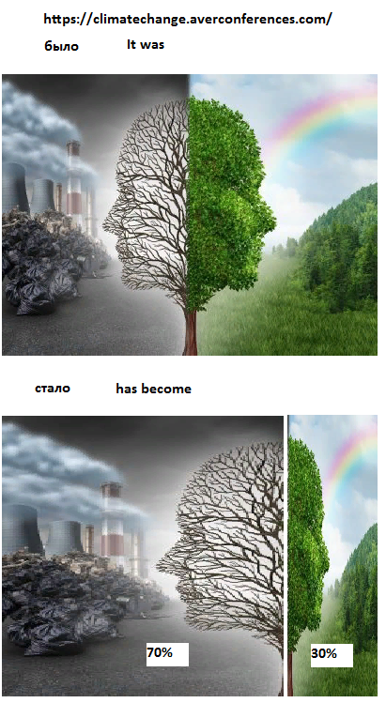
A new type of vapor appears for nature - artificial vapor.
Let's recalculate the minimum known figure of the fence - 4000 km3
In 1km3 = 1000x1000x1000 = 1,000,000,000 = 1 billion m3.
In 1m3 = 1t, then 4000 x 1bn. m3 = 4x1012 or 4,000,000,000,000, or 4trn m3, if we assume that all this water evaporates in the process itself and after use. It evaporates during boiling, heating, cooling, after discharge into the sewer, from the sumps. The same vapors, let us call them artificial, include vapors from the surfaces of the cultivated soil, numerous landfills, artificial reservoirs, fires, floods, asphalt, exposed areas from the forests of the entire planet. In addition to direct evaporation, all water passed through pipes, pumps, heaters, turbines, concrete banks is deprived of its natural function and the ability to dissolve minerals. During evaporation, it does not carry a “report” on the fulfillment of its mission on the ground.
From a fairly reputable source http://www.refsru.com/referat-17732-3.html it is known that carbon emission is 400 billion tons in 100 years.
From another source, https://ru.wikipedia.org/wiki/%D0%A3%D0%B3%D0%BB%D0%B5%D0%BA%D0%B8%D1%81%D0%BB%D1 % 8B% D0% B9_% D0% B3% D0% B0% D0% B7_% D0% B2_% D0% B0% D1% 82% D0% BC% D0% BE% D1% 81% D1% 84% D0% B5 % D1% 80% D0% B5_% D0% 97% D0% B5% D0% BC% D0% BB% D0% B8: In 2008, 8.67 billion tons of carbon were released into the atmosphere as a result of burning fossil fuels.
Let's take this figure as a basis and compare it with the volume of artificial fumes: then 4 trillion / 8.67 billion = 4,000,000,000,000/8,670,000,000 = 40,000/867 = 4,613. There are 4,613 times more artificial fumes than CO2. This is far from being “on par”. This is a gigantic volume difference between artificial fumes and CO2 emissions.
Physically, each of us sees that constant cloudiness above our heads covers the sun, the presence of heavy clouds, lowers temperature, plant growth, creates heavy rains with rivers flowing from the banks in some places. On the contrary, the prolonged absence of clouds leads to heat and fires in other places.
Dramatically, over the past two centuries, the quality of fumes has changed. From all land areas taken from nature - more than half of all land, water evaporates without fulfilling its natural purpose. From the usual natural cycle of water, we - humanity - are destroying the most important link in a consistent chain of transformations. These are organic transformations of water by biota. The main purpose of water is to dissolve the decomposable organic matter, minerals, salts and deliver them to plants and animals, and release the waste products of the entire biota by evaporation into the atmosphere. This quality, volume, speed and frequency of evaporation are decisive elements of the mechanism of atmospheric phenomena. And this link catastrophically disappears with the development of civilization. Water taken by man from natural sources, after performing the tasks specified by man, evaporates without these actions. As she came from heaven, she went back to the atmosphere from arable land, asphalt, from drying dishes, from production. Specifically for technological operation: https://studme.org/19530613/ekologiya/stochnye_vody#552: Water disposal rates in various industries vary widely. So, for example, when producing 1 ton of oil, 0.4 m3 of wastewater is produced, while producing 1 ton of coal in mines - 0.3 m3; in the smelting of 1 ton of steel or cast iron - 0.1 m; in the production of 1 ton of viscose staple fiber - 233 m3; 1 ton of fertilizer - 3.9 m3; 1 t of synthetic surfactants - 1 m; 1 ton of sulfite cellulose - 218 m3; 1 ton of paper - 37 m3; 1 ton of cement - 0.1 m3; 1 ton of linen or silk fabrics - respectively 317 or 37 m3; 1 ton of meat - 24 m3; 1 ton of bread - 3 m3; 1 ton of oil - 2.6 m3; 1 ton of refined sugar - 1.2 m3; in the manufacture of one passenger car - 15.5 m3; one bus - 80 m3; one main diesel locomotive - 710 m3. When 1 MWh of electricity is generated at thermal and nuclear power plants with reverse water supply systems, an average of 5 m3 of wastewater is generated. And yet - http://ekolog.org/books/21/5_2.htm: Volumes of water consumption in industry vary by industry. So, for the production of 1 ton of cotton fabrics, 250 m3 of water is consumed, and for the production of 1 ton of synthetic fiber - 2500 - 5000 m3 of water. A lot of water is spent in the production of non-ferrous metals: the smelting of 1 ton of nickel requires 4000 m3 of water.
Each of the elements of these types of costs evaporates water directly in the processes and from its effluents to the atmosphere. Their volumes have become commensurate with organic fumes. That is why nature warns us with local natural disasters. Further - complete flooding of the planet.
The classic environmental textbooks show a variety of pollution: http://portal.tpu.ru/SHARED/w/WALERY-W-B/instr_work/Theoretical_bases_PEP/Tab/tutorial_Theoretical_bases_EP.pdf:
Classification of types of environmental pollution
1. Mechanical. Clogging of the environment with agents that have only a mechanical effect without chemical and physical consequences (for example, garbage)
2. Chemical. Changes in the chemical properties of the environment that negatively affect ecosystems and technological devices
3. Physical Change ...
And then a dozen different types of pollution.
All accounted for climate experts. Only artificial vapors were not taken into account.
New for nature - artificial fumes - can be attributed to the same pollution. And the volumes of these pollution are orders of magnitude higher than all others.
Hydroelectric power stations around the world compress water into the finest jets and break the water structure into turbine blades. What can be the evaporation of such water from subsequent movement on the surface of the river?
Artificial vapors that did not undergo organic transformations changed the quality, the volume of water in the atmosphere, the turnover rate, and other parameters that determine the properties of clouds. A new mechanism has appeared that has a new effect on atmospheric phenomena. Distribution by territories, precipitation volumes, and time of precipitation have changed. Heavy clouds do not reach the polar and mountain glaciers and precipitate along the road. Hence the rise in the level of the oceans and the decrease in glaciers.
To stop climate change, it is necessary to return water to its natural functions and free it from slavery. Reduce water consumption in all types of its consumption, in all technological processes.
In pursuit of a reduction in carbon dioxide emissions, we further increase our fumes.
One of these elements is the accumulation of water in the reservoirs of hydroelectric power stations.
In total on the globe - http://ekolog.org/books/21/5_2.htm - to date, over 30 thousand reservoirs have been built, the total volume of which is about 6 thousand km3. The total area of ​​the world's reservoirs is 400 thousand km2, which corresponds to the territories of such states as, for example, Norway, Morocco, Paraguay.
Now the processes of artificial evaporation of water are increasing with menacing acceleration. New cities and constructions are being built, rivers are turning, canals are breaking, millions of different methods and devices for artificial evaporation are invented and manufactured - irons and humidifiers, washing, washing, drying, quenching, cooling devices.
Development and flooding of the remainder of the land continue:
http://www.georgiatimes.info/news/69279.html:
Georgia will begin construction of 17 new hydroelectric power stations
In Russia:
http://ru-news.ru/eco.php
In order to provide water resources to the water-deficient regions of Russia in 2008-2011, eight reservoirs were put into operation, and construction of seven more was started.
In China:
http://www.saveplanet.su/mynews.html
China will direct about $ 80 billion to change the direction of the rivers.
Kazakhstan is going to build an artificial river from east to west.
If we want to leave a prosperous planet for our descendants, we must stop this madness and begin to return its natural functions to water. One of the most important steps in this direction is the cessation of all water storage facilities.
Each type of water flow should be radically revised. Not in the form of good wishes, with concern for the environment, and policy, with the mandatory implementation of modern innovative achievements in relevant fields. Especially in agriculture, https://yandex.com/search/?lr=162&clid=2270456&win=346&text=ris%20checks%2 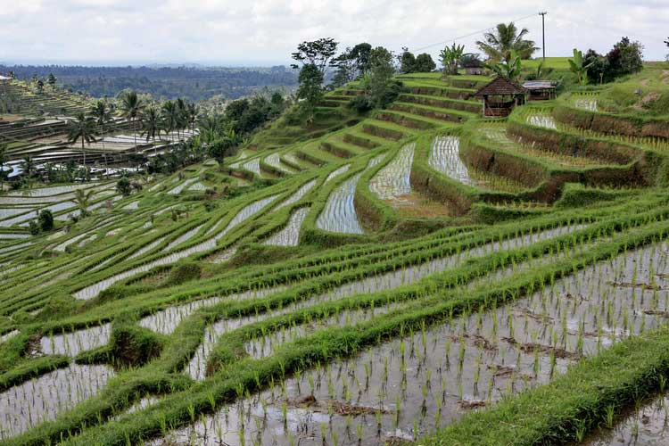
0photo:
Especially in the production of rice, cotton, vegetables.

In the industry: https://yandex.com/search/?text= cooling towers%20this&clid=2270455&banerid=6101003224%3A4655801518424859060&win=346&lr=162
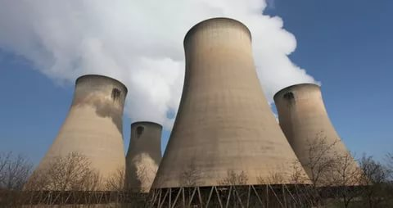

Transfer cooling to other methods. Do not dispose of, but use the heat of heated water.
At home. https://yandex.ru/search/?text=cost%20water%20on%201%20person%20in%20day&clid=2270455&banerid=6101003224%3A4655801518424859060&win=346&lr=162:
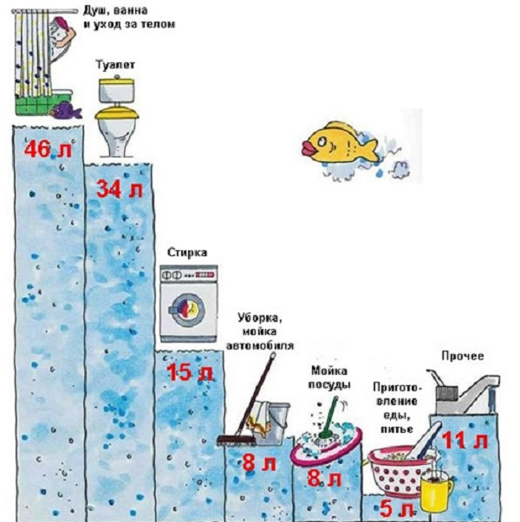
Now many different ideas and projects are being developed to collect, accumulate and treat wastewater. Why invest in thorough cleaning, so that later, for example, wash off the feces. We use a lot of water unreasonably, so centralized sewer systems formed. They are unnatural in nature. Gigantic volumes of water are collected in sedimentation tanks, processed, often discharged back into rivers.
An important example of the elimination of sewer networks is toilets on airplanes and dry closets. Flushing of sewage with used water, and other opportunities to reduce the use of clean water - a new concept on a city scale can lead to the elimination of the collection and accumulation of wastewater. Wastewater after washing and washing is disinfected, treated in the basements of houses and used for washing cars, asphalt, watering local vegetation - flowers, shrubs, trees. Each house and apartment must have at least two plumbing systems. One of them is for toilets and urinals. Repeated use after minor processing with the exception of odors. Drinking and washing dishes should be clean, and for washing, wet cleaning and washing, water can go through several stages of cleaning after inexpensive operations.
The main directions in the new concept should be
• Complete and unconditional cessation of design and construction of new hydroelectric power plants with accumulation of water in flooded areas.
• Gradual release of all existing artificial constructed reservoirs in the world.
• Flood prevention by cleaning and deepening the bottom of rivers. Ownerless rivers silt up, become shallow, in floods they leave the banks and create boundless areas of evaporation. A new strategy for controlling the movement of water in rivers is needed. There are such developments.
• Gradual replacement of immeasurable and ugly watering of fields with gulf and spraying for drip irrigation. Complete revision of crop production with economical water consumption.
• A sharp decrease in water consumption in all areas, especially in utilities. Eliminate centralized sewage by switching to reuse of water in toilets.
• Elimination of waste and ore landfills, as in the Scandinavian countries and Japan. It is known that the area of ​​the world landfill is equal to the area of ​​Mexico, and it is growing.
• Move to reduce useless flights and trips. Aviation and transport destroys significant amounts of moisture in the air. Maybe increase ticket prices by 2 to 10 times by redirecting funds to compensate for the destroyed structures of water in the air.
• Every roof, wall, every meter of asphalt and concrete pavement is contrary to nature. It is necessary to strive for the landscaping of all such areas. Vertical and roof landscaping are known, and even with the yield of plant products.
• Review all types of water consumption and switch to waterless technologies in all spheres of life. For example, there are dry cleanings of the surface of the car, washing clothes. There are technical solutions for cleaning roads without water.
Only in this way can we save life on the planet for posterity.
The logic of the constructed hypothesis has some theoretical justification and a promising direction of development. Scientific research could lead to a real discovery that will create a new strategy for saving life on the planet. Read more at https://lupinepublishers.com/environmental-soil-science-journal/fulltext/change-of-evaporations-leads-to-climate-change.ID.000125.php and other 120 publications.
I invite you to cooperation to save life on the planet.

