New Opportunities for Biochar from Biomass Energy
Thomas R Miles, Executive Director, US Biochar Initiative, USA

Abstract (300 word limit)
The US Biochar Initiative promotes the production and use of biochars from urban wood and residues from bioenergy, forestry, and bioenergy industries. Biochar markets continue to grow in North America creating new opportunities to convert wood residues to sustainable carbon while restoring soil health and improving water quality. More than155 US companies supply an estimated 50,000 tons of biochar per year which is used in agriculture, landscaping, and environmental remediation. Most of the biochar is a co-product of biomass energy made through gasification and combustion. New uses such as wallboard, cement, packaging, and electronics have increased the potential to sequester carbon by converting wood residues to biochar and renewable energy. This presentation will show how bioenergy producers can make biochars at existing facilities to improve soil health; restore degraded urban soils and abandoned mine lands; reduce water pollution from pharmaceuticals and fertilizers; remove nutrients, metals and bacteria from stormwater; and access new carbon markets.

Image
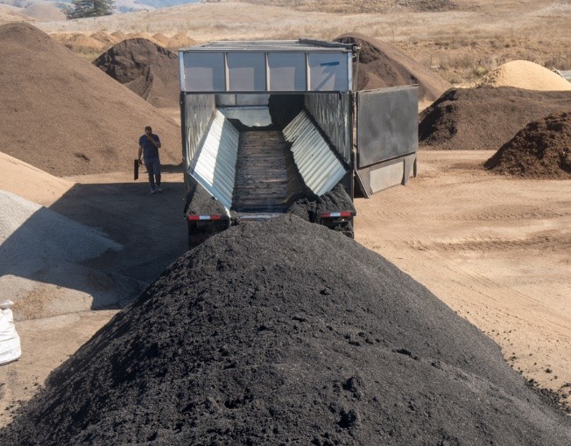
Recent Publications (minimum 5)
- Chapter 1. Biochar: feedstocks, production, and characterization, in Alberto Tagliaferro, Carlo Rosso and Mauro Giorcelli eds. Biochar, Emerging Applications, IOP Publishing, in press.
- Bioenergy Including Biomass and Biofuels, 2020, Chapter 1 in K. R. Rao. ed. “Energy and Power Generation Handbook, 2nd edition. American Society of Mechanical Engineers, in press.
- Introduction to Biochar Products, Systems, and Processes, 2018. Biomass Carbonization and Torrefaction Summit, Atlanta, April 16, 2018. Biomass Magazine (Presentation)
- Aqueous Contaminant Removal and Stormwater Treatment Using Biochar. 2016. With Myles Gray and Erin Rasmussen in Agricultural and Environmental Applications of Biochar: Advances and Barriers. SSSA Special Publication 63. M. Guo, Z. He, and S.M. Uchimiya, editors. doi:10.2136/sssaspecpub63.2014.0048.5
- Chapter 6. Biomass Feedstocks in Handbook of Biomass Gasification, Harrie Knoef, ed. Second edition. 2012. BTG Biomass Technology Group, Enschede, Netherlands.
- Corrosion and Deposit Investigations During Large Scale Co-combustion of Switchgrass at a Coal-fired Power Plant. 2006. T. R. Miles et. al. Presented to Impacts of Fuel Quality on Power Production, October 29 – November 3, 2006, Snowbird, Utah, Electric Power Research Institute.
- Alkali Deposits in Biomass Power Plants: A Preliminary Investigation Of Their Extent and Nature. 1993-1995. National Renewable Energy Laboratory, U.S Bureau of Mines, Sandia National Laboratories, U.C. Davis, Joint funding by eight cooperating industries. Included straw combustion in Europe. (NREL/USDOE, Golden, CO).

Figure 1. Biochar delivered from a biomass plant to
a composting facility.

Biography (150 word limit)
Tom Miles is the president of T.R. Miles, Technical Consultants, Portland, Oregon, a biomass energy consulting firm, which designs, develops, installs, and commissions systems for processing wood, agricultural, and urban residues. His knowledge of ash transformations led to recycling nutrients using pyrolysis of residues to biochar. He has sponsored and hosted online discussions of biomass energy since 1994 and biochar since 2006. He is Executive Director of the United States Biochar Initiative and past chairman of the International Biochar Initiative.
.
Email: tmiles@trmiles.cim

Notes/Comments:

