Title: Conductive polymers from biomass

Jonas Lindh¹, Petter Tammela¹, Maria Strömme ^{1,}
¹Department of Engineering Sciences, Nanotechnology and Functional Materials, Uppsala University, Sweden

Keywords: Green Chemistry, Renewable conducting polymers, Biomass utilisation, Utilisation of hemicellulose from residue streams
- Abstract Body
We will create the scientific base for sustainable industrial processes for using the waste-residue streams from pulp production (annually consisting of ~400 Mtons of hemicellulose) more efficiently to produce chemicals for electric energy storage devices based on renewable materials. Today, the value of the residue streams lies merely in the low heat content of hemicellulose (15 MJ/kg), revealing an enormous waste of a pristine biomaterial that could be used in a smarter way from a resource efficiency and an energy system perspective. We will perform the research needed to allow for industrial implementation of a continuous flow, green chemistry-based process of producing pyrrole from hemicellulose and anticipate that this will lay the foundation for the next generation of biorefineries using the residue streams much more resource efficiently. This will also stimulate the implementation of conducting polymers in electric energy storage systems based on renewable materials with low environmental footprint. The project will benefit from the existing collaboration between Uppsala University and BillerudKorsnäs aiming at developing forestry product-based electric energy storage devices based on a discovery made by our research group.

- Image:

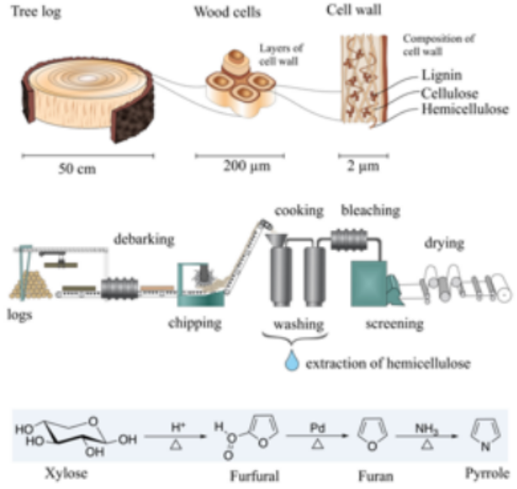

- Biography:
Dr. Jonas Lindh is a researcher of Nanotechnology at Uppsala University, Sweden. He has a background in organic chemistry and metal catalysis focusing on palladium catalyzed reactions. In 2012 he joined the group of Prof. Maria Strømme, where he has performed research on chemical modification of nanocellulose and has developed a number of methods to modify e.g. the surface, charge, functionality and morphology of nanocellulose derived materials.

- Presenting author details


Full Name: Jonas Lindh
Contact number: +46184713073
Twitter account:
Linked In account:
Session name/ number:
Category: Poster presentation
Passport Number:

