Domestic biogas production and use to provide energy security to rural households- a case study in Nepal

Shanti Kala Subedi ¹, Ralph E. H. Sims², Stephen Hasslet³, Phil Murray², Rochelle Steward-withers⁴

1 Himalaya College of Engineering, Tribhuban University, Kathmandu, Nepal
2Centre for Energy Research, Massey University, Palmerston North, New Zealand
3 Institute of Fundamental Sciences, Massey University, Palmerston North, New Zealand
4School of People, Environment and Planning, Massey University, Palmerston North, New Zealand
Email: sksubedi3@hotmail.com

Key Words: Biogas, agriculture residue, co-digestion technology, energy security, environment emission.

Abstract Body (250 words except references)

Biogas development is one of the government's priority programmes in Nepal (WECS, 2010; Bajgain and Shakya, 2005; Katuwal and Bohara, 2009; SNV, 2010). However, the replication of the technology is still slow (BSP-Nepal, 2015). Biogas production is lower than its full capacity (Rao and Baral, 2011) and cannot cover the energy demand of a typical household all year round, especially during winter (KC. Et al, 2011, SNV, 2010, Katuwal and Bohara, 2009). Hence, this study aimed to explore the potential solution to increase domestic biogas production and use so that its benefits for energy security and environmental emission reduction can be optimised.

Both quantitative and qualitative research approach were applied. Surveys of biogas households in Nepal were conducted to collect household-level information. This research analysed the effect of co-digestion of dung with agricultural residues to increase biogas yield by using Volumetric Methane Prediction (VMP) model. The cost effectiveness of co-digestion technology is checked out by using financial analysis. The impacts of improved biogas production on energy cost, energy consumption, and associated greenhouse gas (GHG) emissions reduction were obtained by using Long-range Energy Alternative Planning (LEAP) system model.
This study showed that co-digestion of dung with crop residues could improve biogas production up to 150% and would meet most of the household cooking energy demand throughout the year. Also, the total annual cost of energy after co-digestion is up to 37% cheaper than the existing biogas production, and even up to 45% cheaper than the energy cost of non-biogas households. An improved production can reduce average annual energy consumption by 46-57 gigajoules and GHG emissions, mainly from avoiding deforestation, by 16.7-19.3 tCO2e per household compared to a non-biogas household.

Image:

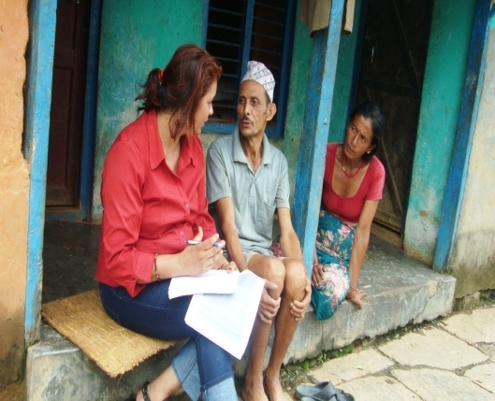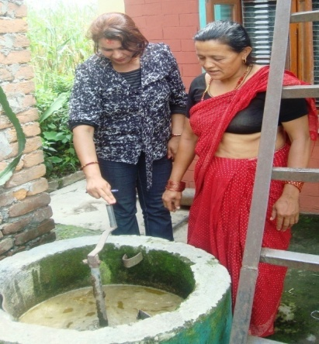
Image (a) Image (b)
Image: (a) Interviewing with biogas household owners during the household survey in Nepal;
b) Observation of biogas production process with a biogas user in Nepal
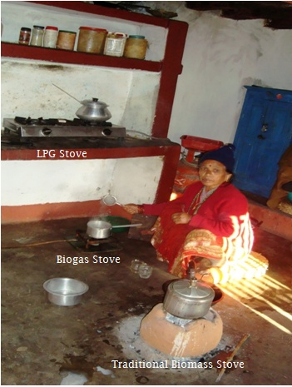
Figure (c)
Figure (c): A biogas user, in Nepal, is using LPG, biomass stove and biogas stove at the same time to fulfil biogas deficit.

References:

- Bajgain, S., & Shakya, I. (2005). The Nepal Biogas Support Program: A successful model of public private partnership for rural household energy supply. Kathmandu, Nepal: SNV-Netherlands Development Organisation and Biogas Sector Partnership – Nepal.

- BSP-Nepal. (2015). District and fiscal year wise production of biogas plants (Unpublished). Kathmandu, Nepal: Biogas Support Programme Nepal (Shrestha, B., Personal communication, 12/03/2015).

- Katuwal, H., & Bohara, A. K. (2009). Biogas: A promising renewable technology and its impact on rural households in Nepal. Renewable and Sustainable Energy Reviews, 13(9), 2668-2674.

- KC, S., Khanal, S. K., Shrestha, P., & Lamsal, B. (2011). Current status of renewable energy in Nepal: Opportunities and challenges. Renewable and Sustainable Energy Reviews, 15, 4107-4117.

- Rao, P. V., & Braral, S. S. (2011). Attribute based specification, comparison and selection of feedstock for anaerobic digestion using MADM approach. Journal of Hazardous Materials, 186, 2009-2016.

- SNV. (2010). Biogas support programme fuels rural household energy supply in Nepal. Paper for UNCTAD Expert Meeting on Green and Renewable Technologies as Energy Solutions for Rural Development, Geneva, 9-11 February 2010.

- WECS (2010). Energy sector synopsis report Nepal. Kathmandu, Nepal: Water and Energy Commission Secretariat, Government of Nepal. Retrieved from www.wec.gov.np.

Biography (100 words)

Shanti experienced energy crisis since her childhood as she was born and grown up in a rural community in Nepal. She was so determined to work on it since that time. On the way of her mission, Shanti completed her PhD degree in Energy and Environment, explored an appropriate biogas production technology, and recommended governments for adaptation.
Shanti is currently working as a research chief in Tribhuban University Nepal where her researches focuses on Energy, Environment and Society. She is a Managing Director at Krishnam Smart Engineering Solution Pvt. Ltd - which works for renewable energy development projects in Nepal.

Presenting author details

Full Name: Shanti Kala Adhikari Subedi
Contact Number: 00977 98655 54967
Twitter Account: sksubedi3@hotmail.com
Linked in account: shantisubedi@hcoe.edu.np
Session Name/ Number: Energy and Environment/8
Category: Oral Presentation
Passport Number: 06210002 (Issued in Nepal)

