Citizen‘s view on Agrophotovoltaics – a responsible research and innovation study in Germany

Rösch, C.¹, Ketzer, D.², Weinberger, N.¹
¹ Karlsruhe Institute of Technology (KIT), Karlsruhe, Germany
² Steinbeis 2i GmbH, Steinbeis-Europa-Zentrum, Karlsruhe Deutschland

Keywords: Agrophotovoltaics, renewable energies, Responsible Research and Innovation, public perception

- Abstract
The German energy transition induces conflicts between biomass and power production when open space photovoltaic is installed on agricultural land. Combining food and power production with photovoltaics at the same site and time, Agrophotovoltaics (APV) may help solving the food versus fuel dilemma. However, what is society’s opinion on this technology? The presented study investigated the views of citizens on APV technology based on the concept of Responsible Research and Innovation (RRI).

To reach that objective, we applied a multi-stage inter- and transdisciplinary research approach referring to the RRI concept. Citizen’s and stakeholder’s knowledge, expectations and apprehensions as well as their values and evaluations on the APV concept were assessed and integrated in the development of a framework for APV. In the region of Lake Constance in Germany, where the APV pilot plant was installed, we conducted two citizens’ workshops and one stakeholder workshop as well as a survey at the opening ceremony of the pilot plant.

Our findings indicate that after exhausting roof and sealed area PV potentials, the participants would prefer APV over open space PV and biogas plants. However, making the innovation responsible means for them embedding APV in a restrictive framework that e.g. defines site criteria and obliges agricultural cultivation below APV. Appropriate plant ownership and operation concepts are also regarded as crucial for a successful implementation and operation of APV. Our research identified chances and challenges including conflicting sustainability goals in the technology development and implementation that need to be addressed in further research.

- Image

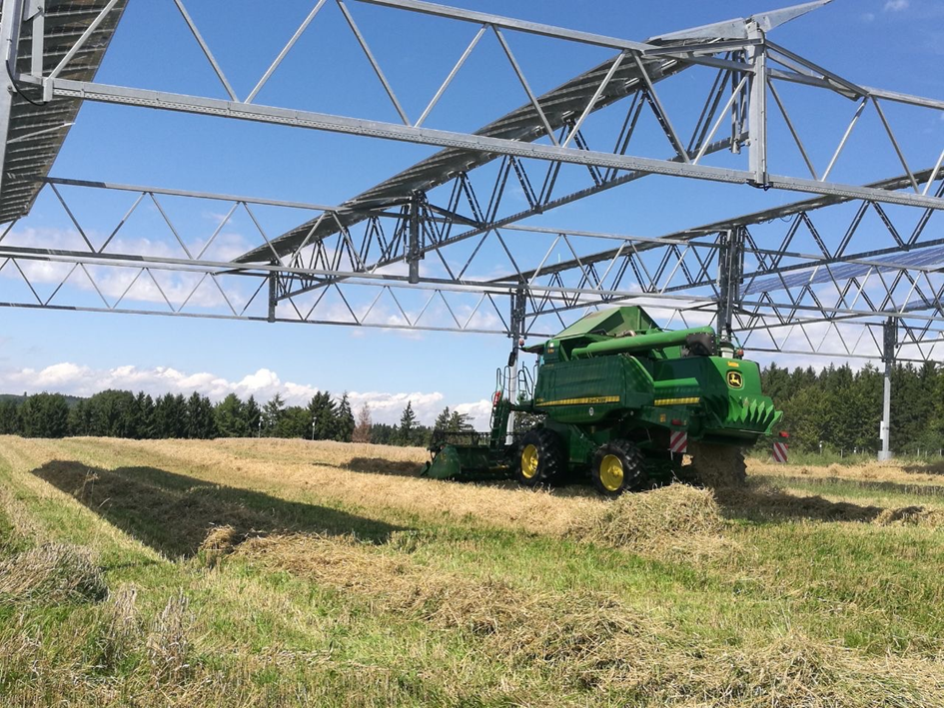
Figure 1: Agrophotovoltaics pilot plant in Heggelbach, Germany. Source and Copyright: Hofgemeinschaft Heggelbach.

- Reference
- Ketzer, D.; Weinberger, N.; Rösch, C. and S. B. Seitz (2019): Land Use Conflicts between Biomass and Power Production – Citizen participation in the technology development of Agrophotovoltaics. Journal of Responsible Innovation (under review)
- Rösch, C. (2018): Citizen participation for a responsible design of Agro-photovoltaics. Proceedings "Responsible Research and Innovation in Plant Sciences". ETH Zürich (in press)
- Rösch, C. (2016): Agrophotovoltaik – die Energiewende in der Landwirtschaft. GAIA 25(2016)4, S. 242-246
- Biography
Dr. Christine Rösch was trained as an agricultural biologist and graduated from the University of Hohenheim. She is head of the research area “Sustainability and Environment” at the Institute of Technology Assessment and Systems Analysis (ITAS), one of the biggest institutes of the Karlsruhe Institute of Technology (KIT). Most of her scientific work deals with technology and sustainability assessment in the field of bioeconomy and energy. She has led several national and European projects in this field and has published many papers in reputed journals.

- Presenting author details


Dr. Christine Rösch
Head of the Research Unit Sustainability and Environment
Karlsruhe Institute of Technology (KIT)
Institute for Technology Assessment and Systems Analysis
Karlstraße 11
D-76133 Karlsruhe
Phone: +49 721/608–22704
E-Mail: christine.roesch@kit.edu
Web: https://www.itas.kit.edu/english/staff_roesch_christine.php

