Global warming with special reference to AJMER RAJASTHAN INDIA.
Abstract
INTRODUCTION
Rajasthan is the second largest state in India occupying an area of 342274 sq. km.
It stretches between 23 ⁰ N’ to 30 ⁰ 12 ‘ N lat. And 69 0 30’ E 78 0 17’ E long.
It forms the eastern extremity of great arid and semiarid belt of the world.
A striking geological feature of Rajasthan is the presence of Aravallis the oldest
Plateau mountains of the world.
Aravalli range literally means line of peaks, range of mountains in west India running
approximately 692 km. in NE direction, across Indian states Gujarat, Rajasthan , Haryana and
Punjab. The southern end is Palampur near Ahemdabad Gujrat and terminates into Raisina
hill (last extension ).The area west to Aravallis is desert and area east
of this mountain is semiarid.
Ajmer is located centrally in Rajasthan also known as heart of Rajasthan. About 7
miles from the city is Pushkar lake created by the touch of lord Brahma. The Dargah of
Khawaja Mouinuddin Chisti is holiest shrine next to Mecca in the world. Ajmer has hot
dry summer and cold bracing winter. The temperature varies from 6-45 ⁰ C . The winter
extends from November to February and summer from march to june followed by rainy
Season.
Effects of Global warming in water scarce Ajmer.
GHG are increasing in Ajmer.

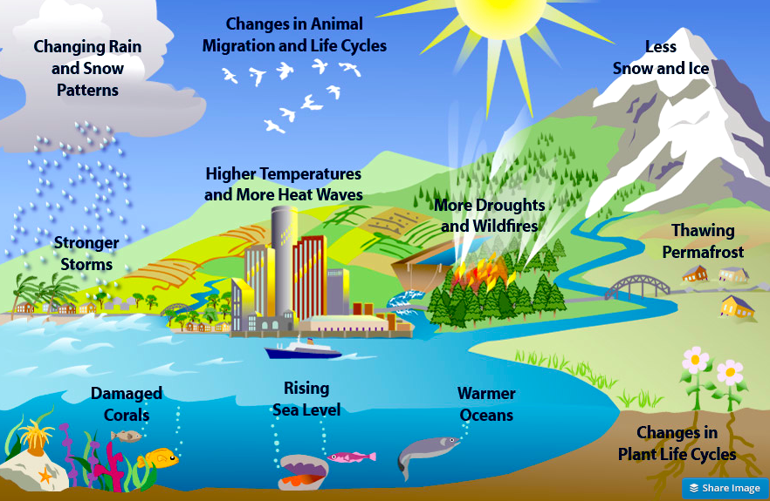Our atmosphere is getting hotter,
