Traditional knowledge on the therapeutic use of insects in Nagaland, North-East India
L.N. Kakati* and Lobeno Mozhui
Department of Zoology, Nagaland University, Lumami 798627, India

Abstract
Indigenous or folk medicine comprises medical aspects of traditional knowledge that developed over generations within various societies before the era of modern medicine. The ethnic communities of Nagaland are known to consume different types of insects for therapeutic purpose traditionally, besides using them as delicacies and as folk traditions and beliefs which are regarded as part of their cultures. Medicinal insects have always played an important role in the indigenous lives of the tribal people. The present study documents the different types of insects utilized in traditional medicine and emphasizes on the cultural importance of their uses in the region. The documentation is based on semi-structured questionnaires and group discussions with total number of 340 informants. The relative importance of medicinal insects within a culture was documented using the fidelity level and informant consensus factor. About 45 important insect species belonging to 10 orders and 25 families were documented to possess therapeutic properties. Topical application of Mylabris variabilis for treating dermatological disease showed the highest fidelity level of 100%. Honey and its derived products has been widely used in folk healing and regarded as the most important medical agent. The use of medicinal insects varies among the different Naga tribes suggesting the difference in culture leading to selection of insect’s species for medicinal purpose. However, a large number of insect species are used for treating gastro-intestinal, dermatological and respiratory diseases by two or more of the indigenous groups. Although insects constitute an almost inexhaustible resource for pharmacological research, apart from bee and its derived products, medicinal insects have received little attention and need further exploration from both an ethnographic focus and a pharmacological perspective. Therefore, documentation of traditional knowledge and promoting traditional medicinal is not only necessary but can serve a purpose in developing novel drugs.

Image
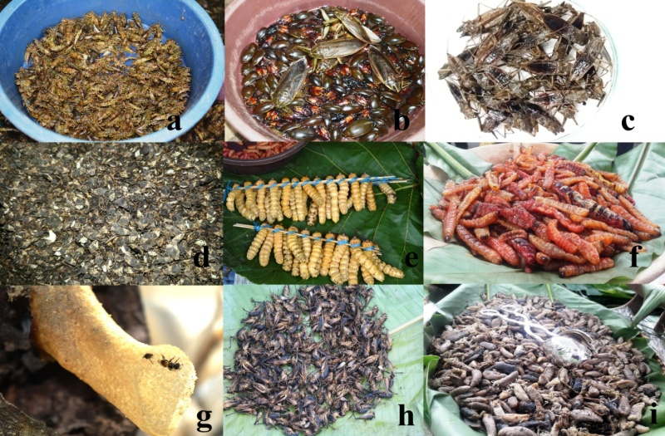
Plate 1: Medicinal insects of Nagaland, (a) freshly harvested dragon nymphs, (b) freshly collected water bug and water beetles, (c) boiled water scorpion, (d) leafhopper nymphs, (e) wood larvae, (f) dry cooked carpenter worm, (g) nest entrance of stingless bee-important medicinal agent, (h) boiled bush crickets and, (i) cooked wasp larvae and eri silkworm larva.
References
Anungla P, Ao B, Yenisetti SC, Lal P (2019) Ethnozoology and entomophagy of Ao tribe in the district of Mokokchung, Nagaland. Indian Journal of traditional knowledge 18(3):508-515.
Erren TC, Koch MS, Meyer-Rochow VB (2013) Common sense: folk medicine that ethnobiological and ethnomedicinal research cannot afford to ignore. Journal of Ethnobiology and Ethnomedicine 9, 80
Meo SA, Al-Asiri SA, Mahesar AL (2017) Role of honey in modern medicine. Saudi Journal of Biological Sciences 24:975-978.
Meyer-Rochow VB (2017) Therapeutic arthropods and other, largely terrestrial, folk-medicinally important invertebrates:a comparative study and review. Journal of Ethnobiology and Ethnomedicine 13, 9.
Mozhui L, Kakati LN, Ao B (2017b) Entomophagy and Entomotherapy of Lotha tribe in Nagaland. Nagaland University Research Journal 10:138-151.

 L. N. Kakati is a professor at the Department of Zoology, Nagaland University and effortlessly works on edible insects, mass production and life cycle of various insects in Nagaland. He has expertise on soil-micro arthropods, earthworms, sericulture, muga culture, edible insects etc.
Email: kakati_ln@yahoo.com
Notes/Comments:

