Edible insects: the most promising and alternative food of Nagaland, North-East, India
Lobeno Mozhui*, L.N. Kakati and Patricia Kiewhuo
Department of Zoology, Nagaland University, Lumami, India

Abstract
With the rapidly growing population, edible insects have garnered worldwide attention and are no longer considered as an emergency food or a food source for the poor, but an important biological resource with substantial health benefits. Inhabited by sub-mongoloid sixteen (16) major tribes called the “Nagas” having cultural affinities with the South-East Asian aboriginal people, Nagaland is bestowed with natural resources and rich biodiversity supporting various insects association within its natural vegetation where, many insects are consumed as delicacy, medicinal and as folk traditions and beliefs by the tribal. This study documents the diverse types of insects consumed in the region and emphasizes on the potential of edible insects as a natural food resource to combat future food security. Documentation was done by conducting in-depth personal interviews, group discussions and observations with 340 informants. The collected data were analyzed by determining the use value (UV) of each insect species. Over 100 insect species representing 9 orders are considered as health foods by the indigenous people. Popular consumed insects are beetles, dragon nymphs, grasshoppers, katydids, crickets, stink bugs, bees, wasps and wood larva. Preferences in insect consumption vary from tribe to tribe and one’s own palatability and availability. The popularity of edible insects suggests insects as one of the most promising and alternative food in the region. While there is potentiality of industrialization of insects as bio-resource, it is important to keep a balance between the utilization and the biodiversity conservation to promote sustainable development of insect industry. Hence, knowledge of ecology of edible insects and development of mass rearing technologies will not only help in keeping the biodiversity of these species population but also provide the source of livelihood and food security through wider acceptance by the people in general.

Image
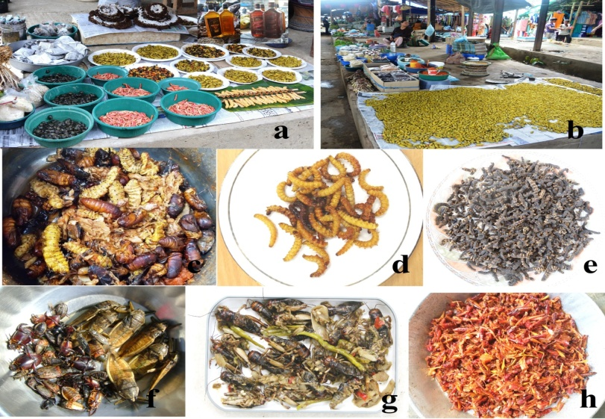
Plate 1: (a & b) Wide variety of insects and insect products sold at local market in Kohima district and Dimapur district, (c) silkworm larvae and pupae cooked in fresh bamboo shoot and local spices, (d) fried bamboo larvae, (e) smoked tent caterpillars, (f) freshly collected aquatic insects, (g) crickets cooked in fresh bamboo shoot, a delightful delicacy, (h) grasshoppers cooked in dried bamboo shoot, a local favorite dish.
References
1. Alexander P, Brown C, Arneth A, Dias C, Finnigan J, Moran D, Rounsevell M (2017) Could consumption of insects, cultured meat or imitation meat reduce global agricultural land use? Global Food Security 15:22-32.
2. Bernard T, Womeni HM (2017) Entomophagy: Insects as food. In: Insect Physiology and Ecology. (Eds: Dr. Vonnie Shields.), InTechOpen, pp.233-253.
3. Mozhui L, Kakati LN, Changkija S (2017a). A study on the use of insects as food in seven tribal communities in Nagaland, Northeast India. Journal of Human Ecology 60(1):42-53.
4. Seni A (2017) Edible insects: Future prospects for dietary regimen. International Journal of Current Microbiology and Applied Sciences 6(8):1302-1314.
5. Van Huis A, Dicke M, van Loon JJA (2015) Insects to feed the world. Journal of Insects as Food and Feed 1(1):3-5.


Lobeno Mozhui (LM) is a Research Scholar from the Department of Zoology, Nagaland University, Lumami, working on edible insects of Nagaland, India and is passionate about the potential of edible insects for mass production and its ability to combat food security. L. N. Kakati is a Professor at the Department of Zoology, Nagaland University, Lumami. He is the supervisor of LM and effortlessly works on edible insects, mass production and life cycle of various insects in Nagaland. Patricia Kiewhuo is a Research Scholar from the Department of Zoology, Nagaland University, Lumami.
Email: Lobenommozhui@gmail.com

Notes/Comments:

