CONSERVATION AND RESTORATION OF BENEFICIAL INSECTS IN THE BIO-ECOSYSTEM
Dr M. S. PALANISWAMI
Entomologist & Former Project Co-ordinator & Director (Act), ICAR – CTCRI, Trivandrum, India. Email: palaniswamims@gmail.com
ABSTRACT
Insects have adapted to every environment on earth and play a vital role in the ecosystem. In all terrestrial ecosystems, insects are one of the most important and diverse groups of species. They make most of the world’s biodiversity and contribute significantly to vital ecological functions such as pollination, biological pest control with parasitoids and predators, nutrient recycling and decomposition (saprophages and coprophages), as soil engineers changing the soil ecosystem, food source and food chain. Mutually beneficial relationship has been developed between pollinators and phanerogams through co-evolution. Entomophilous plants cannot survive without insects that assist pollination.
Mostly insects are attributed as pests to humans, crops and animals, but harmful ones are only a small part of the world’s insect population. In fact majority of them are beneficial to humans and the environment in one way or other. Insects, or chemicals extracted from them have been used for thousands of years to help us with medical issues (entomotherapy). Insects are to play an important role as dietary and nutrient supplement in the near future (entomophagy). While dislike for insects (entomophobia) is common, there is the other side where insects need to be loved and appreciated (entomophilia).
Insect diversity is now faced with habitat degradation, species extinction, and a decline in the natural enemies of harmful insects. In general, the main threats are habitat loss due to incorrect agricultural practices, invading infrastructure, invasive alien species, pollution and climate change (abiotic and biotic).
As of July 2016, the International Union for Conservation of Nature (IUCN) lists 58 extinct species, 46 possibly extinct species, and one extinct in the wild species of insect. As of 2017, at least 66 insect species extinctions had been recorded. The abundance decline was attributed to artificial lighting, land use changes such as urbanization, agricultural use and pesticide use. Studies summarized in a 2019 review suggested a large proportion of insect species are threatened with extinction in the 21st century. International trade in insect species is regulated through the Convention on International Trade in Endangered Species (CITES). A few insect species are listed, many more species need to be listed in CITES.
We should understand that a good proportion insect species are fundamental to our existence. Without them it would be an impoverished world with alarming decline of resources that the beneficial insects so benevolently bless us with! Conservation and restoration is our prime focus. Geographical diversity, species, and populations are prime indicators for conservation and restoration.
Widespread use of pesticides is detrimental to beneficial insects. There has to be strict “agro-vigilance” on this issue to influence future policy making. Development, recommendations and implementations of good practices (GPBI) is to be formulated through National Biodiversity and Strategy Action Plans on a regional basis. We need global insect conservation and restoration initiatives,“think global, act local.”
References:
Michael J. Samways 2018 Insect Conservation for the Twenty-First Century. In book: Insect Science-Diversity, Conservation and Nutrition. http://dx.doi.org/10.5772/intechopen.73864
Matthew S. Jones and William E. Snyder 2018 Beneficial Insects in Agriculture: Enhancement of Biodiversity and Ecosystem Services. https://doi.org/10.1002/9781118945582.ch5. In: Insect Biodiversity: Science and Society, II, Robert G Foottit and Peter H. Adler. Print ISBN:9781118945575 John Wiley & Sons Ltd.
Anna K. Fiedler, Doug A. Landis, Steve D. Wratten 2008 Maximizing ecosystem services from conservation biological control: The role of habitat management. Biological Control 45: 254–271.
Gill, Kelly Ann 2013 Development of best-practices for conserving beneficial insects within Iowa's agricultural landscape. Graduate Theses and Dissertations. 13048. https://lib.dr.iastate.edu/etd/13048.

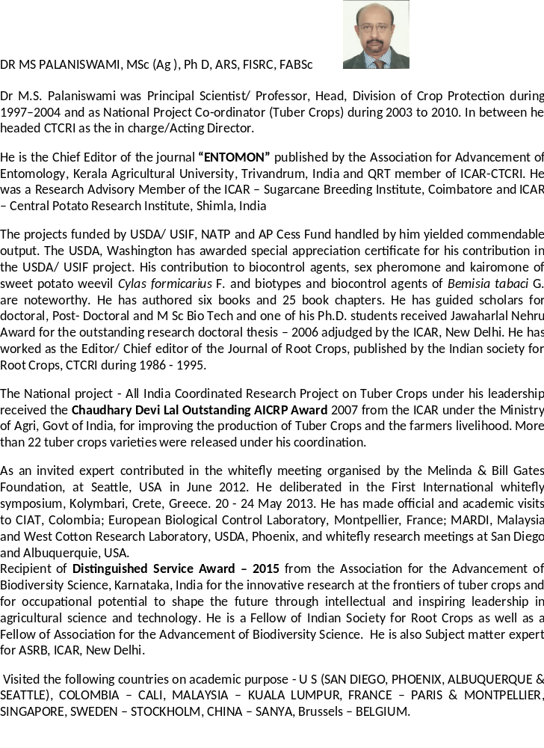
Notes/Comments: Keynote speaker at Biodiversity 2020

