Search for genetic resources of wild roses for improvement of cultivated roses
Ryosuke Sakamoto, OIT, Osaka, JAPAN
Yoshihiro Ueda, Flower FCP, Gifu, JAPAN
Li Wang, Sichuan Univ., Sichuan, CHINA
Koji Kawamura, OIT, Osaka, JAPAN

Abstract
Rose is one of the most popular ornamental plants in the world. But, due to its low genetic diversity, cultivated roses have little resistance to diseases. As a consequence, a lot of pesticides are commonly used in rose gardens. In order to increase disease resistance of cultivated roses, wild genetic resources should be used for rose breeding. This study aims to search for appropriate wild genetic resources of rose for improvement of modern cultivated roses. Most modern roses are continuous-flowering, and this continuous-flowering characteristic is derived from the Chinese old rose cultivar ‘Old Blush’; Consequently, almost all modern roses are believed to be descendants of Old Blush. We therefore focus on searching for wild ancestral species of Old Blush, which should be nice genetic resources for improvement of modern cultivated roses with continuous-flowering characteristics.
We collected DNA samples of wild roses in Sichuan, China from 2018-2019, because old literature indicates the origin of Old Blush is in Sichuan. We sequenced two genes, KSN and AP2, which are responsible genes for continuous-flowering and double-flower characteristics of Old Blush, respectively (Iwata et al. 2012; Hibrand-Saint Oyant et al. 2018). Wild rose species are once-flowering and simple-flower characteristics, and transposon insertions in KSN and AP2 result in continuous-flowering and double-flower Old Blush. We can therefore expect that DNA sequences of these two genes of wild ancestral species of Old Blush are identical to those of Old Blush without transposon insertions (Fig.1).
The results show that the KSN gene sequence of a wild rose, Rosa chinensis var. spontanea is identical to that of Old Blush without insertion, indicating that the species is a wild ancestral of Old Blush. The AP2 gene sequence of Old Blush is most close to that of R. chinensis var. spontanea and R. gigantea, indicating that the latter species may be also involved in the origin of Old Blush. We identified two probable ancestral wild species of Old Blush and suggest that they have a high priority for conservation due to their importance as genetic resources for rose breeding.

Image
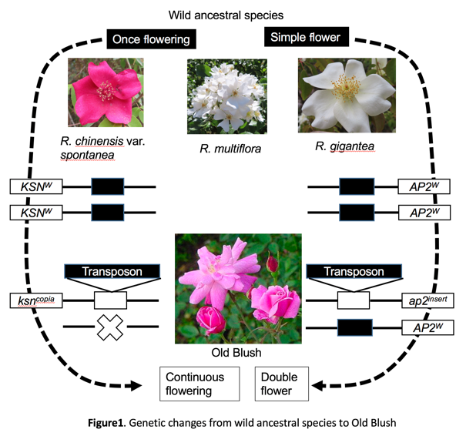
Recent Publications
- Kawamura K et al (2011) Quantitative trait loci for flowering time and inflorescence architecture in rose. Theor Appl Genet, 122:661-675.
- Iwata H et al (2012) The TFL1 homologue KSN is a regulator of continuous flowering in rose and strawberry. Plant J 69:116-125.
- Horibe T et al (2015) Molecular genetic studies on the continuous-flowering roses that are not originated from Rosa chinensis. Acta Hort 64: 185-192.
- Otagaki S et al (2015) Genotype of FLOWERING LOCUS T homologue contributes to flowering time differences in wild and cultivated roses. Plant Biol 17: 808-15.
- Hibrand Saint-Oyant L et al (2018) A high-quality genome sequence of Rosa chinensis to elucidate ornamental traits. Nature Plants 4:473-484.

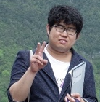Biography
Ryosuke Sakamoto is 2nd grade Master course student in Department of Environmental Engineering, Osaka Institute of Technology, Japan. He has studied rose genetic resources by especially focusing on the continuous-flowering characteristic and Chinese wild roses. The leader of this study is Dr. Koji Kawamura, associate professor of Osaka Institute of Technology, and collaborators includes researchers in Sichuan University, China, French National Institute of Agriculture, France, and Nagoya University, Japan.
Email: koji.kawamura@oit.ac.jp

Notes/Comments:

