Development of IT Enabled Tool for Monitoring the worldwide use of Biological Resources from India
Mithilesh D Kandalkar, Technical Expert, GIZ, India

Abstract (300 word limit)
Situation:
Under the scope of Biological Diversity Act 2002 and Access & Benefit Sharing Guidelines, National Biodiversity Authority (NBA) of India aims to enable the effective monitoring of the use of bio-resources and associated traditional knowledge from India. At present, most of the users accessing bio-resources from India for research & commercial purposes are outside the preview of NBA, leading to its illegal & unsustainable use. Also because of lack of information, benefits arising out of its utilization cannot reach to providers. Hence NBA is now seeking to enhance its capacity to monitor the utilization of Indian bio-resources and associated traditional knowledge with the help of an IT based monitoring tool.

Objective:
The objective of this tool is to monitor utilization of bio-resources, characterized by two different scenarios:
- Access and utilization are undertaken with approval of NBA: Access to bio-resources or associated knowledge from India for commercial utilization, research/transfer of research result/ applying for any Intellectual Property Right within or outside India, after obtaining prior approval of National Biodiversity Authority
- Access and utilization are undertaken without approval of NBA: Enable NBA to effectively monitor and perform regulatory actions against any non-compliance within and outside India.
Approach:
IT enabled Monitoring Tool, will access globally available databases on biodiversity information related to India through scientific publications, patent databases, taxonomic data and information on bio-resource based commercial products. Any trace of information highlighting the use of bio-resource or associated traditional knowledge of Indian origin would be tracked and necessary information about it shall be flagged to authority. The tool will also emphasize whether the required permission for access was prior obtained by the user or not. In case of non-compliance appropriate actions shall be taken.

Applied Digital Technology:

The IT enabled Monitoring Tool would be a cloud based system, integrating the real-time information from globally available data-sources like EU patents, US patents, CrossRef, Web of Science, GBIF, Microsoft Academic Graphs (MAG) etc., filtering the information specific to India through a sophisticated data mining approach and creating its own metadata repository containing information relevant to India only. This data repository shall be dynamically updated through Application Programing Interfaces (APIs), ensuring an up-to-date datasets.

This tool would be using advance interfaces like R, Python and D3 to perform the machine learning function for cleaning the data sets and capture the desirable information with higher accuracy. This functionality will also be useful to monitor the activities related to bio-resources accessed by registered users of NBA and scrutinize whether their actions are within the scope of granted permissions.

Achievements through Digitalization:

It is practically impossible to monitoring all those who are utilizing bio-resources from Indian origin within/outside country. Though this information is digitized and available online, it is extremely scattered and thus is difficult to interpret.

With the IT enabled Monitoring Tool following shall be achieved:

- Integration of information on patents, scientific literature and taxonomic data form various relevant data sources available across the world into a single standardize format for effective access
- Automatically tracking the activities of bio-resource users and readily available statistics highlighting trends of uses of bio-resources from India
- Seamless scanning through complex documents on patents & scientific literature and obtain relevant information for monitoring purpose
- Automatically capturing of any new information published online on use of Indian bio-resource or traditional knowledge
- System generate reports, statistics and alerts mechanism

Image

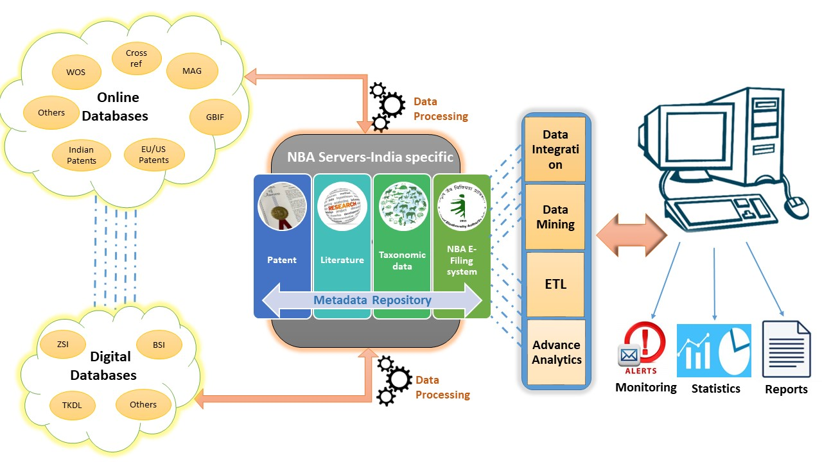

Biography (150 word limit)
Mithilesh holds a Master's degree in Rural Management from Xavier Institute of Management, Bhubaneswar. He has experience in establishing Agriculture Value Chains, specifically for horticulture crops across Maharashtra, Gujarat, Andhra Pradesh & Telangana. Prior to GIZ, he was working with NCDEX as Assistant Product Manager handling the portfolio of two major crops, Maize & Wheat. His former assignment at GIZ was with Rural Insurance Services Program, in partnership with NABARD & Dept. of Agriculture, GOI. Currently, he is working as Technical Expert with the Access & Benefit Sharing Partnership and looking after the project coordination for the state of Maharashtra. He is looking after the development of of Good practices on Access & Benefit Sharing in India & Development of IT enabled tool for National Biodiversity Authority (NBA) of India which will support NBA to monitor the worldwide use of bio-resources from India.
Email: mithilesh.kandalkar@giz.de

Notes/Comments:

