Applying manure improves haricot bean response to phosphorus on acidic soils, eastern Ethiopian highlands

Gebreyohannes Girmay, PhD, Mekelle University, Ethiopia
Tesfaye Lishan, MSc, Mekelle University, Ethiopia

Abstract
Statement of the Problem: Haricot bean (Phaseolus vulgaris L.) production in Ethiopia is mainly limited by poor nutrient availability on non-neutral soils. Attempts so far done in using only mineral fertilizers on such soils brought little improvement in haricot bean yield. Thus, the purpose of this study is to examine the effect of integrated application of manure and triple superphospate (TSP) on improving haricot bean yield and nutrient availability on Nitisols of the eastern Ethiopian highlands. Nine treatment combinations of manure and TSP were tested on a randomized complete block design with three replications. The results showed highest pods (38 vs 32 over the control) and effective nodules (221) per plant when applying 5tha⁻¹ manure and 100kgTSP. Haricot bean yield doubled (3.4tha⁻¹ vs 1.6tha⁻¹ on the control) when 5tha⁻¹ manure and 100kgha⁻¹ TSP was applied. Moreover, available phosphorus was improved from 7mgkg⁻¹ to 16mgkg⁻¹ on plots that received 5tha⁻¹ manure and 100kgha⁻¹ TSP. Applying manure improved organic carbon content (2.2 vs 1.5), total nitrogen (0.34 vs 0.28) sulfur (33 vs 25mgkg⁻¹), available potassium (421 vs 209gkg⁻¹), exchangeable calcium (30 vs 25cmol(+)kg⁻¹), and magnesium (6.3 vs 4.7cmol(+)kg⁻¹) compared to control or sole TSP application. Maximum benefit to cost ratio of 9.9 was achieved by applying 7.5tha⁻¹ manure with 50kgha⁻¹ TSP. Combined application of manure and mineral phosphorus can double haricot bean yield while improving the C:N ratio and nutrient availability of Nitisols found in the Ethiopian and other tropical highlands of Africa.
Keywords: Manure application, Nitisols, Phosphorus availability, Haricot bean yield, Benefit-cost, Ethiopia
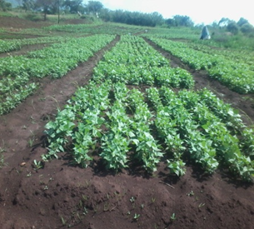  (a) | 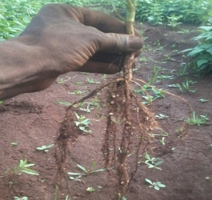  (b) | 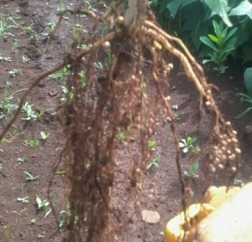  (c)
Figure 1 Experimental layout (a), effective nodules per plant of haricot bean on the control plot (b), and effective nodules per plant of haricot bean when applying 5tha⁻¹ and 100kgha⁻¹ TSP in the eastern Ethiopian highlands.

Recent Publications
- Alhrout, H. H., Aldalin, H. K. H., Haddad, M. A., Bani-Hani, N. M., & Al-Dalein, S. Y., 2016. The impact of organic and inorganic fertilizer on yield and yield components of common bean (Phaseolus vulgaris). Advances in Environmental Biology, 10(9): 8-14.
- Tesfaye Dejene, Tamado Tana and Elias Urage., 2016. Response of common bean (Phaseolus vulgaris l.) to application of lime and phosphorus on acidic soil of Areka, southern Ethiopia. Journal of Natural Sciences Research, 6 (19):2224-3186
- Walelign Worku., 2014. Sequential intercropping of common bean and mung bean with maize in Southern, Ethiopia. Experimental agriculture, 50(1): 90-108.
- Wondwosen Wondimu & Tamado Tana., 2017. Yield response of Common bean (Phaseolus vulgaris L.) Varieties to combined application of Nitrogen and Phosphorus fertilizers at Mechara, Eastern Ethiopia. Journal Plant Biology & Soil Health, 4(2): 7.
- Wondwosen Wondimu, Abebe Bogale, and Tsegaye Babege., 2018. Evaluation of varietal responses for growth, yield and yield components of haricot bean (Phaseolus vulgaris L.) in two districts at Bench-Maji Zone, South west Ethiopia. African Journal of Plant Science.12 (1): 1-6.

Biography
Gebreyohannes Girmay has his expertise in soil fertility management systems focusing on exploring techniques for improving soil quality and health. He teaches and advices post graduate students in the soil science, dryland ecology and resource management, dryland agronomy, sustainable watershed management, and dryland agroforestry and land restoration programmes in Mekelle University, Ethiopia. His current research activities focus on integrated soil fertility management, carbon sequestration in soils, reservoir conservation and sediment use, and land evaluation for irrigation.
Email: gebreyohannes.girmay@gmail.com

Notes/Comments:

