A Nature-based Approach for Managing Invaded Rangelands
Issakwisa B. Ngondya, PhD (Biodiversity Conservation & Ecosystem Management), the Nelson Mandela African Institution of Science and Technology (NM-AIST), Arusha-Tanzania

Abstract
Statement of the Problem: Over decades invasive plants have been reported to exert negative pressure on native plants and hence devastating the stability and productivity of the receiving ecosystems. They have also been reported to affect soil characteristics therefore further jeopardizing ecosystem sustainability. These effects are usually irreversible if appropriate actions cannot be taken immediately after invasion, resulting in high cost of managing them. Further, managing invaded rangelands has been challenging due to higher cost of using chemical herbicides and their unpredicted effects on native plants and environment. The nature based approach for managing invaded rangelands highlights on the utilization of a natural occurring phenomenon responsible for ecosystem formulation on restoration of invaded rangelands. As a low cost and low impact management approach, the approach provides for a sustainable and ecologically friendly approach for managing invaded rangelands for improved productivity.
Methodology & Theoretical Orientation: Series of experiments were conducted in screen house and demonstration plots at NM-AIST on the effects of utilizing native fodder crops Cynodon dactylon and Desmodium intortum in restoring Gutenbergia cordifolia, Tagetes minuta and Bidens schimperi invaded rangelands. The study was (is) further under pilot in the field (Ngorongoro Conservation Area (NCA)) before scaling up into restoration of larger area of the invaded NCA.
Findings: As expected in pilot restoration plots we could see under higher treatment of D. intortum crude extract and reseeding of both C. dactylon and D. intortum
- Reduction of invasive plants; G. cordifolia and B. schimperi ground cover
- Improvement of overall native plant cover
- Improvement of species diversity
Conclusion & Significance: Therefore, preliminary results suggest that competitiveness of native plants such as Cynodon dactylon that can out-compete invasive plants, allelopathic effects from leaf crude extracts and reseeding of fodder crops such as Desmodium spp presents an opportunity for the successful restoration of B. schimperi, T. minuta and G. cordifolia invaded rangelands for improved rangeland productivity.

Image
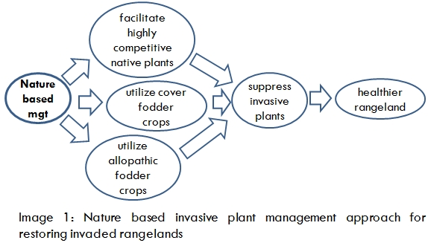
Recent Publications
- Issakwisa Ngondya, Anna Treydte, Patrick Ndakidemi and Linus Munishi (2019). Can Cynodon dactylon be used to suppress invasive weeds? Competition experiments with Tagetes minuta and Gutenbergia cordifolia in Tanzania. International Journal of Pest Management. In press

William Blake, Issakwisa Ngondya, et., al (2018). Soil erosion in East Africa: an interdisciplinary approach to realizing pastoral land management change. Environmental Research Letters 13: 124014
- Issakwisa Ngondya, Anna Treydte, Patrick Ndakidemi and Linus Munishi (2017). Invasive plants: Ecological effects, status, management challenges in Tanzania and the way forward. Journal of Biodiversity and Environmental Sciences 10(3): 204-217.
- Issakwisa Ngondya, Linus Munishi, Anna Treydte and Patrick Ndakidemi (2016). A nature based approach for managing the invasive weed species Gutenbergia cordifolia for sustainable rangeland management. Springer Plus 5: 1787.
- Issakwisa Ngondya, Linus Munishi, Anna Treydte and Patrick Ndakidemi (2016). Demonstrative effects of crude extracts of Desmodium spp. to fight against the invasive weed species Tagetes minuta. Acta Ecologica Sinica 36: 113- 118.


Issakwisa B. Ngondya is an expert in Nature based restoration of invaded rangelands. His passion is to witness healthy rangelands for both conservation and improved livelihood. His Nature based approach for restoring invaded rangelands is based on the process of plant-plant competition of nutrients, space and allelopathy. The approach was developed following series of experiments (laboratory, screen house and demo-plots at NM-AIST, Arusha Tanzania) during his four years of Doctoral studying and is now under pilot (in the field-within Ngorongoro Conservation Area (NCA), Arusha-Tanzania) before scaling up in Tanzanian invaded rangelands. Currently the approach is responsive to most of problematic invasive plants of the family Asteraceae.
Email: ngondyai@nm-aist.ac.tz

