Research Center on Metagenomics and Bioprospecting in the Cerrado Biome
(RCMB)
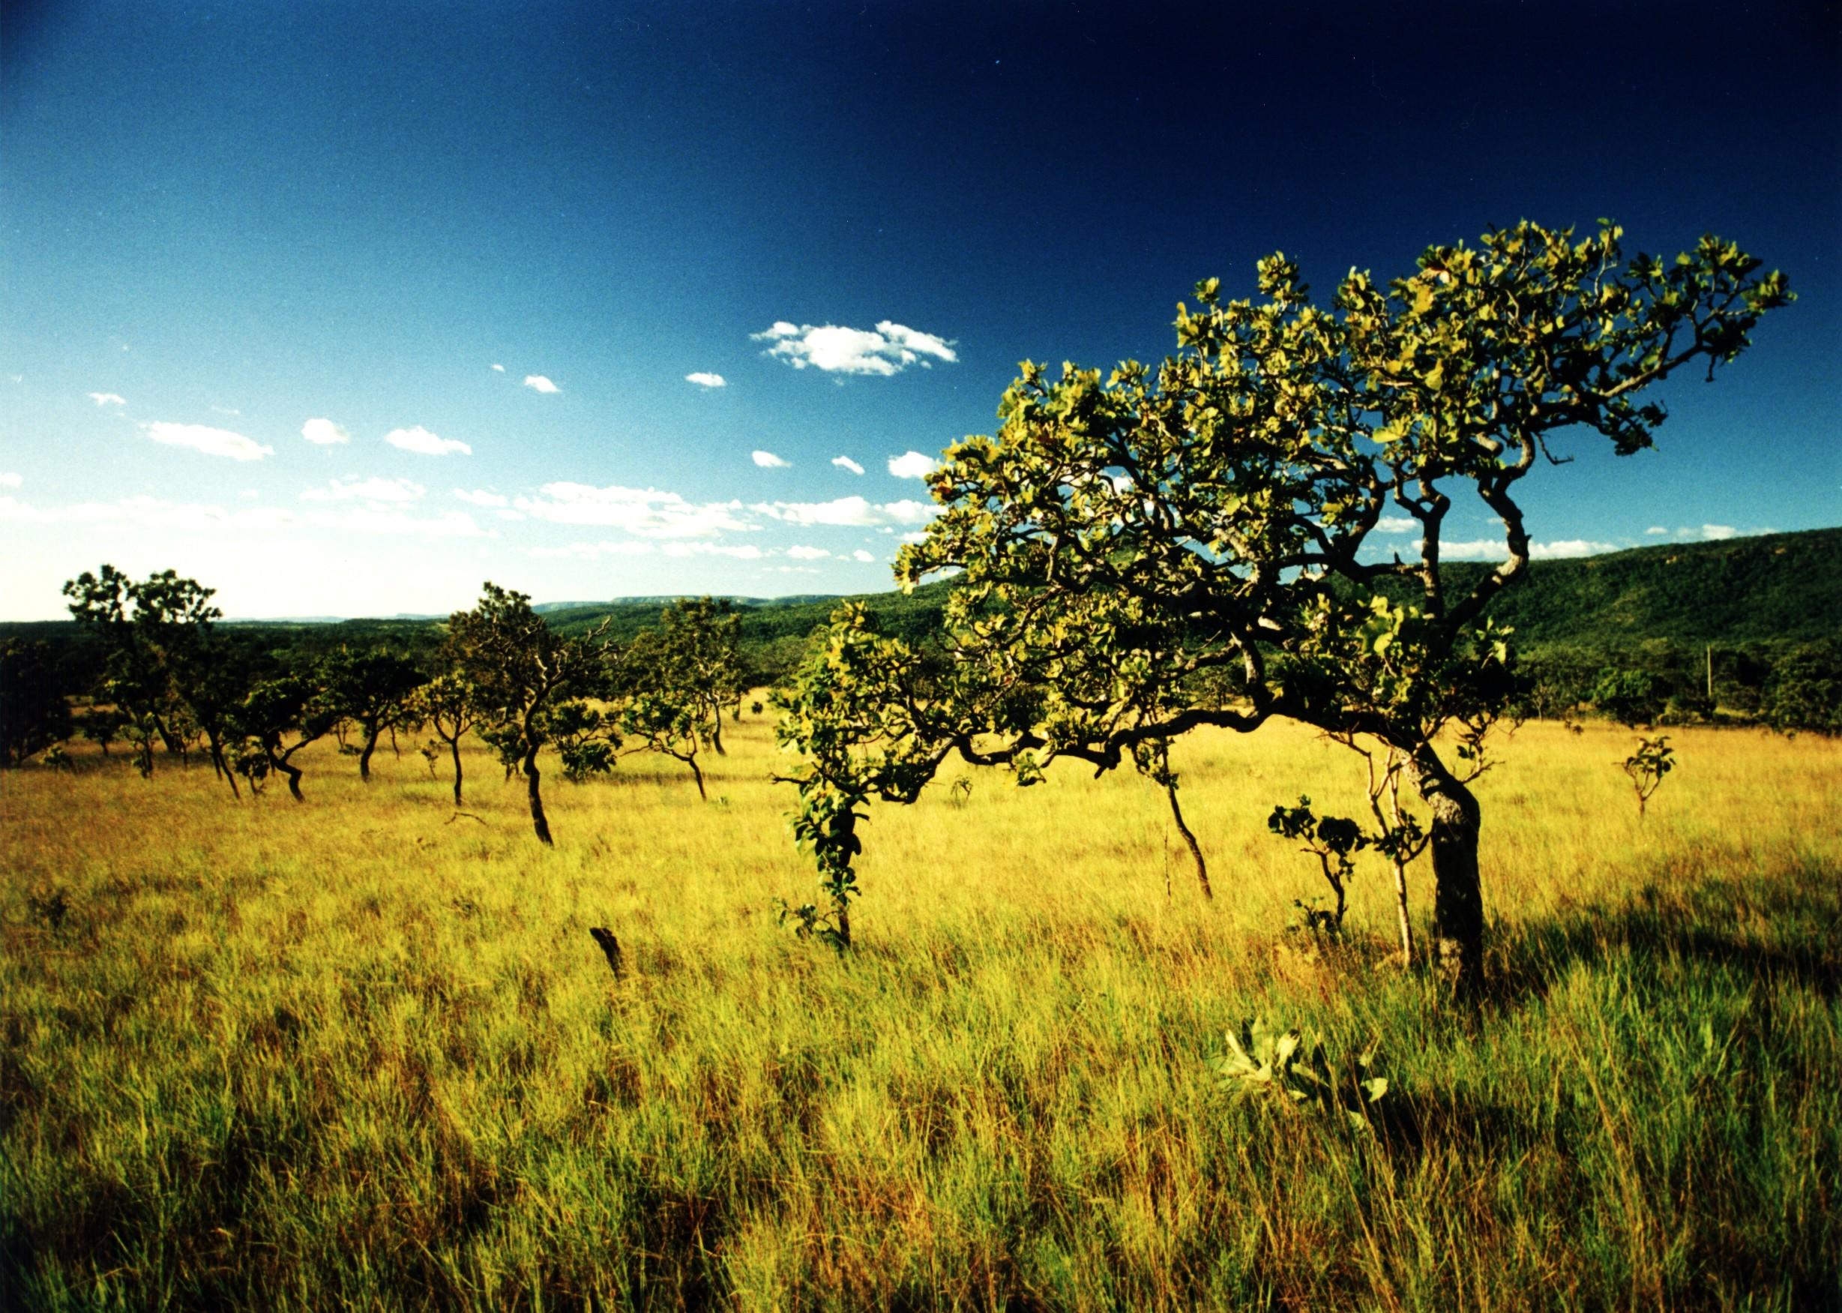

The project for the Research Center on Metagenomics and Bioprospecting in the Cerrado Biome (RCMB) is a non-for-profit initiative proposed by the Instituto Ecológica Palmas – a Brazilian NGO created in 2000 with the mission of mitigating the effects of climate change and protecting biodiversity through scientific research, environmental conservation, and community-directedsustainability activities.

The project emerges as a biotechnology prospecting strategy of new genes, enzymes, bioactive metabolites and drugs in unexplored ecosystems, namely ecotone savannas in the State of Tocantins. Metagenomics and Bioprospecting activities for the discovery of new substances of industrial interest have spurred many investments of this nature in various regions of the world. Recent examples are Costa Rica and Thailand, where huge investments were made in research, development of new pharmaceuticals, intensification of bio- entrepreneurship and creation of biotech companies.

The proposed research will include bioprospection of new molecules and screening for potentially high valuable products. For this, due to the implementation of state-of-the art technologies and high-tech installations, only minimum quantities of biological material shall be necessary (a few grams). This approach thus enables a sustainable bioprospecting of biodiversity components. Therefore, this technology is important in exploring genetic resources, conducting ecology studies and bioprospecting insensitive environments subjected to human intervention or in environmental protection areas.
The model proposes to integrate the Center research activities and business incubators focused on bioprospecting, biotechnology and development of innovative products of biological origin. This will create significant knowhow and synergies that have the potential to generate relevant economic benefits for the region.
This proposal details the two components that form the pillars of the integrated RCMB: the construction of the center (administrative structure and laboratories) and the incubators/accelerators to stimulate entrepreneurship of small and medium enterprises in this sector.
This initiative also aims to promote bio-entrepreneurship in the biodiversity sector following the recently created Brazilian Laws and public policies on Biodiversity.

Most of the biomass present in the planet is in the form of microorganisms. Recent molecular studies indicate that 1 g of soil may contain about 10 billion cells and thousands of microbial species. The discovery that the vast majority of these microorganisms are not cultivable (<1%) stimulated the development of technologies for culture-independent molecular studies (metagenomics).
Currently, metagenomics arises as the main method of biotechnological search for new genes, enzymes and bioactive drugs. Metagenomics-based bioprospecting activity and the discovery of new substances of industrial interest has stimulated huge investments in research and the creation of several biotechnology companies worldwide.
Large pharmaceutical companies, for instance, often hire small and medium enterprises to bioprospect for new molecules and to do the initial screening for potentially valuable products.
The South Amazon Ecotone is located at the contact region between the Cerrado and the Amazon forest, and is commonly defined as the Amazonian savannas. The climate and geological characteristics of this region enable the development of a complex and sensitive biotic system and high level of endemism. This system depends on microorganisms to maintain the essential ecological processes. In general, the various interactions that occur between microorganisms and the environment (e.g. nutrient cycling) and other macro-organisms (e.g. symbionts) are considered essential to maintaining the health of ecosystems. Studies conducted at the beginning of this millennium, indicate that the Brazilian Cerrado belongs to the group of 25 “hotspots”recognized as the main centers of biodiversity in the world.

The environmental conditions that enable the development of ecotone unique gene pools probably hold immeasurable potential for biotechnology. However, the biotechnological potential associated with this diversity is still mostly unknown as the Amazonian savannas have been poorly studied.
This project proposes the creation of a research Center for Metagenomics and Bioprospecting in Cerrado (RCMB). Its main task will be to promote the bio-entrepreneurship, study, conservation and sustainable management of the Cerrado and its transition ecosystems.

