Maritime transport and Aquaculture as an inadvertent vectors of amphipod species occurring in Bizerte lagoon (North Tunisia, South Mediterranean Sea)
Marwa khammassi, PhD, Tunisia
Sarra Labidi, PhD, Tunisia
Mohamed sghaeir Achouri, Professor in ecology, Tunisia

Statement of the Problem : Determination of the vector and pathway of non-indigenous species is a valuable tool to management and control efforts (Ruiz and Carlton, 2003). In fact, the development of a navigable water network allowed larger vessels, with large loads of ballast water, into the Bizerte lagoon as well as the commercial transport of aquaculture species favors the introduction of non-indigenous species (NIS).
The purpose of this study is to determinate the vectors favors the entry of benthic species on Tunisian lagoons. Hence, here the goal is to report amphipods data collected from Bizerte lagoon and to provide a comparative analysis of previous inventories performed in the lagoon, the new records and the geographical range extensions
Methodology & Theoretical Orientation: Samplings were carried out at 33 stations in April and July during two consecutive years (2016 and 2017) differing in altitude, and a vast variety of habitats (sediment, macroalgae and seagrass) were sampled.
Findings: A total of 18 amphipod species were recorded. Among them, 9 species were reported for the first time: Monocorophium insidiosum, Leucothoe incisia, Melita palmata, Maera inaequipes, Caprella scaura, Elasmopus Pectenicrus, Lysianasa costae, Serejohyale spinidactylus and Jassa marmorata. The classification of species in geographical distribution group shows that most species have an Atlantic–Mediterranean distribution (66.6%), followed by cosmopolitan species and lessepsian species having 16.66% with 3 species for each group (figure 1).
Conclusion & Significance: the development of navigable water network and the commercial transport of aquaculture species has opened the lagoon both to international trade and introduction of non-indigenous species. This is particularly relevant to the Bizerte lagoon where the introduction of NIS has involved a variety of vectors and pathways that have changed over time.
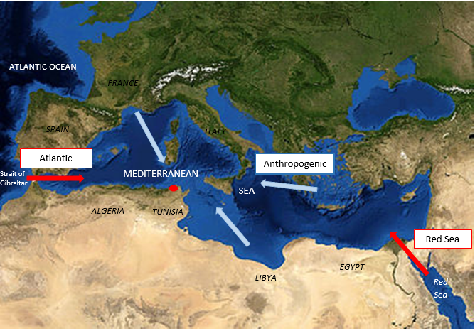
Figure1: possible ways favors the introduction of new species of amphipods in Bizerte lagoon ( Bizerte lagoon)

Refernce:
Ruiz GM, Carlton JT (2003) Invasion vectors: a conceptual framework for management. Invasive species: vectors and management strategies (ed. by G.M. Ruiz and J.T. Carlton). Island Press, Washington, D.C. 459–504.



Biography
Marwa khammassi is a Tunisian PhD student in Biology at the University of El Manar Tunis (Tunisia), member of the laboratory of diversity management and conservation of biological systems.His research mainly dealt with characterizing the distribution of benthic macrofauna marine traffic-related in southern Mediterranean lagoon (Tunisia, Bizerte lagoon). Marwa plans to continue his work on use of the macrobenthic fauna as biological indicators of pollution in Tunisa and is interested in assessing the implications of environemental policies on aquatic environement quality.
Email:kh-marwa@hotmail.fr

Notes/Comments:

