Intraspecific trait variation improves species response to neighborhood crowding and abiotic factors
Zhanqing Hao, PhD, Shenyang Institute of Applied Ecology, Chinese Academy of Sciences
Shuai Fang, PhD, Shenyang Institute of Applied Ecology, Chinese Academy of Sciences

Abstract (300 word limit)
Intraspecific trait variation (ITV) can play an important role in community assembly and the maintenance of biodiversity. However, fundamental gaps remain in our understanding of how ITV affect species dynamics and mediate species response to biotic and abiotic constrains. We developed a hierarchical Bayesian neighborhood modeling approach to quantify the simultaneous effects of climate factors and crowding by neighbors on the survival 97 tropical tree species located in eleven 0.5-1ha plots of temperate forest in northeast China. We build multi-level regression models to evaluate how key leaf functional traits mediate tree survival response to climate factors and neighborhood crowding. Specifically, we contrasted results from mean and habitat specialized trait values. With the increase of the annual minimum temperature, the survival rate of trees increased, suggesting that low temperature stress can significantly inhibit tree survival. However, water stress has no significant impact on tree survival. Trees had higher survival when the heterogenetic neighborhood increased, while conspecific neighborhood had no influence on tree survival. Species with high leaf area and high leaf nitrogen content had lower survival rates, while species with high leaf carbon isotope content and high leaf carbon content had higher survival rates. The species with higher leaf carbon stable isotope were not sensitive to the promotion effect of heterogenetic neighborhood, while the species with larger area was not sensitive to the inhibition of low temperature. In addition, considering intraspecific trait variation can significantly improve the predictive ability of functional traits and more accurately reflect the response of trees to neighborhood composition and abiotic factors.

Image

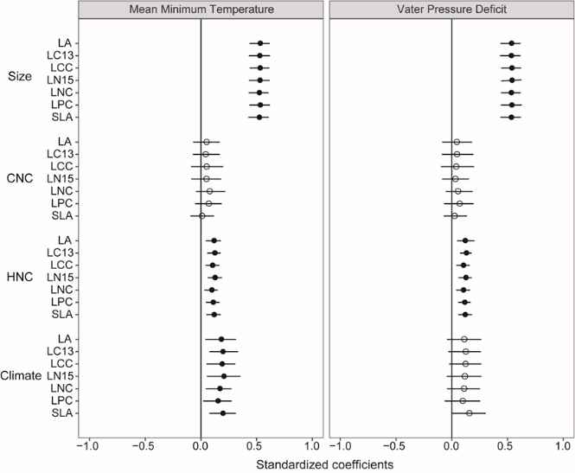
Recent Publications (minimum 5)
- X Wang, T Wiegand, NG Swenson et al.,(2015) Mechanisms underlying local functional and phylogenetic beta diversity in two temperate forests. Ecology 96 (4), 1062-1073
- X Wang, T Wiegand, NJB Kraft et al., (2016) Stochastic dilution effects weaken deterministic effects of niche‐based processes in species rich forests. Ecology 97 (2), 347-360
- Jia S, Wang X, Yuan Z, et al. Global signal of top-down control of terrestrial plant communities by herbivores[J]. Proceedings of the National Academy of Sciences, 2018, 115(24): 6237-6242.
- 2. Yuan Z, Wang S, Ali A, et al. Aboveground carbon storage is driven by functional trait composition and stand structural attributes rather than biodiversity in temperate mixed forests recovering from disturbances[J]. Annals of Forest Science, 2018, 75(3): 67.
- Wang, X., et al. (2018). "Ecological drivers of spatial community dissimilarity, species replacement and species nestedness across temperate forests." Global ecology and biogeography.

Biography (150 word limit)
Prof. Zhanqing Hao focused on the biodiversity and ecological functions. As one of the Chinese scientists who participated in biodiversity research, he initiated the establishment of 25ha temperate permanent monitoring forest plot in Northeast China in 2004, which is the earliest temperate forest plot in china and had been an important member of Chinese Forest Biodiversity Monitoring Network (CForBio). After that, a series of forest plots had been established along successional stages and latitude gradients. All those forest plot provided great opportunity to detect the biodiversity patterns and maintaining mechanisms in temperate forests.
Email: hzq@iae.ac.cn

Notes/Comments:

