Biodiversity as an economic value for the protection of ecosystems

Oldemar Carvalho Junior, Instituto Ekko Brasil, Brazil
Alesandra Bez Birolo, Instituto Ekko Brasil, Brazil

Abstract
Statement of the problem: The preservation of ecosystems requires a significant demand for resources, such as personal, financial and infrastructure, which are increasingly difficult to justify due to lack of sustainability and restrictions of use. Tourism could be a good response, however, while goods and services that support visitation are relatively easy to account, other less tangible environmental services, such as biodiversity, can be difficult to be valued. To evaluate these assets is important in order to take the best decisions for ecosystem management. In this work emergy is applied to evaluate the natural capital, in a conservation area in the south of Brazil. The objective is to be able to predict the economic and environmental viability of the study area for a conservation tourism proposal. Methodology & Theoretical Orientation: To place the value of biodiversity in perspective, emergy synthesis of the main storages and ecological processes in the study area are calculated. For the evaluation of renewable inputs to the Peri Lake, solar energy, rainfall, runoff, and wind annual averages are used. Findings: The highest value is recorded for biodiversity ($354 billion), shrub and herbaceous vegetation represents $14 billion emdollars, tree biomass $5.7 billion emdollars, and water extracted for supply $12,4 thousand emdollars. Conclusion & Significance: Biodiversity clearly dominates the environmental assets of the study area. Biodiversity represents the information of the ecosystem reflected in the diversity of the species. It also results in a large input of grants from sponsors, driving most of the research in the area. These results show that the local government strategy, focused only on water extraction is not a good one. Tourism conservation based on natural assets, for example, could be much more attractive.

Image
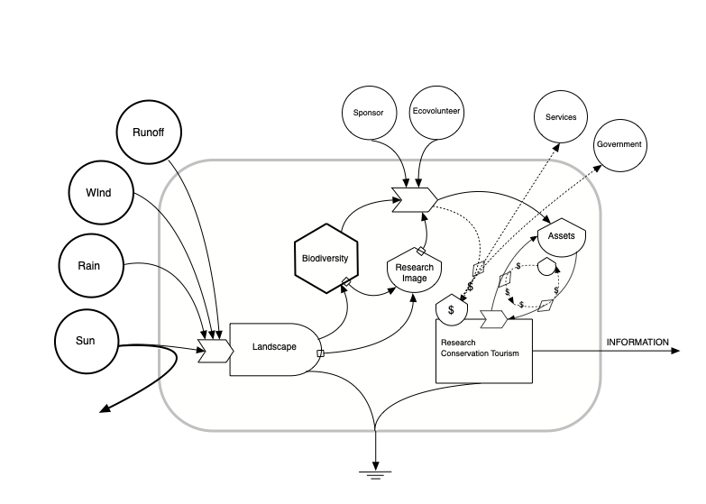

Figure 1. Energy-flow model for the study area, showing main driving energies, components, pathways of energy, material and information flows, and exports, taking into consideration the biodiversity.

Recent Publications

- Carvalho Junior O, SilvaC, PereiraW, FonsecaVC, BiroloAB (2017) Environmental accounting of natural capital and ecosystem services for the Aquidauana River, Southern Pantanal, Brazil. Wulfenia 24 9.
- Carvalho Junior O (2016) Emergy Analysis of the Peri Lake System and the Role of the Neotropical Otter. IJRRAS 29(1): 31-54.
- Marmontel M, CalvimontesU, Carvalho-JuniorO (2015) Rediscovery of Pteronura brasiliensis in the Amanã Sustainable Development Reserve, Amazonas, Brazil. Latin American Journal of Aquatic Mammals 10(2): 147-151.
- Carvalho-Junior O, DutraPPC, AlvesV, RamosPR (2014) Projeto Ariranha: aplicação do gerenciamento de projetos visando à conservação da biodiversidade. Navus - Revista de Gestão e Tecnologia 4(2):33-49.
- Rodrigues LAR, LeuchtenbergerC, KasperCB, Carvalho-JuniorO, Fonseca da SilvaVC (2013) .Avaliação do risco de extinção da Lontra neotropical Lontra longicaudis (Olfers, 1818) no Brasil. Biodiversidade Brasileira 3(1): 216-227.

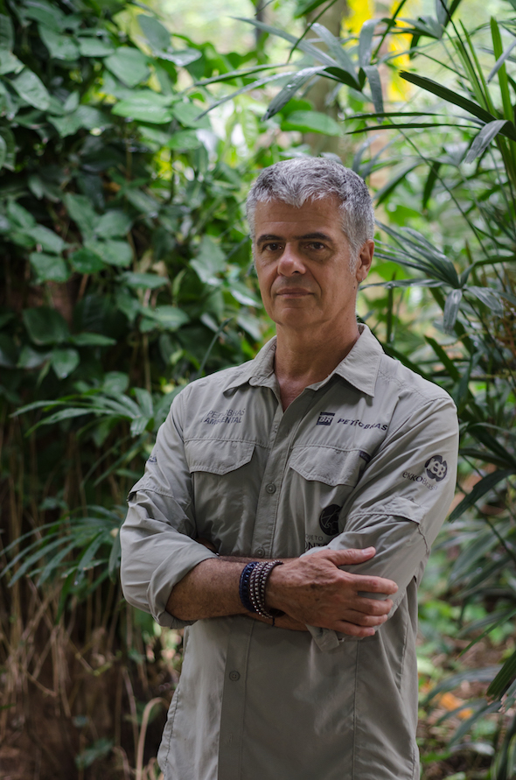 Biography

Oldemar Carvalho Junior has his expertise in Neotropical otters, energetic modeling and physics of the environment. He is responsible for implementing the first and only Latin America Scientific Breeding for Research of the Mustelidae family. Over the past 10 years, he has worked with animal research in captivity and in the wild, in two major Brazilian biomes: the Coastal Zone of Atlantic Forest and the Pantanal. Due to the excellent results obtained he was invited to coordinate the Neotropical Otter Sub-group in Latin America by the IUCN (The International Union for Conservation of Nature). During his professional and academic career, he has received some awards such as the Professional Talent in 2012, Expression in Ecology in 2008 and he was appointed to the Brazilian Immortal Prize in 2008.

