Urban woodlands as outlier populations for forest migration under climate change
Qiyao Han, PhD candidate, Queen’s University Belfast, UK
Greg Keeffe, Professor, Queen’s University Belfast, UK

Abstract (300 word limit)
In response to the rapid climate change, many tree species will have to move towards the poles at a rate far beyond their normal speeds. Although modern cities are always considered as non-permeable barriers to such movements, they simultaneously create an “inadvertent” modification of the climate (urban heat island effect) that tree species could take advantage to catch up with the changing climate. This study discusses the importance of urban woodlands for the climate-driven migration of trees. The result demonstrates the potential of urban woodlands to serve as outlier tree populations as well as seed dispersal pathways for forest migration. Since cities with urban heat island effects are already ahead of current temperatures, they could provide a more beneficial microclimate than their surroundings for the survival of outlier tree populations in front of their natural ranges, from witch species would move following the paths of their dispersal agents. On the other hand, the effects of urban heat island would concurrently be mitigated by the cooling effects of trees, resulting in a comparatively stable microclimatic condition under global climate change, which in turn allows these outlier populations to grow for decades to reach reproductive maturity. In conclusion, we suggest that tree species should be strategically relocated to the city in front of their natural ranges, in order to facilitate the process of forest migration.
Image
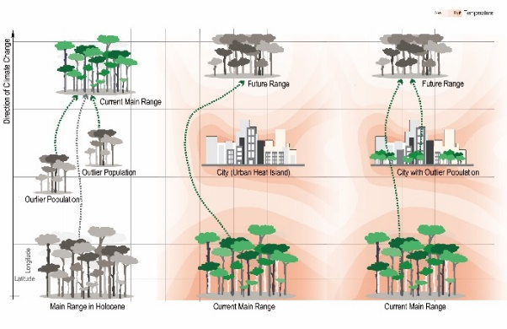

Figure. Illustration of the potential of urban woodlands to serve as outlier tree populations for forest migration.
Recent Publications (minimum 5)
- Dyderski Marcin K., Paź Sonia, Frelich Lee E., and Jagodziński Andrzej M., "How Much Does Climate Change Threaten European Forest Tree Species Distributions?" Global Change Biology 24, no. 3 (October 2018): 1150-63.
- Eli D. Lazarus and Brian J. McGill, "Pushing the Pace of Tree Species Migration." PLOS ONE 9, no. 8 (August 2014): e105380.
- C. W. Woodall, D. J. Nowak, G. C. Liknes, and J. A. Westfall, "Assessing the Potential for Urban Trees to Facilitate Forest Tree Migration in the Eastern United States." Forest Ecology and Management 259, no. 8 (March 2010): 1447-54.
- Jonathan Lenoir, Tarek Hattab, and Guillaume Pierre, "Climatic Microrefugia under Anthropogenic Climate Change: Implications for Species Redistribution." Ecography 40, no. 2 (November 2017): 253-66.
- Juvenal Lopez and Judy L. Stone, "Single Planting Creates Expanding Naturalized Population of Quercus Palustris Far from Its Native Range Limit." Rhodora 120, no. 982 (April-June 2018): 143-53.

 Biography (150 word limit)

Qiyao Han holds an undergraduate and master’s degree in Landscape Architecture. Currently, she is an Architecture PhD student at the School of Natural and Built Environment, Queen’s University Belfast, working on “Mapping the flow of forest migration through the city under climate change”, funded by the China Scholarship Council. Email: qhan01@qub.ac.uk
Greg Keeffe is an academic and urban designer with 25 years’ experience in sustainability, energy use and its impact on the design of built form and urban space. He is The Head of the School of Natural and Built Environment at Queens and a Professor of Sustainable Architecture. He has extensive experience of working closely with architects and planners to develop exciting ways of re-invigorating the city through the application of innovative sustainable technologies, informing his work on the sustainable city as synergistic super-organism. In this way, he has sought to develop a series of theoretical hypotheses about our future existence on the planet, through a series of technological and spatial interventions. Most of his work comes out of a free-thinking open-ended discussion about how things should be. Email: g.keeffe@qub.ac.uk

Notes/Comments:

