Biochar Utilization: Emerging Technology for Improving Soil Productivity and Mine Spoils Remediation

Gilbert C. Sigua,* Jeff M. Novak, and Mark Johnson USDA-ARS, Florence, South Carolina, USA 29501; EPA, Corvallis, Oregon, USA 97333

Abstract
Recycling and using raw materials from the waste we generate are some of the environmental challenge that we face today. Promotion of innovative and appropriate technologies is necessary to achieve sound and sustainable natural resources management. Biochar production using pyrolysis technology can utilize most urban, agricultural or forestry biomass residues, including wood chips, corn stover, rice or peanut hulls, tree bark, paper mill sludge, animal manure, and many other recycled organics for improving soil quality and soil remediation. Biochars as specialized soil amendments can provide multifunctional roles with remarkable agronomic and environmental significance. The use of biochar and other organic amendments for mine spoil remediation are still unclear. Phytostabilization can be enhanced by using soil amendments like biochars that immobilize metal(loid)s when combined with plant species that are tolerant of high levels of contaminants. Our biochars studies demonstrated the favorable and beneficial effects of different designer biochars on soil productivity and phytostabilization of heavy metals in contaminated mine spoils. Application of 80:20 blends of pine chips and poultry litters was found to be superior over other blends of biochars because of its favorable effects on soil and biomass productivity and nutrient uptake of winter wheat. Our research investigations have also confirmed that biochars have binding mechanisms to sequester metals. Recently, biochars ability to sequester metals has caught the attention of the mine reclamation sector. It is proposed that biochar is a suitable amendment to remediate heavy metals in mine spoils, as well as improve chemical conditions for enhanced plant growth. Better plant growth will improve phytostabilization, increase containment of metal-laden sediment, while also reducing potential metal uptake by plants. As such, utilization of a biochar with appropriate chemical and physical characteristics is crucial for effective binding of heavy metals while also improving plant growth conditions in the mine spoils.

 Dr. Gilbert C. Sigua is a Research Soil Scientist at the USDA-ARS Coastal Plains Soil, Water, and Plant Research Center in Florence, South Carolina, USA. His research program focuses on both the short-term and long-term solutions to enhancing agricultural and environmental sustainability and improving water and nutrient management in humid region. Gilbert is a nationally and internationally recognized expert and authority in his field because of his work on agricultural, ecological, and environmental management research as evidenced by his various international projects in Brazil, Australia, Philippines, Japan and Cambodia. Dr. Sigua’s scholarly achievements and expertise have been widely recognized through numerous honors and awards. As a testimony to this, he was recently awarded major fellowship awards, to wit: (a) Fellow of American Society of Agronomy; (b) Fulbright Fellow; (c) Japan Society for Promotion of Science Fellow; (d) DOST “Balik Scientist” Fellow; and (e) Fellow of Soil Science Society of America.

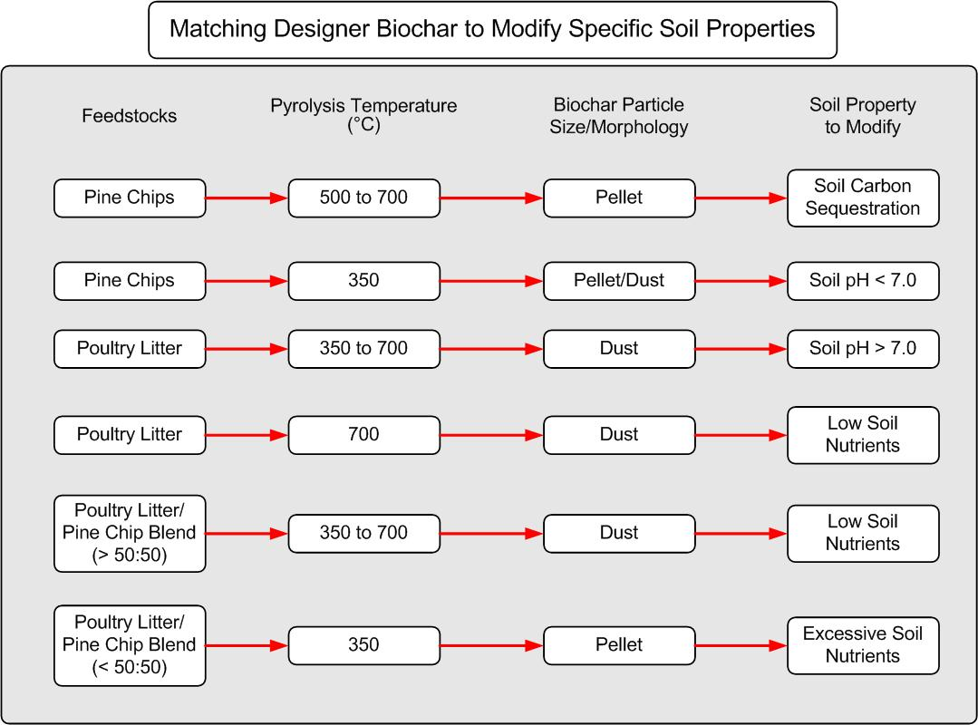
Recent Publications:
- Sigua, G.C., Hunt, P.G., Stone, K.C., Cantrell, K.B., and Novak, J.M. 2014. Contrasting effects of sorghum biochars and sorghum residues on soil chemical changes of Coastal Plains Ultisols with winter wheat. Soil Sci. 179(8): 369-408.
- Novak, J.M., Sigua, G.C., Busscher, W.J., Cantrell, K.B., Watts, D.W., Glaz, B., and Hunt, P.G. 2015. Plant macro and micro-nutrient dynamics in a biochar-amended wetland muck. Water, Air, and Soil Pollution. DOI:10.1007/s11270-014-2228-y.
- Sigua, G.C., Hunt, P.G., Stone, K.C., Cantrell, K.B., and Novak, J.M. 2015. Increasing biomass of winter wheat using sorghum biochars. Agron Sustainable Develoment. 35:739-748.
- Sigua, G.C., Novak, J.M., and Watts. D. 2016. Ameliorating soil chemical proerties of a hard setting subsoil layer in coastal plain USA with different designer biochars. Chemosphere. Chemosphere 142: 168-175.
- Sigua, G.C. Novak, J. Watts, D., and Johnson, M. 2016. Efficacies of designer biochars in improving biomass and nutrient uptake of winter wheat grown in a hard setting subsoil layer. Chemosphere. 142: 176-183.
- Sigua, G. C., Novak, J.M. Watts, D.W., Szogi, A.A., Shumaker, P.D. 2016. Impact of switchgrass biochars with supplemental nitrogen on carbon-nitrogen mineralization in highly weathered coastal plains ultisols. Chemosphere. 145: 135-141.
- Novak, J.M., Ippolito, J.A., Ducey, T.F., Watts, D.W., Trippe, K.M., Spokas, K.A., Sigua, G.C., and Johnson, M.G. 2018. Remediation of an acidic mine spoil: Miscanthus biochar and lime amendment affects metal availability, plant growth, and soil enzyme activity. Chemopshere. doi:10.1016/j.chemosphere.2018.04.107.

