Abstract

Title: A different approach: Biostimulants in seed treatment as plant defence elicitors against insects

HAAS J¹
¹Laboratory of Biological Control, Department of Biology, Federal University of Technology – Parana (UTFPR), Campus Dois Vizinhos, Brazil

- Abstract Body
The definition for biostimulants is fluid and complex, but it is agreed that biostimulants are substances from biological origin that improves plant productivity. These substances may be applied to the soil or directly to the plant and they stimulate nutrient uptake/efficiency and tolerance to abiotic stress, leading to better crop quality and yield. In this process, biostimulants can affect gene expression creating a long-term effect. Even though these substances are not directly related to enhancing plant resistance to biotic stress caused by pathogens and herbivores, this aspect is yet to be explored. As some biostimulants can regulate gene expression and influence plant metabolism, they might as well induce the production of physical barriers or metabolites that negatively affect harmful organisms. There is some information regarding how pathogens are affected, but insect pests have been mostly set aside. So far, we know that different fertilizer treatments lead the plant to produce chemicals that affect pests and may even attract natural enemies; also, that plants developed from cabbage seeds treated with chitosan negatively impact Plutella xylostella. Considering all these facts, some biostimulants could be used for priming plants against insect pests, working as a vaccine: primed plants show fast/strong activation of defence responses when challenged by biotic stress. This line of research could result in better understanding of how biostimulants affect insect-plant interactions. In a more practical view, it could lead to new uses for existent commercialised products or even to the development of new ones that could take part in a more sustainable and clean agriculture.

Keywords: priming, seed treatment, sustainable agriculture, biotic stress

- Image:
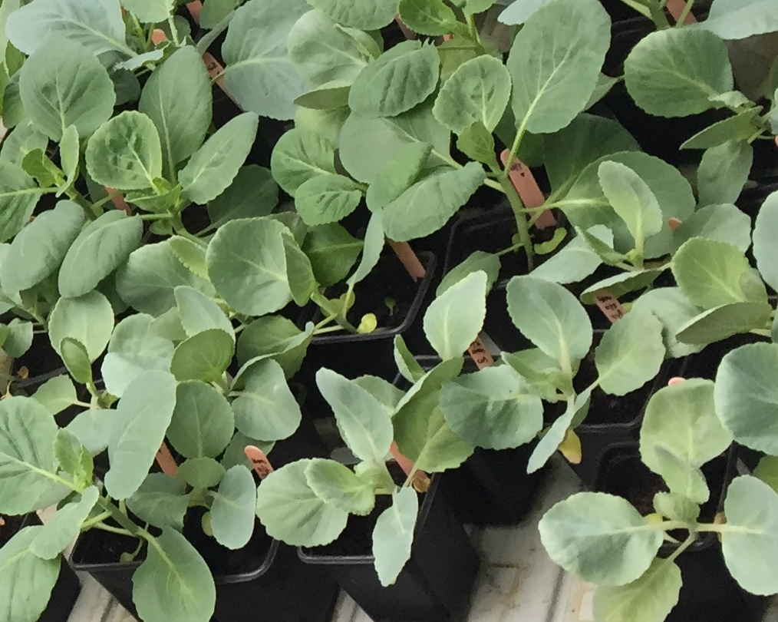
Brassica oleracea plants developed from seeds treated with chitosan

- Reference:
- Billard, V., P. Etienne, L. Jannin, M. Garnica, F. Cruz, J-M. Garcia-Mina, J-C. Yvin and A. Ourry, 2014. Two Biostimulants Derived from Algae or Humic Acid Induce Similar Responses in the Mineral Content and Gene Expression of Winter Oilseed Rape (Brassica napus L.). J Plant Growth Regul., 33: 305.
- Haas, J., E.R. Lozano, E.S. Vismara, S.M. Mazaro and G.M. Poppy, 2018. Getting ready for battle: Do cabbage seeds treated with jasmonic acid and chitosan affect chewing and sap-feeding insects performance? Ent. Exp. App., p. 1-8.
- Savvides, A., S. Ali, M. Tester and V. Fotopoulos, 2016. Chemical Priming of Plants Against Multiple Abiotic Stresses: Mission Possible? Trends Plant Sci., 21: 329-340.
- Walters, D.R., J. Ratsep and D. Havis, 2013. Controlling crop diseases using induced resistance: challenges for the future. J. Exp. Bot., 64: 1263-1280.

- Biography:
Jucelaine Haas has completed her PhD at the age of 34 years from the Federal University of Technology – Parana (UTFPR), Brazil. She is a Professor of Entomology at UTFPR.
- Presenting author details



Full Name: Jucelaine Haas
Contact number: +5546991322134
Twitter account: @jucelainehaas
Linked In account: https://www.linkedin.com/in/jucelaine-haas-41a39712/
Session name/ number:
Category: Oral presentation
Passport Number: FR534217

