Title: Structure and Inhibitor Design in Integral Membrane Pyrophosphatases

Goldman A^{1, 2}, Vidilaseris, K², Harborne, SPD¹, Wilkinson, C^{1,}, Turku, A³,
Xhaard, H³, Wilkinson, A⁴, Harris, SA¹, Fishwick, CWG¹, Khattab, A⁵.

¹ Astbury Centre for Structural Molecular Biology, University of Leeds, Leeds, UK
² Program in Molecular and Integrative Biosciences, University of Helsinki, Helsinki, Finland
³ Faculty of Pharmacy, University of Helsinki, Helsinki, Finland
⁴ School of Chemistry, University of Leeds, Leeds, UK
⁵ Haartman Institute, University of Helsinki, Helsinki, Finland

Keywords: Integral membrane pyrophosphatases, Inhibitor Design, Drug Design, X-ray crystallography
- Abstract
Pyrophosphatases (PPases), found in all organisms, are essential enzymes, providing the thermodynamic “pull” for eg DNA synthesis by hydrolysing pyrophosphate. A key question in these – as in all enzymes – is their exact structural mechanism. This requires fleshing out static structures into a dynamic picture of enzyme motion. Membrane-bound pyrophosphatases (mPPases), which couple H⁺/Na⁺ transport to pyrophosphate synthesis/hydrolysis, are important in the infectivity of protozoan parasites. M-PPases have a unique structure with an alternate-access ion pumping mechanism (1).

I will describe the work that led to a thorough model for the mechanism of mPPases and how it differs from other inorganic pyrophosphatases. I will show how three new mPPase structures in different catalytic states indicate that closure of the substrate-binding pocket by helices 5-6 affects helix 13 in the dimer interface, which suggests a possible allosteric mechanism. The closure also leads to a downward motion of helix 12, which springs a “molecular mousetrap”, repositioning a conserved aspartate and activating the nucleophilic water (3). Corkscrew motion at helices 6 and 16 rearranges the key ionic gate residues and leads to ion pumping. The structures, the implied position of the pumped ions in those structures, as well as electrometric data, allow us to propose a full catalytic “binding-change” model, where binding causes pumping, which in turn causes hydrolysis. This model has recently been validated and extended by molecular dynamics (4). Finally, I will discuss our efforts towards developing novel mPPase inhibitors that can kill protozoan parasites (unpubl.).

- Image:

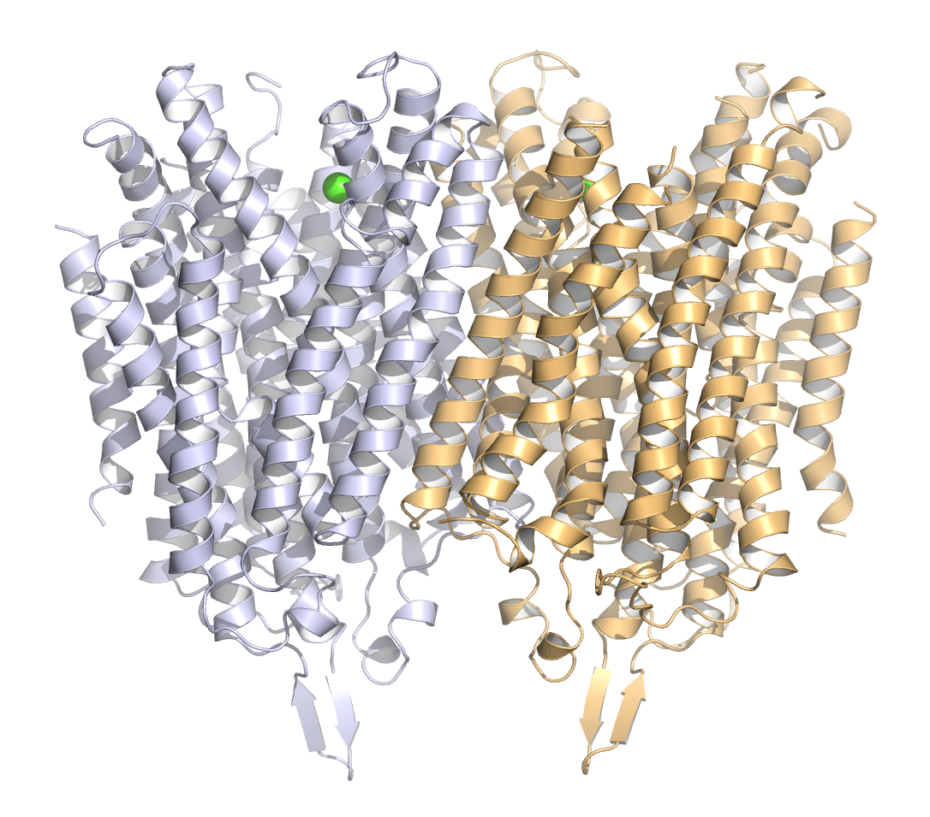

- References:
- Kellosalo, J., Kajander, T., Kogan, K., Pokharel, K. & Goldman, A. The Structure and Catalytic Cycle of a Sodium-Pumping Pyrophosphatase. Science 337, 473–476 (2012).
- Shah, N. R., Wilkinson, C., Harborne, S. P. D., Turku, A., Li, K.-M., Sun, Y.-J., Harris, S. & Goldman, A. Insights into the mechanism of membrane pyrophosphatases by combining experiment and computer simulation. Structural Dynamics 4, 032105 (2017).
- Li, K.-M., Wilkinson, C., Kellosalo, J., Tsai, J. Y., Kajander, T., Jeuken, L. J., Sun, Y.-J. & Goldman, A. Membrane pyrophosphatases from Thermotoga maritima and Vigna radiata suggest a conserved coupling mechanism. Nat Commun 7, 13596 (2016).
- Biography:
Adrian Goldman completed his PhD at the age of 27 in the laboratory of Professor Thomas A. Steitz at Yale University. He has been a faculty member at Rutgers University (1987-1992), the University of Turku (1992-1999) and the University of Helsinki (1999-present). He currently holds joint appointments at the University of Leeds and the University of Helsinki. He has published more than 150 research papers, serves on various editorial boards and has an h-index of 36.

- Presenting author details


Full Name: Adrian Goldman
Contact number: +44 (0)113 343 8537:
Session name/ number:
Category: Oral presentation

