Abstract Template

Title: The structural mechanism of transport by the mitochondrial ADP/ATP carrier

Ruprecht JJ¹, King MS¹, Zögg T^{2,3}, Aleksandrova AA⁴ Pardon E^{2,3}, Crichton PG¹, Steyaert J^{2,3}, Kunji ERS¹

¹MRC Mitochondrial Biology Unit, University of Cambridge, Cambridge Biomedical Campus, Cambridge, CB2 0XY, UK.
²VIB-VUB Center for Structural Biology, VIB, Pleinlaan 2, B-1050 Brussels, Belgium.
³Structural Biology Brussels, Vrije Universiteit Brussel, Pleinlaan 2, B-1050 Brussels, Belgium.
⁴Computational Structural Biology Section, National Institute of Neurological Disorders and Stroke, National Institutes of Health, Bethesda, MD 20892, USA.

Keywords: Oxidative phosphorylation, Transport mechanism, Membrane protein structure, Mitochondria

- Abstract Body:
Mitochondrial ADP/ATP carriers in the inner membrane belong to the mitochondrial carrier family and they transport ADP into the mitochondrial matrix for ATP synthesis, and ATP out to the cytosol to fuel the cell. They cycle between cytoplasmic-open and matrix-open states, in which the substrate-binding site is alternately accessible from either compartment for ADP or ATP binding. We will present data that will resolve their mechanism in atomic detail. In agreement with earlier published data, the structural evidence demonstrates that the carrier functions as a monomer [1] and has a single substrate binding site [2] and two salt bridge networks that regulate access to this site in a conformation-dependent way [2-4]. The structural analysis also explains the role of all conserved sequence features of mitochondrial carriers, showing that the mechanism is universal for this class of transport proteins.

- Image:

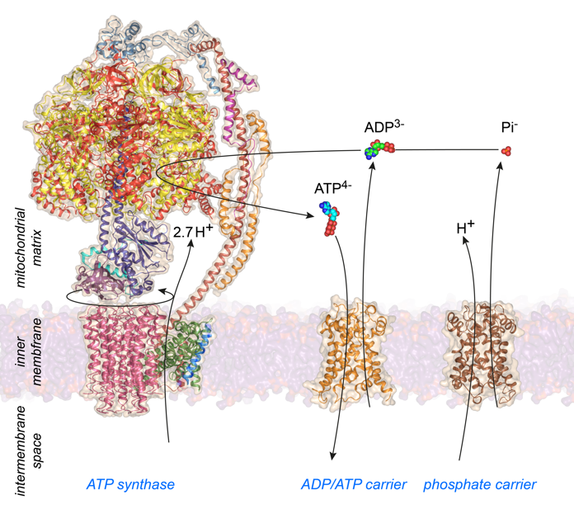

- Reference:
- L. Bamber, M. Harding, M. Monné, D.J. Slotboom, E.R.S. Kunji, The yeast mitochondrial ADP/ATP carrier functions as a monomer in mitochondrial membranes, Proc. Natl. Acad. Sci. U.S.A., 104 (2007) 10830-10834.
- A.J. Robinson, C. Overy, E.R.S. Kunji, The mechanism of transport by mitochondrial carriers based on analysis of symmetry, Proc. Natl. Acad. Sci. U.S.A., 105 (2008) 17766-17771.
- J.J. Ruprecht, A.M. Hellawell, M. Harding, P.G. Crichton, A.J. Mccoy, E.R.S. Kunji, Structures of yeast mitochondrial ADP/ATP carriers support a domain-based alternating-access transport mechanism, Proc. Natl. Acad. Sci. U.S.A, 111 (2014) E426-E434.
- M.S. King, M. Kerr, P.G. Crichton, R. Springett, E.R. Kunji, Formation of a cytoplasmic salt bridge network in the matrix state is a fundamental step in the transport mechanism of the mitochondrial ADP/ATP carrier, Biochim. Biophys. Acta, 1857 (2016) 14-22.

- Biography:
Edmund Kunji holds a Ph.D. in Mathematics and Natural Sciences from the University of Groningen and was an EMBO Postdoctoral Fellow with Richard Henderson at the MRC Laboratory of Molecular Biology, Cambridge. Since 2000, he is a Research Group Leader at the MRC Mitochondrial Biology Unit, University of Cambridge, where he works with his group on structures of transport proteins to elucidate the transport processes in mitochondria.

- Presenting author details


Full Name: Edmund Kunji
Contact number: +44-1223-252850
Twitter account: https://twitter.com/Mitocarriers
Session name/number: Membrane protein structure and function
Category: Oral presentation

