COMPUTATIONAL STUDY OF THE INTERACTIONS BETWEEN HUMAN DEOXYHAEMOGLOBIN AND THE PHYTOCHEMICALS FROM SOME ANTISICKLING PLANTS
Ismaila Olanrewaju Nurain¹; Yang Zhang² and Clement Olatunbosun Bewaji³
¹Department of Medical Biochemistry, School of Basic Medical Sciences, College of Pure and Applied Sciences, Kwara State University Malete. PMB 1530 Ilorin, Kwara State, Nigeria.
²Deparrtment of Computational Medicine and Bioinformatics, University of Michigan, Ann Arbor, Michigan 48109, United States.
³Biochemistry Department, Faculty of Life Science, University of Ilorin, Ilorin, 240103,
Corresponding author: ismaila4u2@yahoo.com
(I) ABSTRACT
Sickle cell disease is a genetic blood disorder that affects the shape and transportation of red blood cells in human blood vessels, leading to various clinical complications. It affects millions of people in the world, claiming huge amount money. In addition to the synthetic drugs, several antisickling plants have been reported for the management of this disease. Although, the antisickling potentials of Cajanus cajan leaf (CCL), seed (CCS), and Zanthoxylum zanthoxyloides leaf (ZZL) have been reported, their mechanisms of actions and interactions with human erythrocytes deoxyhaemoglobin (2HBS) have not been explored. This work therefore investigated, using computational approach, the mechanisms of interactions of these plants with human erythrocytes deoxyhemoglobin. The results depicted that the phytochemicals from CCL, CCS and ZZL that interacted with 2HBS were urs-12-ene, 5-hydroxypentyl-1,3-dimethyl-3,7-dihydro-1H-purie-2,6-dione and 4-nitrophenyl-β-D-glucopyranoside respectively. The affinity energy dissipated with CCL, CCS and ZZL were -8.8, -6.7 and -9.8 Kcal/mol. respectively. While the number of hydrogen bonds formed were 8, 5 and 4 respectively. The amino acid residues of the 2HBS involved in the interactions were (Arg91, Lys93, Arg882, Ser81), (Lys87, Asp51, Lys68) and (Lys68, Glu71, Lys67, Glu48) for CCL, CCS, and ZZL respectively. The ability of these phytochemicals to interact with the amino acids in the binding sites of deoxyhaemoglobin could be responsible for their antisickling properties. Therefore, further research on their antisickling potential is therefore recommended. This serves as a step towards discovering a novel antisickling drug.
Key words: Sickle cell disease, antisickling, medicinal plants, haemoglobin polymerisation, drug discovery, molecular docking simulation.

(II) Image
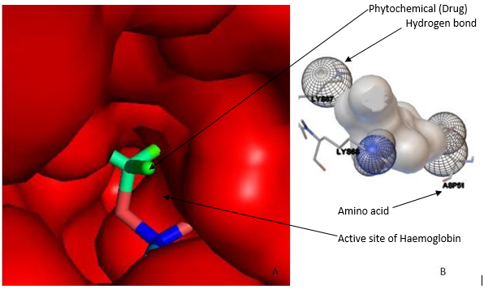
(A) 5-Hydroxylpentyl-1,3-dimethyl-3,7-dihroxylpurinedione from C. cajan Seed Extract in the active site of 2HBS (B) Predicted interactions between 5-Hydroxylpentyl-
1,3-dimethyl-3,7-dihroxylpurinedione and active site amino acid of 2HBS
(III) References
- Nurain I. O., Bewaji C. O., Jarrett S. J., Davenport R. D., and Zhang Y. (2016) Potential of three ethnomedicinal plants as antisickling agents. Molecular pharmaceutics. 14(1):172-182.
- Nurain I. O., Ibitoye I O., and Brewaji C. O. (2017) Molecular docking analysis of secondary metabolites of stem bark of enantia chlorantha with human calcium pump. Journal of Protein and Proteomics. 9(1):19-30.
- Nurain I. O. and Bewaji C. O. (2018) Interaction of some antisickling agent with human erythrocytes calcium pump. Journal of bioscience and Biotechnology. (Accepted for publication).
(IV) Biography of Presenting Author:
Dr Ismaila Nurain graduated 2017 from the University of Ilorin Nigeria with a PhD in Biochemistry. His Master’s Degree was also from the same University. He is a member of many professional bodies including Nigeria Society of Biochemistry and Molecular Biology (NSBMB), Nigerian Society for Experimental Biology (NISEB), Science Association of Nigeria (SAN). He has won several awards and grants locally and nationally. He attended University of Michigan as a research/visiting scholar during his PhD through a National Research Grant for staff development. He is open to postdoctoral fellowship at any suitable laboratory to further his research in biochemistry and molecular biology.
(IV)
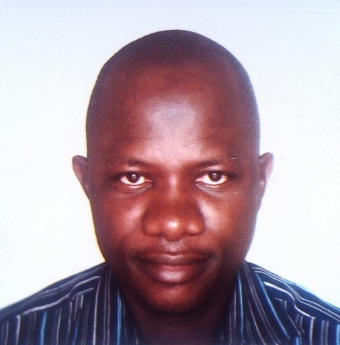

Full Name (Surname last): Ismaila Olanrewaju Nurain
Contact number: +2348068088828
Linked In account: linkedin.com/ismaila4u2@yahoo.com
Session name/ number:
Category: Oral presentation
Passport Number: A 04768754

