Additive Manufacturing for Occlusal Splints in Orthognathic Surgery- Technology Integrated into Science
Santosh Kumar Malyala, Department of Mechanical Engineering, National Institute of Technology Warangal, Telangana, India.
Ravi Kumar .Y, Department of Mechanical Engineering, National Institute of Technology Warangal, Telangana, India.
Dr. Chitra Chakravarthy, Department of Oral & Maxillo Facial Surgery, Navodaya Dental College Raichur, Karnataka, India.

Abstract (300 word limit)
Additive manufacturing is a state of the art technology which provides a unique and simple solution to complex problems and has been evolving steadily since 1985. Presently this technology has has integrated many domains all under one single roof. This current work deals with the integration of medical and engineering sciences to bring about an immense change in conventional treatment modalities . This study aims at fabricating a patient specific occlusal splint used for orthognathic surgery. Conventionally the fabrication of this splint involves articulating the patient's casts and fabricating the splints following mock surgery on the articulator. This procedure does not assure accuracy and may compromise the outcome of the surgery as the splint forms an important aspect in achieving good results. As the present case needed a surgery involving both jaws, it required the fabrication of an interim splint after the maxillary surgery and the final splint guiding the occlusion after the mandible was osteotomised. To design the splints, the patient's CT data was first obtained and a virtual surgery performed according to the surgical plan. After achieving satisfactory results in terms of jaw position and occlusion, additive manufacturing was used the fabricate customised splints to replicate the same results which were achieved during the planning stage. The inputs from virtual and preplanning surgery gave an precise streamlined procedure for the actual surgery with minimum time and maximum safety. Patient has benefited with a 30 percent of reduction in surgical time. This procedure can be applied to the surgeries like orthognathic surgery, trauma to the jaws where the occlusion is disturbed and for guiding the occlusion after jaw resections in Maxillofacial surgery.

Image

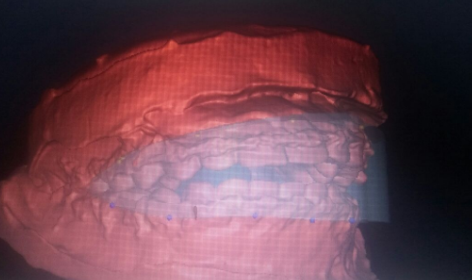
Fig 1: Maxilla and mandible scan with initial splint
Recent Publications (minimum 5)
- Sharma, Sunil et al. ;Pediatric Mandibular Fractures: A Review; International Journal of Clinical Pediatric Dentistry (2009).
- Gopinath, Arjun K et al ;Open Reduction And Internal Fixation In Pediatric Mandibular Fractures: A Report Of 10 Cases And Review Of Literature; International Journal of Oral Care; Research 4 (2016):
- Scolozzi, Paolo, and Georges Herzog; Computer-Assisted Virtual Planning For Surgical Guide Manufacturing And Internal Distractor Adaptation In The Management Of Midface Hypoplasia In Cleft Patients; The Cleft Palate-Craniofacial Journal (2016):
- Lee, Jung-Woo et al; Minimal Invasive Treatment Using Patient-Specific Template For Mandibular Fractures In Children: “Wing-Splint” By CAD/CAM Technology; British Journal of Oral and Maxillofacial Surgery 54.10 (2016):
5. Jung-woo Lee; Computer-Assisted Virtual Surgery And Splint Fabrication For Paediatric Mandible Fracture;. Journal of International Society for Simulation Surgery 2.2 (2015).


Biography (150 word limit)
Santosh Kumar Malyala Working as a Senior Research Fellow at National Institute of Technology Warangal India. Completed Masters in Product Design and Development course from NIT Warangal in 2009. Done Mechanical Engineering in Bachelors degree. working in collaboration with Panania dental College Hyderabad and Navodaya Dental College Raichur for medical cases where 3D printed models or implants play major role in case of complex surgeries. Worked as a Research Associate, with ESIGELEC research institute in France as part of GEOCOLIS project from Feb 2009 To July 2009. Apart from the above, been a part of various Software design and development teams at major MNCs. Published more than 20 research publications in Various international publications and conferences, Technical presentation done at Singapore, USA and Australia. .
Email: msantoshpdd@xxxmail.com

Notes/Comments:

