EFFECTS OF CONTROLLED ATMOSPHERE STORAGE AND TEMPERATURE ON QUALITY ATTRIBUTES OF MANGO
ZINABU HAILU; TESHOME WORKU
Addis Ababa University, Addis Ababa, Ethiopia
Addis Ababa Institute of Technology, School of Chemical and Bio Engineering, Food engineering
Corresponding author E-mail: zinisheh@gmail.com: Cell phone: +251-9 22098403
ABSTRACT

This study was conducted to analyze the effects of Controlled Atmosphere Storage (CAS) and low temperatures on quality attributes of cv. Keitt mango. Mango is one of the choicest fruits in the world and popular due to its delicious taste, pleasant aroma and nutritional value. To date, only 3% of the total world production is being exported due to the perishable nature of the product, lack of proper storage and other postharvest related diseases. Post-harvest loss of mango in Ethiopia is estimated to be between 25-40% and would occur during handling, transportation and storage. Storage loss could arise owing to atmospheric conditions and temperature. CAS is agricultural technologies which monitor and adjust constantly the level of CO₂ and O₂ within storage to reduce the rate of physiological and biochemical changes, ethylene sensitivity and incidence of decay development of mangoes and also inhibit pathogen growth. Thus, this study was under taken to determine the optimum storage conditions of Ethiopian mango in order to reduce considerable postharvest mango losses. In this work, randomized block design experimental was employed for optimization of the influencing factors mainly CAS and temperatures. Accordingly, experiments were carried out at constant storage temperature of 7ºC with different atmospheric conditions of A (10%CO₂ + 6%O₂+84%N₂), B (8%CO₂+ 6%O₂+86%N₂), C (5%CO₂+5%O₂+90%N₂) and Control (0.03% CO₂ + 21% O₂+79%N₂). Besides, fruits also stored at different constant temperatures of 7 ºC, 10 ºC, 13ºC and control (21-24 ºC) respectively. The result obtained showed that effect of CAS on quality attributes (weight loss and firmness) of cv. Keitt mango significantly improved the storage life as compared to that stored at ambient atmosphere with list significant difference values being at 0.05=3.12 and 1.708 respectively. In addition, the effect of temperature on Total soluble solid, Titrable acidity, pH, weight loss, firmness and skin color was found to be significant in prolonging the storage life of the fruit with List significant difference values of 0.05(0.317, 6.58, 3.46, 4.148, 6.50 and 2.41).The study revealed that the fruit stored at 7ºC under 10%CO₂ +6%O₂storage condition, as confirmed by sensory analysis, was given better preference to extend cv. Keitt mango up to 6weeks. On the other hand, the fruits stored at 13ºC with no CAS conditions showed better storage time of up to 21 days without chilling injury effect. Finally, it can be conclude that application of CAS technology can significantly enhance the quality and storage life thereby minimizing post-harvest losses of mango fruit.
Key words: cv. Keitt, Controlled Atmosphere Storage (CAS), Temperature, List Significance Difference

1. INTRODUCTION

Mango (Mangifera indica L.) is native to south Asia and known as king of the fruits due to its excellent
flavor, delicious taste and high nutritive values. There are over thousands varieties around the world, the most common are Keitt, Kent and Tommy Atkins and they are also grow in Ethiopia. Mango is produced mainly in-west and east of Oromia, SNNPR, Benishangul and Amhara (Desta, 2005), which are specific areas of Ethiopia and they have a potential to produce wide variety of mango fruit. According to Ethiopian central statistical agency report in 2011/12 report about 12-14 % of total fruit production is mango. But, it is exported less than 2 %( Joosten, 2007). This is due to perishable nature of the product, lack of proper handling and lack of proper storage (Leon et. al, 1997). Besides, the post-harvest loss of mango is 26.3 %.( Tadesse 1991) Thus, Maintenance of fruit quality for a specific period of time before its consumption is important factor in the post-harvest life of the fruit. The physiological changes may occur in harvested fruit due to unfavorable atmospheric conditions especially fluctuation in temperature and humidity. Fresh mango fruits have a short storage life of 4 to 12 days at room temperature and can also suffer low temperature injury (chilling injury) during refrigerated storage (Lakshminarayana, 1973). Therefore, it is necessary to develop improved methods of mango storage in fresh state that can enhance its shelf life without any detrimental effect on the quality. Various methods of extending the storage life of mangoes have been tested but little research has been conducted on controlled atmosphere (CA) techniques. Controlled atmosphere Storage (CAS) has been shown to be beneficial technique in reducing the rate of physiological and biochemical changes, ethylene sensitivity and incidence of decay development of perishable fruit products (Medlicott & Jeger, 1987) and as a result of it senescence is delayed. The response of mangoes to CA condition reported in the literature has been shown to vary. Nakamura et al., (2004) reported that CA storage having 5-10% CO₂ is effective to suppress the respiration rate of ripe mango. Lalel et al., (2003) found that CA comprised of 2% O2 and 2% CO₂ is better for maintaining the aromatic compounds of ripen fruit. Similarly Mitra & Baldwin (2005) stated that low temperature, hypobaric and CA storage can keep the mango fruit for about two to four weeks however, they suggested further research in this area. Lalel et al.,(2005) reported that CA treatments reduced respiration rate, de-greening of the skin and fruit softening of mangoes but yellowness of the skin, total soluble solids (TSS), total sugars content and taste of the ripe fruit were maintained. In another research Palding and Reeder (1977) recommended that shelf life of keitt mangoes can be increased up to 35 days without any significant quality effect by storing them at 13ºCin 5% CO₂ and 5%O₂. Different varieties of mangoes showed different responses to CA storage (Rattanapanone, 2001).Therefore, the study focused with effects of controlled atmosphere storage and temperature on quality attributes of Ethiopian mango to reduce the post-harvest loss and maintain desired quality. The experiment was carried out to evaluate the effects of CAS and temperature, determine sensory evaluation and optimum storage condition of cv. Keitt mango.

2. MATERIALS AND METHODS

The mango cv. Keitt sample used in this experiment was collected in plastic bags from Addis Ababa Et-fruit. The fruits were sorted according to their size, weight and color. Then the sorted fruits were washed by tape water, and dry through blowing dried air stored in CA storage, and ambient storage condition. To determine the effects of temperature and CAS, Completely Randomized Design (CRD) was used with below treatments: Storing fruits at constant temperature of 7°C under CAS conditions of A-(6% O₂ + 10%CO₂), B-(6%O₂+ 8% CO₂), C-(5%O₂+ 5% CO₂) and D-Control(21% O₂ + 0.03% CO₂ ). Besides, the effect of temperatures without considering CAS effect was also studied fruits stored at different storage temperature of 7°C, 10°C, 13°C and Control (21-24°C) respectively. About 112 uniform cv. Keitt mango fruits samples were used for studying out of which 42 samples were stored at CAS, with gas tight plastic bag in order to control the atmosphere by using closed system, 14 samples were stored in ambient atmosphere, while the remaining 56 samples were investigated for temperature effects. Each Sample was randomly taken within five day intervals to evaluate the effect of Controlled Atmosphere Storage (CAS). CAS chambers were calibrated to establish the specified gas composition by a gas blending flow system. The gas blending system generated CA conditions using external supplies of gases from, pressurized gas cylinders fitted with double-stage regulators and outlet controlling devices. These outlets were connected to the inlet flexible pipes that were inserted into the gas tight plastic containers in which the mangoes were stored. Fruits were then stored at specified temperature with different controlled atmosphere which were evaluated every 5 days for total soluble solids (TSS), Titratable acidity (TA), pH, weight loss, firmness, and skin color. To investigate effects of different temperatures, sample was taken within 7 days interval using I Button. The One-Wire Viewer a Java™-based software package is used to explore Maxim's 1-Wire and I Button devices with a personal computer. The 1-Wire and I Button devices communicate over a single data line plus ground reference, using the 1-Wire protocol. The skin color was measured by using skin indicator chart 1-deep green 2-light yellow-green, 3-yellow-light green, 4-yellow-orange5-golden orange. Flash firmness was measured (kg/mm²) using FACCHINI-48011-Model (Italy) penetrometer with 8mm probe diameter. Total soluble solid (TSS) was measured by using Model-RF18 (India) handheld sugar refractometer. Titrable Acidity of the fruit was measured by means of an acid base titration method using a juice sample (10 ml juice + 10 ml distilled water) and 0.1N Sodium hydroxide (NaOH) with phenolphthalein color indicator and pH was measured using digital pH meter. Weight loss also measured using digital weight balance. For the sensory evaluation tests, ten panelists was selected from the university and the tests involved individuals in isolated tasting conditions. Five of panelists were asked to give their individual ratings on all quality attributes of stored fruits including color, aroma, taste, flavor, firmness and overall acceptability of the stored fruits with different conditions while the other five panelists were asked to evaluate quality of the effects of temperatures with a 9-point structured hedonic scale to conduct the preference test: 1- dislike extremely and 9- like extremely. The scores marked by panelists were collected and an average was calculated for each parameter. One way Analysis of variance (ANOVA) was performed on the data collected using Microsoft excel and Origin Pro 8 soft ware’s. Comparison between treatment means at 5% level of significance was calculated.

3. RESULTS AND DISCUSSION

The effects of controlled atmosphere storage (CAS) and low temperatures analysis for quality attributes of cv. Keitt mango and the optimum conditions for long storage were studied. In addition, sensory analysis for the final product using nine hedonic scale also carried out. The results of samples analyzed in this work are presented in tabular and graphical form.
3.1 The Effect of CAS on Quality Attributes of cv. Keitt Mango
Skin color: as the skin indicator chart showed that(1-deep green, 2-light yellow-green, 3-yellow-light green, 4- yellow orange, 5- golden orange), Skin color of fruits stored at ambient atmosphere changed their color from deep green to yellow orange after 15 days and to golden-orange after 30 days of storage (see on appendix Table 4.2B), whereas the skin color of fruits stored at controlled changed their color after 25 days from deep green to yellow orange and to golden orange colors after 40 days of storage (see on appendix Table 4.1A).The loss of green color was the most obvious change in mango which was probably due to the physiochemical change by degradation of the chlorophyll structure and increased in carotenoids pigments during storage. The principal agents responsible for this degradation might be oxidative system, pH change, and enzymes like chlorophyllase (wills et.al. 1982).The experimental result observed, showed in significant of CAS on skin color (new LSD at 0.05=1.36) between fruits stored in CAS and ambient atmosphere as presented in (Fig 4.1) and the effect of CAS and ambient atmosphere had similar mean result(5-golden orange) after 40 days storage.
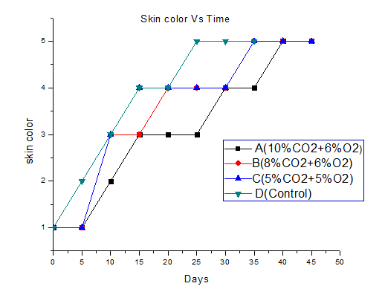
Fig 4.1: Skin color of mangoes at 7ºC after storage under controlled atmosphere
Flash Firmness: Mangoes exposed to CAS used in this work remained greener and more firm than those stored in ambient atmosphere (Fig 4.2). The current investigations confirmed the view that CAS conditions delay fruit ripening and softening (Kader, 1986).Ripening and senescence rates in many climacteric fruits like mangoes, can be affected by control of the availability of O₂ and CO₂ to the fruit during respiration and that these two compounds can have a significant inhibitory effect on ability of ethylene to initiate ripening (Ben-Yehoshua et al., 2005). Thus, flash firmness of fruits kept in air significantly decreased very rapidly from 14.1kg/mm² to 0.099 kg/mm² after 35 days of storage (see on appendix Table 4.2B) and new LSD at 0.05=1.708.The flesh firmness of fruits which were kept under (CAS) with treatment of (10% CO₂ + 6%O₂) had high firmness than the other treatments after 6 weeks storage with mean firmness result being 5.541 kg/mm² (Fig 4.7)
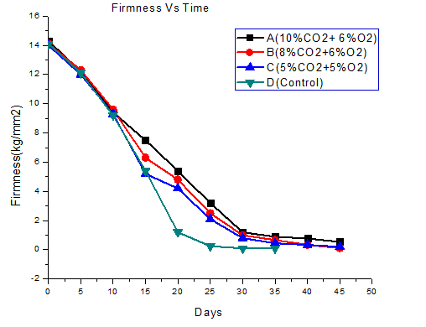
Fig 4.2: Flesh firmness of mangoes at 7ºC after storage under controlled atmosphere

Total Soluble Solid (TSS):it was observed that, TSS of fruits stored in ambient atmosphere were increased from 4.1 to 18.86ºBrix after 30 days and decreased to 14.8ºBrix after 35days storage ( see on appendix Table 4.2B). The increase in TSS might be due to alteration in cell wall structure and break down of complex carbohydrates into simple sugars. As showed the graph below fig4.3 the total soluble solid of fruits stored at ambient atmosphere sharply decreased in between 30 to 35 storage time, this is due to metabolic process as the temperature become high microbial and respiration activities become increased ,conversion of sugar into alcohol(ethanol)become exist. The acidity of the fruit also becomes high. This increase and decrease in TSS are directly correlated with hydrolytic changes in starch and conversion of starch to sugar being important index of ripening process in mango fruits and other climacteric fruits and further hydrolysis decreased the TSS during storage (kittur et.al. 2001).Beside, fruits stored at controlled atmosphere storage also increased the TSS content from 4.1 to 18.25ºBrix after 45 days of storage (see on appendix Table 4.1A). As the result showed, it would stay in CAS further days without significant quality effects. From the CAS treatments; treatment- A (10%CO₂+6%O₂) had less TSS content with average (13.5ºBrix) than of the other treatments as shown in Fig 4.2. Hence, this treatment has a potential to extend the storage life of fruits beyond 45 days of storage time. No significant change was observed in TSS between the fruit samples kept at ambient atmosphere and CAS (new LSD at 0.05=4.406).

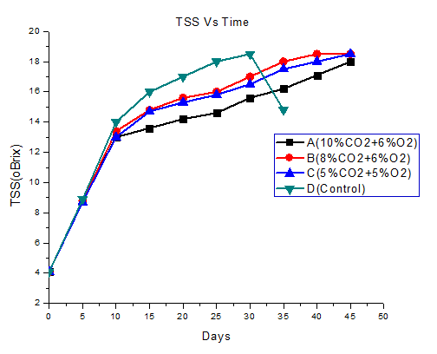

Fig 4.3: Total soluble solid content of mangoes at 7ºC after storage under controlled atmosphere.

Titratable Acidity (TAA): The change in Titratable acidity of the mango (cv. Keitt) recorded during storage at ambient temperature of (21-24ºC) is presented in appendix Table 4.2B. The results revealed that percent Titratable acidity of treated cv. Keitt mango ranged from 1.665% to 0.0234% with an average of 0.52% (Fig 4.7) during storage and the pH also increased from 2.4 to 5.16 after 35 day of storage. the results observed, indicated that percent of Titratable acidity showed decreasing trend during 35 days of storage period might be due to the degradation of citric acid which could be attributed to ripening or reduction in acidity may be due to their conversion into sugars and their further utilization in metabolic process of the fruit. These results coincided with those of Doreyappa-Gowda and Huddar (2001) who reported similar pattern in different varieties of mango fruit stored at 18-34ºC under gone a series of Physico-chemical changes during ripening and the major changes were considerably increased in pH from 2.85 to 4.38 and decreased in acidity from 2.71 to 0.04% during ripening. Thus, no significant change in TAA and pH; between fruits kept at ambient atmosphere and CAS were observed (new LSD at 0.05=0.536 and 1.118) respectively (Fig4.4).
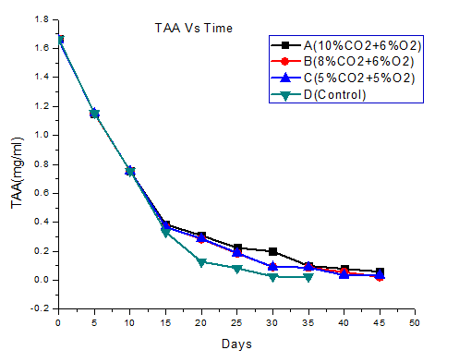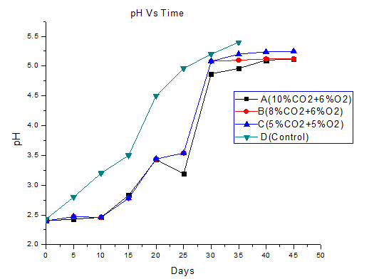
Fig 4.4 Titrable acidity and pH of mangoes at 7ºC after storage under controlled atmosphere
.

Weight loss (%): The reduction in weight is attributed to the physiological loss in weight (PLW) due to respiration, transpiration of water through peel tissue and other biological changes taking place in the fruit. The effect of CAS was highly significant on weight loss of stored fruit (new LSD at 0.05 =3.12). The mean weight loss percentage of fruits stored with treatment A (10% CO₂+ 6%O₂) was less (0.75%), whereas fruits stored at ambient atmosphere was high (5.87%) after 4-6 weeks of storage (Fig4.6).

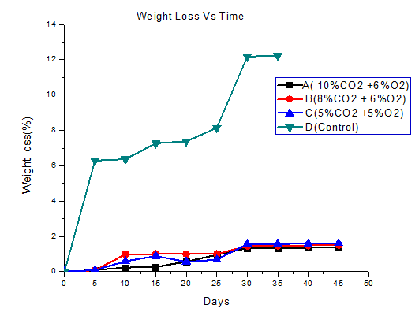

Fig 4.6: Weight loss of mangoes at 7ºC after storage under controlled atmosphere

3.2 Effect of Temperatures on Quality Attributes of Stored cv. Keitt Mango
Total Soluble Solid (TSS): Significant increase in sucrose content of mango has been observed during ripening and this has been attributed to an increase in total soluble solids during ripening. This is due to transformation of starch into soluble sugars as the carbohydrates in the fruit are broken down under the action of phosphorylase enzyme during ripening into simple sugars (Mitra S et.al., 1997). Storage temperature significantly (new LSD at 0.05=0.317) affected the TSS of fruits. As the mean storage temperature decreased TSS values obtained were 14.07 ºBrix, 12.87 ºBrix, and 9.87 ºBrix for the fruit stored 21-24 ºC, 13ºC and 7ºC respectively after 3weeks storage time (Fig4.7).
Titratable Acidity (TAA):Titrable Acidity of the stored fruit were significantly decreased as the temperature of the storage increased (new LSD at 0.05=6.58) after three weeks of storage (see Table 4.3C appidx) with the mean values of 1.2865 mg/10mg juice at temperatures of 7ºC and 0.937 mg/10mg juice at ambient temperature(21-24ºC) after 3 weeks storage period. The decline in acidity could be due to susceptibility of citric acid to oxidative destruction as impacted by the ripening environment, and also it is a consequence of starch hydrolysis leading to an increase in total sugars and a reduction in acidity (Aina JO, 1990).

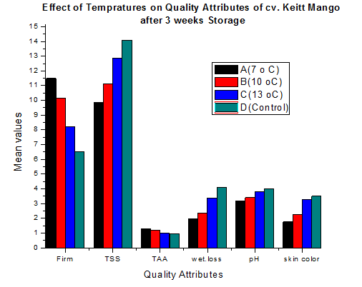
Fig 4.7: Effects of temperatures on cv. Keitt mango quality attributes after 3 weeks storage

Increase in pH during ripening of mango fruits has been reported by other authors (Tovar B.et.al.2000) and was similar to what was observed in the present study. According to the authors, there is an inverse relationship between titratable acidity and pH. The increase in pH (decline in acidity) could be due to utilization of acids as respiration substrates (Dadzie BK et.al.1997).The pH of the fruits also significantly affected by storage temperatures (new LSD at 0.05=3.46); as the storage temperature increased from 7ºC to ambient temperature (21-24ºC). The pH of the fruits also increased from 3.18 to 4.01 after three weeks storage as shown in (see on appdixTable 4.3C).
Skin color: the average skin color of fruit samples stored at 7 ºC, 10 ºC, 13 ºC and 21-24ºC were light yellow green light yellow green, yellow-green and yellow orange respectively(see on appdixTable 4.3C). According to the result, the effect of temperatures on skin color of the stored fruits was not significance changes fruits which was exposed to 7, 10, and 13ºC, whereas fruits stored in between 7 ºC and ambient temperature(21-24º ) was significant (new LSD at 0.05=2.41).
Flash Firmness: Effect of storage temperatures on firmness of cv. Keitt showed significantdifference between fruits stored at temperature of 7 ºC and ambient (21-24ºC) temperature (see on appidx Table4.3C)with new LSD at 0.05=6.50)
Weight loss (%): Maximum average weight loss percentage loss observed for fruits stored at ambient temperature (4.44%) after three weeks storage (new LSD at 0.05=4.148). As temperature of storage increased the average weight loss also increased (Table4.3C).
It was observed that Mangoes stored at low temperature leads to certain physiological disorder observed such as Chilling Injuries (CI). The primary cause of CI is thought to be the damage of cell membrane that initiates a cascade of secondary reaction. CI is a time and temperature problem. Mango fruits are subjected to CI when stored below 10°C. The symptoms include grayish scald- like discoloration of the skin, skin pitting, uneven ripening, and reduction in the level of carotenoids, aroma and flavor during ripening (Thomas,. P et.al a1983).Most of mangoes cultivars shows injury below 10°C (50 °F), especially if fruit have just reached maturity. Tolerance to chilling injuries increases during ripening (Medlicott et al. 1990). Chilling injury (CI) has been reported to occurs in mango fruit at temperatures below about 10-13°C, although some cultivars (Dasheri, Langara) were reported to be safely stored at 7-8°C for up to 25 days. Storage at 10 to 13°C (50 to 55°F) with 85 to 90% relative humidity should give a shelf-life of 14 to 28 days for mature green fruit, depending upon variety (Jobin Decor 1988).The result of the experiment showed that fruits stored at temperature of 7ºC after three weeks storage time, were exposed to CI starting from 7 days storage, for the fruit stored at 7ºC with symptoms of un ripening, skin pitting, discoloration, poor aroma and flavor during ripening and is in agreement with Jobin Decor result (Fig4.9).
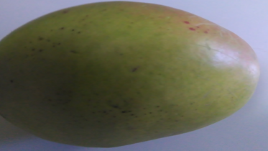
Fig 4.8: Photograph of Keitt variety mango fruit before storage
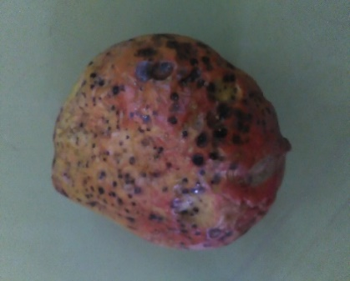
Fig 4.9: Photograph of Keitt type mango fruits stored at temperatures of 7ºC.

3.3 Effect of CAS and Temperatures on Sensory Quality Attributes (SQA)
Color changes in mango fruit are due to the disappearance of chlorophyll and appearance of other pigments (Lakshminarayana at.el.1980). The observed results of skin color of fruits stored with treatment (10%CO₂ + 6%O₂) showed maximum preference with it mean and standard deviation result was 8.4+0.89 (Table4.4). Fruit flavor depends upon taste (balance between sweetness and sourness or acidity, and low to no astringency) and aroma (concentrations of odor-active volatile compounds). Taste development is due to a general increase in sweetness, which is the result of increased gluconeogenesis, hydrolysis of polysaccharides, especially starch, decreased acidity, and accumulation of sugars and organic acids resulting in an excellent sugar/acid blend (Grierson et al., 1981) Sourness or acidity is determined by the concentrations of the predominant organic acids, which are citric acid, malic acid, and tartaric acid. Some amino acids, such as aspartic and glutamic acid may also contribute to sourness. Several factors affect sugar and acid contents in mango, including cultivar (Kapse et al., 1989) The flavor of Mangoes stored under treatment conditions of A (10%CO₂ + 6%O₂) and B (8%CO₂ + 6%O₂) with average values of 7.4 was preferred by panelists.
But, the overall acceptance was high for fruits stored with treatment A (10%CO₂ + 6%O₂) mean result of 8.0 (see on appendix Table 4.4

Similarly, the effects of temperatures on quality of stored fruits was evaluated by sensory panelists, the color of the fruits stored at temperature of 13 and ambient (21-24ºC) had high preferences with their mean values got 7.6 (see on appendix Table 4.5E). Fruit samples stored at temperature of 13ºC got maximum overall acceptance, while fruits stored at temperature of 7ºC got minimum overall acceptance (Table 4.5E)

4. CONCLUSIONS
Mangoes are highly nutritious and favorable fruits. However, post-harvest losses and quality deterioration due to exposure to temperature and improper handling management challenged the productivity and wider usage of the fruit. In Ethiopia, the post-harvest loss (transporting, handling and storage) of mango is estimated as to be about 23.6% from this total loss about 7-10% is storage loss. The major storage loss factors are atmospheric conditions and temperature. Thus, study was carried out by using CAS technology which is constantly monitor and adjust the CO₂ and O₂ levels within gas tight stores or containers to reduce storage loss and extending the storage life of mangoes for better duration without loss of its quality.
The Controlled Atmosphere Storage (CAS) positively affected the quality parameters and significantly improved the shelf life of mangoes. It extends storage life of cv. Keitt mangoes for up to 6 weeks without significant quality loss with treatment at 7°C under 10%CO₂ + 6%O₂+84%N_{2.} This condition is better to store the mangofor long time without significance loss relative the other conditions and quality of the fruit after storage also confirmed by sensory analysis, thus the above condition is best. On the other hand, the effects of storage temperature on quality attributes of mangoes were significant. The cv. Keitt mangoes stored at 13ºC had better quality after 3 weeks storage time as confirmed by sensory analysis than of fruits stored with other treatments. In general, extending storage duration more than 6 weeks is extending marketing period and maintained fruits availability.

Declaration
This work was our original work; there is no conflict interest among authors.

REFERENCES
Aina JO Physico-chemical changes in African Mango (Irvingia gabogensis) durin normal storage ripening. J. Food Chem., 1990; 36: 205 – 212.
Ben-Yehoshua S (1985). Individual seal-packaging of fruits and vegetables in plastic film new postharvest technique. Journal of Horticultural Science, 20, 32–37
Dadzie BK and J Orchard Routine Post Harvest Screening of Banana/Plantain Hybrids: Criteria and Methods. INIBAP Technical Guidelines 2, Wageningen, the Netherlands, p 63, 1997.
Desta H, (2005). Export potential of Ethiopia processed fruit and vegetables, export promotion department of English, P., S. Jaffee and J.J. Okello.2006.
Doreyappy-Gowda, I.N.D and A.G. Huddar, 2001, Studies on ripening changes in mango (Mangiferaindica L.) fruits. J. Food Sci. Tec. Mysore, 38: 135- 137.
Joosten F (2007). Development Strategy for Export Oriented Horticulture in Ethiopia. http://library.wur.nl/way/bestanden/clc/1891396.pdf
Kader, A.A. (1986). Biochemical and physiological basis for effects of controlled and modified atmospheres on fruits and vegetables. Food.Technol. 40: 99-104.
Kapse, B. M., Rane, D. A., and Khedkar, D. M. 1989. Correlation between biochemical parameters and organoleptic evaluation in mango varieties. ActaHort. 231:756–762.
Kittur, F.S., N. Saroja, Habibunnisa and R.N. Tharanathan, 2001. Polysaccharide-based composite coating formulations for shelf-life extension of fresh banana and mango. Eur. Food Res. Tec. 213: 306-311
Lakshminarayana, S., M. Subbiah Shetty; and C. A. Krishnaprasad. 1975. Accelerated ripening of Alphonso mangoes by the application of ethrel. Tropical Science. 17: 95-101.
Lakshminarayana, S., N. V. Subhadra; and H. Subramanyam. 1970. Some aspect of developmental physiology of mango fruit. Journal of Horticultural Science 45: 133-142.
Lalel, H.J.D. and Singh, Z. 2004. Biosynthesis of aroma volatile compounds and fatty acids in ‘Kensington Pride’ mangoes after storage in a controlled atmosphere at different oxygen and carbon dioxide concentrations. J.Hort. Sci. Biotechnol. 79:343-353.
Leon DM, De la Cruz J, Parkin KL, Garcia HS, 1997. Effect of controlled atmospheres containing lowO₂ and high CO2 onchilling susceptibility of Manila mangoes.Acta Horticulturae. 455, 635-642.
Medlicott, A.P., Sigrist, J.M.M. and Sy, O. 1990. Ripening of mangoes following low temperature storage. J. Amer. Soc. Hort. Sci. 115:430-434
Mitra S K; Baldwin E Z (1997). Mango. In: Postharvest Physiology and Storage of Tropical and Subtropical Fruits (Mitra S K, ed), pp 85–122. CAB International, West Bengal, India
Spalding, D.H. and W.F. Reeder, 1977. Low pressure (hypobaric storage) of mangoes. Journal of the American Society for Horticultural Science 102: 367-369
Tadesse F (1991). Postharvest losses of fruits and vegetables. Journal of Horticulture, 270, 261-27
Wills, R. B. H., McGlasson,W. B., Graham, D., and Joyce, D. C. 2007. Postharvest; An introduction to the Physiology and Handling of Fruit, Vegetables and Ornamentals. pp. 83–99. UK: CABI Pub.

ACKNOWLEDGEMENTS
Above of all, I thank the almighty God who gave me strength and encouragement and led me through all the rough and difficult times to complete this study. I wish to express my deepest appreciation to my advisors, Mr. Teshome Worku for his endless help in correcting, commenting, and encouraging accomplishing this work. I also like to appreciate their patience in following up this work from the very beginning to the end. I am very grateful to Mr. Mekidim Asefa, for his assistance, invaluable comments and excellent supervision throughout my research work. I also extend my appreciation to Addis Ababa Institute of Technology, School of Chemical and Bio Engineering Laboratory staff members for their technical assistance during experimental work. Finally, I would like to express my sincere gratitude to my families and friends who have been providing their support and encouragement. And also all others who directly and indirectly contributed to this manuscript are highly acknowledged for their voluntary participation.

APPENDIXES
Table 4.1A: Mean results of mango quality attributes stored in CAS for 0- 45 days
Days | Firmness (kg/mm²) | TSS(º Brix) | TAA (%) | pH | Weight loss (%) | Skin color
0 | 14.13 | 4.1 | 1.66 | 2.40 | 0 | 1
5 | 12.16 | 8.8 | 1.151 | 2.45 | 0.0869 | 1
10 | 9.43 | 13.13 | 0.754 | 2.46 | 0.603 | 2.6
15 | 6.33 | 14.36 | 0.373 | 2.79 | 0.533 | 3.3
20 | 4.8 | 15.03 | 0.293 | 3.43 | 0.457 | 3.6
25 | 2.6 | 15.46 | 0.198 | 3.42 | 0.623 | 3.6
30 | 1 | 16.36 | 0.127 | 5.01 | 1.452 | 4
35 | 0.67 | 17.23 | 0.091 | 5.08 | 1.457 | 4.6
40 | 0.48 | 17.86 | 0.056 | 5.15 | 1.475 | 5
45 | 0.29 | 18.33 | 0.0391 | 5.16 | 1.491 | 5
NB: 1-deep green, 2-light yellow-green, 3-yellow-light green, 4- yellow orange,5-golden-orange

\
Table 4.2B: Mean results of mango quality attributes stored in ambient atmosphere for 0-35 days
Days | Firmness (kg/mm²) | TSS(ºBrix) | TAA (%) | pH | Weight loss (%) | Skin Color
0 | 14.1 | 4.1 | 1.665 | 2.40 | 0 | 1
5 | 12.1 | 8.9 | 1.152 | 2.83 | 6.289 | 2
10 | 9.2 | 14 | 0.7541 | 3.24 | 5.370 | 3
15 | 5.4 | 16 | 0.3328 | 3.54 | 3.272 | 4
20 | 1.2 | 17 | 0.128 | 4.56 | 4.384 | 4
25 | 0.25 | 18 | 0.0828 | 4.96 | 3.144 | 5
30 | 0.1 | 18.5 | 0.0256 | 5.27 | 12.182 | 5
35 | 0.099 | 14.8 | 0.0234 | 5.48 | 12.234 | 5
NB: 1-deep green, 2-light yellow-green, 3-yellow-light green, 4- yellow orange,5-golden-orange

Table 4.3C: Mean effect of temperatures on mango quality attributes after 3 weeks storage.
Temperatures | Firm(kg/mm²) | TAA (%) | TSS(ºBrix) | Wet loss (%) | pH | Skin color
7 º C | 11.5 | 1.2865 | 9.875 | 2.6 | 3.18 | 1
10 º C | 10.125 | 1.202 | 11.125 | 2.9 | 3.3975 | 2
13 º C | 8.2 | 0.98975 | 12.875 | 4.25 | 3.81 | 3
Control | 6.255 | 0.9374 | 14.075 | 4.44 | 4.015 | 4
NB: 1-deep green, 2-light yellow-green, 3-yellow-light green, 4- yellow orange, 5- golden orange
Table 4.4D: Effect of CAS on Sensory Quality Attributes of stored fruits (Means + SD)
SQA | A | B | C | D
Color | 8.4 + 0.89 | 7.8 + 0.83 | 7.6 + 1.14 | 7.8 +1.09
Flavor | 7.4 + 1.14 | 7.4 + 0.89 | 6.8 + 1.30 | 7 + 2.00
Taste | 8 + 0.70 | 8.6 + 0.54 | 6 + 1.58 | 5.8 + 2.38
Firmness | 7.4 +1.14 | 7.4 + 0.54 | 7.4 + 0.54 | 8 + 0.00
Over all acceptance | 8 + 0.70 | 7.8 + 0.44 | 7.2 + 0.83 | 6.8 + 1.78
NB: A (10%CO₂+6%O₂), B (8%CO₂+6%O₂), C (5%CO₂+5%O₂) & D (Control)
Table 4.5E: Effect of Temperatures on Sensory Quality attributes (Means + SD)
SQA | 7ºC | 10ºC | 13ºC | Control(21-24ºC)
Color | 4 + 1.58 | 6.4 + 1.51 | 7.6 + 1.14 | 7.6 + 1.14
Flavor | 3.2 + 1.48 | 5.8 + 0.83 | 8 + 0.70 | 7.2 + 0.83
Taste | 3.4 + 0.89 | 5.2 + 0.83 | 7.6 + 1.14 | 5.8 + 0.83
Firmness | 3.8 + 3.8 | 6 + 1.22 | 7.2 + 0.83 | 5.6 + 1.14
Over all acceptance | 3.6 + 3.6 | 6.4 + 0.54 | 8 + 0.70 | 6.4 + 0.54

