Plant cell culture technology; an effective biotechnology tool for taxol and related taxanes production
Samavia Mubeen, PhD, Sun Yat-sen University Guangzhou, China
Chun-Tao He, PhD, Sun Yat-sen University Guangzhou, China
Zhong-Yi Yang, PhD, Sun Yat-sen University Guangzhou, China

Abstract
Taxol, also known as paclitaxel is a most promising chemotherapeutic agent against numerous cancers including ovarian, breast and lungs cancers. This biologically active compound was initially isolated from the inner bark of Taxus brevifolia (Pacific yew). The demand for taxol supply was greatly exceed due to the accumulation of taxol at very low concentration, slow growth of tree and high cost of extraction. Due to these reasons, searches for alternative sources were made including the screening of plants other than taxus, chemical synthesis, semi-synthesis of taxol by conversion of baccatin III (BAC III) or 10-deacethylbaccatin III (10-DAB III) and microbial fermentation. Neither of these sources was viable at industrial level due to the high cost of production, lengthy steps, low production and difficulty in the extraction process. Plant cell culture is an attractive biotechnological strategy to secure sustainable and economical production of taxol and related taxane at the industrial level. Different strategies such as cell line selection, growth condition optimization, physical parameters, elicitation, extraction, and scale-up to bioreactor have been extensively investigated to improve the production of taxol. This review will shed light on recent advances in taxus cell culture technology, focusing on optimizing strategies to improve taxol and related taxoid production in cell culture system. We will also summarize the progress towards the problem associated with the production of taxol by cell culture technology at the commercial level and will also highlight the recent success.

Image

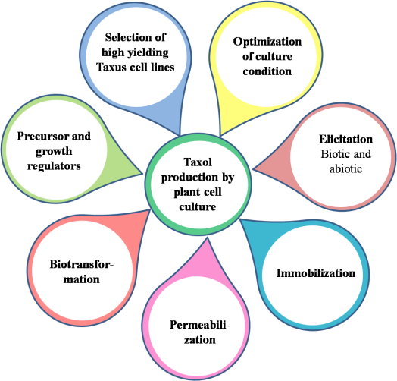
Figure 1. Strategies for improving taxol production from tissue culture technology.
Recent Publications
- Vidal-Limon H, Sanchez-Muñoz R, Khojasteh A, Moyano E, Cusido R M, and Palazon J (2016) Taxus Cell Cultures, an Effective Biotechnological Tool to Enhance and Gain New Biosynthetic Insights into Taxane Production. Bioprocessing of Plant in Vitro Systems. 1-23
- Ochoa-Villarreal M, Howat S, Hong S, Jang M O, Jin Y W, Lee E K, Loake G J (2016) Plant cell culture strategies for the production of natural products BMB reports. 49(3): 149-158
- Wang S J, Wang H J, Li T, Li C, Zhou Y J, Zhong X M (2015) The selection and stability analysis of stable and high Taxol-producing cell lines from Taxus cuspidate. Journal of Forestry Research. 1:1-7
- Li Y L, Huang S W, Zhang J Y, Bu F J, Lin T, Zhang Z H, Xiong X Y (2016) A protocol of homozygous haploid callus induction from endosperm of Taxus chinensis Rehd. var. mairei. SpringerPlus 5(1):659
- Wang Z J, Zhang W, Zhang J W, Guo M J. Zhuang Y P (2016) Optimization of a broth conductivity controlling strategy directed by an online viable biomass sensor for enhancing Taxus cell growth rate and Taxol productivity. RSC Advances. 47 (6): 40631–40640

Biography
Samavia mubeen is doing her PhD from Sun Yat-sen University Guangzhou China. She has completed her master's from Pakistan with major in genome and genetics. Now she is working on Taxus plant which is popular due to its chemotherapeutic agent taxol. Her findings will help to understand the regulation of genes involved in paclitaxel biosynthesis; second, to look at the correlation between gene expression and taxane metabolites. By molecular cloning and transformation of final steps gene of taxol biosynthesis pathway in taxus cell culture, her results will help to establish a platform technology for future metabolic engineering approaches aimed at the production of taxoids in taxus and other than taxus plants.
Email: 2917997949@qq.com
Contact number: +8615521279087

Notes/Comments

