Effect of catechol O-methyl transferase inhibitor on anti-inflammatory activity of luteolin metabolites
Inwook Choi, PhD, Korea Food Research Institute, Republic of Korea

Abstract (300 word limit)
Although luteolin is known to have potent anti-inflammatory activities, much less information has been provided on such activities of its hepatic metabolites. Luteolin was subjected to hepatic metabolism in HepG2 cells either without or with catechol O-methyl transferase (COMT) inhibitor. To identify hepatic metabolites of luteolin without (LMs) or with COMT inhibitor (LMs+CI), metabolites were treated by ß-glucuronidase and sulfatase, and found that they were composed of glucuronide and sulfate conjugates of diosmetin in LMs or these conjugates of luteolin in LMs+CI. LMs and LMs+CI were examined for their anti-inflammatory activities on LPS stimulated Raw 264.7 cells. Expression of iNOS and production of nitric oxide and pro-inflammatory cytokines such as TNF-α, IL-1ß and IL-6 were suppressed more effectively by the treatment with LMs+CI than LMs. Our data provide a new insight on possible improvement in functional properties of luteolin on target cells by modifying their metabolic pathway in hepatocytes

Image
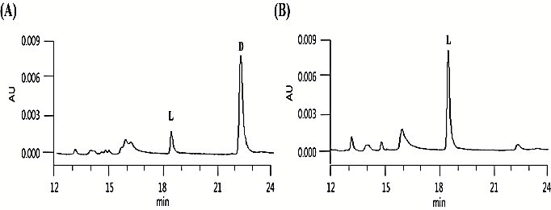
Figure 1. HPLC chromatograms showing the inhibition of O-methylation of luteolin by COMT inhibitor. (A) metabolism of luteolin, (B) metabolism of luteolin and COMT inhibitor. L: luteolin, D: diosmetin.

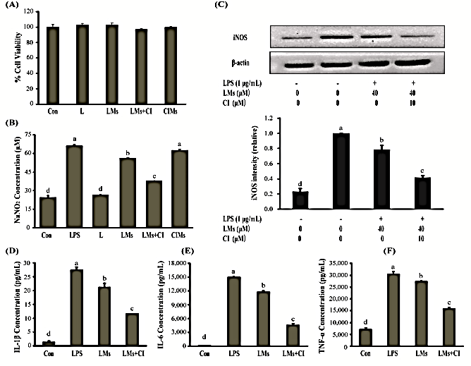
Figure 2. Effects of LMs and LMs+CI on production of NO, pro-inflammatory cytokines and iNOS expression in LPS-stimulated RAW 264.7 cells. (A) Effects of L, LMs, CIMs and LMs+CI on the viability of RAW 264.7 cells. (B) Effect of L, LMs, CIMs and LMs+CI on NO production by LPS-stimulated RAW 264.7 cells. (C) Effect of LMs and LMs+CI on iNOS expression by LPS-stimulated RAW 264.7 cells. (D-F) Effect of LMs and LMs+CI on pro-inflammatory cytokines such as IL-1β (D), IL-6 (E) and TNF-α (F). All data were presented as the mean ± S.E.M. of three independent experiments. Means letters (a, b, c and d) with different letters significantly differ (p <0.05).

Recent Publications (minimum 5)
- Chen Z, Dai YQ, Kong SS, Song FF, Li LP, Wang RW, Zeng S, Zhou H, Jiang HD (2013) Luteolin is a rare substrate of human catechol-O-methyltransferase favoring a paramethylation. Mol Nutr Food Res 57:877-885.
- Seelinger G, Merfort I, Schempp CM (2008) Anti-oxidant, anti-inflammatory and anti-allergic acitivities of Luteolin. Planta Med 74:1667-1677.
- Shimoi K, Saka N, Nozawa R, Sato M, Amano I, Nakayama T, Kinae N (2001) Deglucuronidation of a flavonoid, Luteolin monoglucuronide, during inflammation. Drug Meta Dispos 29:1521-1524.
- Tsao D, Liu S, Dokholyan NV (2011) Regioselectivity of catechol O-methyltransferase confers enhancement of catalytic activity. Chem Rhys Lett 506:135-138.
- Wu W, Li D, Zong Y, Zhu H, Pan D, Xu T, Wang T (2013) Luteoilin inhibits inflammatory responses via p38/MK2/TTP-mediated mRNA stability. Molecules 18:8083-8094.

Biography (150 word limit)
Dr. Choi has worked with great enthusiasm and endeavor for developing functional foods or pharmaceutical ingredients from animal and plant resources and commercializing them. Currently, He is interested in developing the system inferring functional properties of natural extracts (Bio-FINE). The system is based on bio-information that can be extracted by comparing differently expressing genes between normal and natural extracts fed animals. Through the system, various functional properties of single as well as combinatorial natural extracts can be ranked and further utilized for commercialization.
.
Email: choiw@kfri.re.kr

Notes/Comments:

