Session 6: Big Bang Theory

Creation of universe by a multitude of small bangs
Dr. Eng Cristian Popescu, CVW TECHNOLOGIES, Magurele, Romania

Abstract
Standard model of the universe creation assumes there was an initial explosion which then moved in all directions in a linear manner expanding space into nothing. This model is not coherent with the stable period of the universe after settling down and doesn’t explain why we have the current expansion of the universe. In the initial fraction of a second after big bang we have the paradox of light traveling faster than the speed of light and after decreasing its speed down to 300000 km/s, mass get created, without explaining how. In reality is much simpler to assume there was not one big bang, but billions of billions of small bangs, all of the same power, which they occurred everywhere in the same time. If we admit this, then we no longer have light traveling faster than light and we can explain the linear radiation collapsed into a sphere between each 8 explosions (see image) is how mass got created. If we know from E=mc2 that mass is somehow made of energy and light, if initially the entire space was filled with linear radiation, the small bangs collapsed these radiation under the form of spheres. In order to have these global explosions stable, we need a “wall” made from a continuously solid material around the entire universe. As conclusion the universe we assume it must be a sphere. If initially space was flat and these small bangs curved space, than we cannot have linear expansion of the universe from Hubble, as in reality there are no linear trajectories on long distances, at light years scale. Space is not expanding and it never did. Space behaving in a curved manner just curves the trajectory of light coming from far distance stars. As the distance from the star is higher, more time it took for light reaching us, so space had more time to curve it, so in our telescope appears shifting to read a little more, but with the same ratio. The fixed diameter of the universe doesn’t allow an expansion or a contraction; in stead it maintains the curvature of space constant over time.

Image
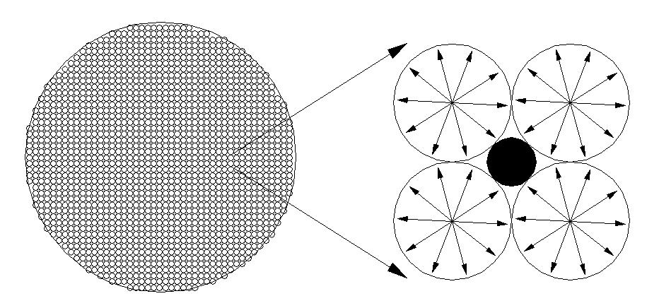
Global big bang formed by a series of small bangs (black sphere is mass)
Recent Publications
- What are reversed spheres?, Feb, 2020, Journal of Applied Material Science & Engineering Research
- Spherical Universe: History of the Universe Assuming a Closed Spherical Shape, Jan 20, 2020, Journal of Physics & Optics Sciences
- Global warming versus global cooling, Jun 17, 2019, Climate Change & Global warming conference, Osaka, Japan
- Solar system formation, May 20, 2019, 2nd European Physics Congress, Berlin, Germany

Biography
Popescu Cristian has completed his studies at Polytechnical University, Energetic Faculty, Hydro department and he has finalized his PhD at the age of 33 years from Technical University of Constructions Bucharest, Romania, with specialty in hydrotechnical constructions. He has a vast experience accumulated in 8 private companies working from research-design to project management and business development for various projects like river regulating flows, pumping stations, water and waste water treatment plants, ports infrastructures and energy projects from hydro, wind, thermal, to nuclear.
Email: cris.popescu100@yahoo.com cristian.popescu@cnv.ro

Notes/Comments On link https://we.tl/t-7qfliyF3Uj there is a video about what I would like to present at the conference.

