Refined diagnosis of pleural effusions with immunocytochemistry of cell blocks
Hirsh Koyi MD PhD^{1,2,3} and Erik Wilander MD PhD⁴
Department of Respiratory Medicine¹, Karolinska Institutet² and Centre for Research and Development, Uppsala university/County Council of Gävleborg³, Gävle, and Department of Pathology⁴, Gävle County Hospital, Gävle, Sweden
Abstract
Background. There are three main reasons for occurrence of pleural serous effusions: 1) cardiac and circulatory disturbances 2) inflammatory or infectious diseases and 3) metastatic spread of cancer mostly adenocarcinoma. Serous effusions admitted to a Department´s of Pathology are mostly examined with the goal to identify or exclude the presence of a malignant disease.
Aim. Our aim is refine the diagnosis of pleural serous effusions with the aid of immunostaining of cell blocks. The method will increase the sensitivity and specificity of the laboratory test in comparison with ordinary microscop examinations of routinely stained (MGG) smears.
Method. Test tubes (200 cases) with serous effusions 20 ml or more are centrifugalized (3000 rates per minute in 10 minutes). The supernatant is removed and the basal precipitate in the test tube is exposed to 2 drops of normal human plasma and 2 drops of thrombin. After that the precipitate is fixed in 10% neutral buffered formalin. The material is embedded in paraffin, sectioned in 4μ thin sections and put on glass slides. One slide is stained with Hematoxylin-eosin and two or more glass slides are used for immunostaining with antibodies to BEREP-4 and CEA in order to identify malignant cells and adenocarcinoma cells in the cell block. Additional antibodies were employed for information of the location of the primary malignancy, when malignant cells are identified, for instance; TTF-1 (lung carcinoma), CDX-2 (intestinal carcinoma) and Gata-3 and estrogen-receptor antibodies for (breast and gynaecological carcinoma)
Results. A number of pleural effusions (n=223) were examined. Of these 155 were consider as benign or non-representative and were diagnosed by cyto-technicians alone. Sixty-eight effusions were stained by immunohistochemistry of cell blocks due to a presence of atypical epithelial cells. All 22 cases with almost certain malignant cells were BEREP4 positive, corresponding to a sensitivity of 100%. Pleural effusions with atypical cells of uncertain significance were BEREP4 positive in 25% (8/32) and effusions with possibly malignant cells were BEREP4 positive in 79% (11/14) (see Table 1),. The immune-histochemical staining significantly refined the diagnosis of malignant cells in the pleural effusions especially in cases in which the preliminary diagnosis was effusions containing cells of uncertain significance and possibly malignant cells.
Conclusion. Immuno-histochemistry of cell blocks of pleural effusions can be used to refine the diagnosis of malignant cells in pleural effusions and also give information of the location of the primary site in the case it is unknown.
Table I. Immunohistochemical staining of cell blocks of pleural effusions with atypical and clearly malignant cells
BEREP4 BEREP4 Total
Positive negative
-------------------------------------------------------------------------------------------------------------------
Atypical cells of uncertain significance 8 24 32 (25%)
Possibly malignant cells 11 3 14 (79%)
Clearly malignant cells 22 0 22 (100%)
---------------------------------------------------------------------------------------------------------------------
Total 41 27 68 (60%)

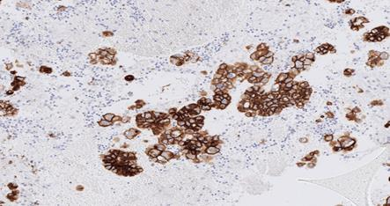 Pleural effusion with BEREP4 positive tumor cells
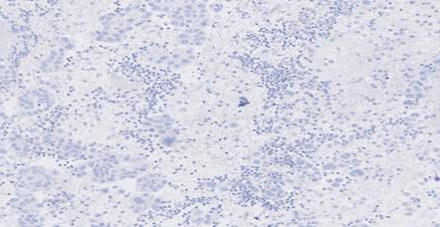 Pleural effusion without BEREP4 positive tumor cells
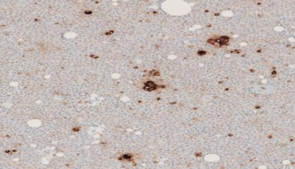 Pleural effusion with CEA positive adenocarcinoma cells
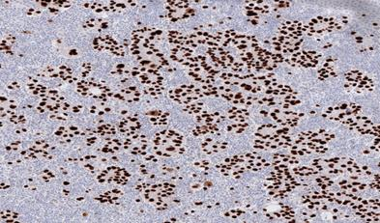 Pleural effusion with TTF-1 positive lung cancer cells

