A novel framework for Motion A.I. consumer products by means of wearable devices

Garofalo Pietro, PhD, Turingsense EU LAB s.r.l., Italy
Di Florio Paola, MSc, Turingsense EU LAB s.r.l., Italy

Abstract
Statement of the Problem: sensing technology such as inertial and magnetic sensors are nowadays commonly available as integrated components in common portable devices (smartphones and smartwatches). Despite of the continuous cost reduction for this technology and the many applications (navigation, display interaction, gaming, trackers), their potential has not been unleashed for all the application that involve measurement of human body joints, monitoring of exercises during rehabilitation, optimization of exoskeletons based on real-time kinematics measurement. Several attempts have shown great progress in the creation of methodologies in several fields (rehabilitation, ergonomics)^{4,5,7} but lacking real specs and solutions to the common technologies’ limitations (e.g. magnetic disturbances). The purpose of this study is to present an innovative framework for the creation of products for consumer markets based on wearable sensing technologies. Methodology & Theoretical Orientation: the framework takes in consideration both the technical challenges at the base of the usage of wearable sensing technology and also the demanding and ambiguous specs from end-user scenarios (Figure 1). Findings: along the years, limitations in the application of magnetic sensing technology in disturbed environment has been overcome by the introduction of “magnetometer-free” techniques¹; cumbersome and tricky positioning of sensors on the body have been solved by integrating sensors directly into shirt and pants²; generic motion capture software limited to research labs have been converted into software platforms for quick and customized development⁶; movement visualization evolved from “lab-oriented” stick figures to real-time 3D avatars for visual feedback³; user-machine interaction has been enhanced by means of scalable and interactive content creation using Motion A.I.¹
Conclusion & Significance: the present study shows a framework that has been successfully applied to consumer products (www.pivot.yoga) allowing people to track their movements and verify the correct poses at home. It is continuously under evolution and customization in order to enable new applications.

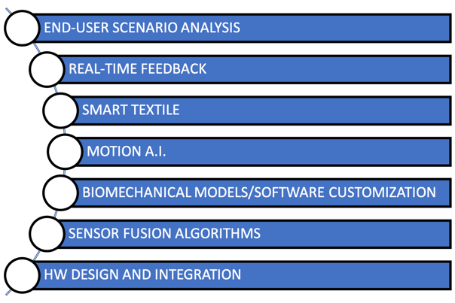
Figure 1- Major components of the framework for the design and implementation of products based on wearable sensing technology
Recent Publications
- Ligorio G et al (2020) Wearable Magnetometer-Free Motion Capture System: Innovative Solutions for Real-World Applications. IEEE SENSORS JOURNAL, VOL. 20, NO. 15
- Verdini F et al (2019) Evaluation of a New Wearable Technology for Kinematic Analysis During Perturbed Posture. IEEE 23rd International Symposium on Consumer Technologies (ISCT), Ancona, Italy
- Ligorio G et al (2018) A full-body 3D reconstruction of yoga poses through inertial sensing. Gait & Posture, 66
- Cutti AG et al (2010) 'Outwalk': a protocol for clinical gait analysis based on inertial and magnetic sensors. Med Biol Eng Comput vol. 48,1: 17-25
- Ferrari A., Cutti, AG., Garofalo P. et al. (2010) First in vivo assessment of “Outwalk”: a novel protocol for clinical gait analysis based on inertial and magnetic sensors. Med Biol Eng Comput 48, 1
- Truppa L et al. (2020) Assessment of Biomechanical Response to Fatigue through Wearable Sensors in Semi-Professional Football Referees. Sensors (Basel, Switzerland) vol. 21,1 66. 24
- Garofalo P et al. (2009) Inter-operator reliability and prediction bands of a novel protocol to measure the coordinated movements of shoulder-girdle and humerus in clinical settings. Med Biol Eng Comput vol. 47,5: 475-86

Biography

Pietro Garofalo received the M.Sc. degree in Biomedical Engineering in 2005 and the Ph.D. in Biomechanics in 2010 from Alma Mater Studiorum - University of Bologna (Italy). Since 2004 he has been involved in research and development in the field of medical devices and rehabilitation by means of inertial sensors, from the development of protocol for human motion analysis to the end-user applications. In 2015, he has joined Turingsense EU LAB (Italy) where he is currently working as Technical Director and drive applications of inertial sensors technology in the field of Tennis, Fitness and Yoga.
Email: pietro.garofalo@turingsense.com


Paola Di Florio received the M.Sc. degree in Biomedical Engineering in 2019 from Universita’ Politecnica delle Marche. She has been involved in projects related to movement analysis and optimization and filtering for the human motion capture. Since 2019 she is working at Turingsense EU Lab (Italy).

Email: paola.diflorio@turingsense.com

Notes/Comments:

